Orange Issy les Moulineaux Les Oliviers Site
Only for the ZOOM streams meetings on 8, 9 and 10 of September 2015

Orange
"Les Oliviers" building
48 rue Camille Desmoulins
92130 Issy Les Moulineaux
Reception : +33 1 57 36 12 00

How to find us

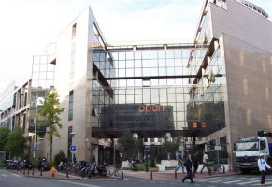

Welcome to the local webpages of the Oliviers site

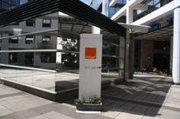
Issy-les-Moulineaux, a French town located in the department of Hauts-de-Seine and the Ile-de-France region, has a population of nearly 65,000 and a density of 15,000 inhabitants/km².

The town of Issy-les-Moulineaux is home to the head offices of numerous telecommunications, IT and information companies. A few streets further on from the Les Oliviers site and Rue Camille Desmoulins,Orange has its Orange Labs laboratory.

Created in 1992, the "Les Oliviers" site is the former head office of the French Directorate General for Civil Aviation, as well as Wanadoo from 2000 to 2004. This site is now home to numerous corporate departments of ORANGE Group.

Enjoy your look around!

Our contacts at the site

Reception
01 57 36 12 00

How to find us

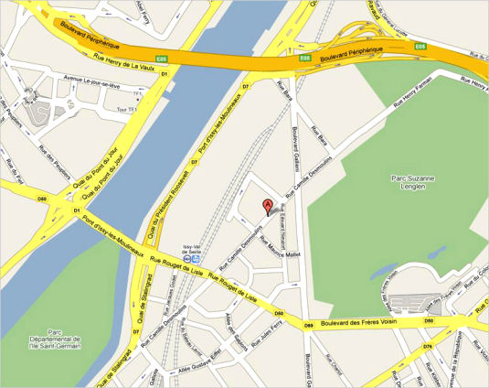

By metro:
Take line 12 and get off at Corentin Celton.
Then take bus number 126 or 189 and get off at the stop "Issy Val de Seine RER".
OR
Take line 12 and get off at Mairie d'Issy. Then take bus number 323 and get off at the stop "Gallieni - Camille Desmoulins".

Alternatively, take number 8 and get off at Balard.

By RER:
Take RER line C and get off at the stop "Issy Val de Seine".
Turn left and go to Rue Camille Desmoulins.

By tram:
Take tram number T2 and get off at the stop "Issy Val de Seine".

By car:
Follow the ring road and come off at Porte de Sèvres.

