

TM Forum Open APIs Conformance Certification

**TM Forum Open APIs**

**Conformance Certification**

*Company Name:* ***Cognizant Technology Solutions***

*Open API Name:* ***TMF620 - Product Catalog Management***

*Open API Version /Swagger File:* ***R17.5 /v2.2***

**Report Date: 04 April 2018**



TM Forum Open APIs Conformance Certification

# What Product or Solution does your API support?

This API implementation will support calls form the order-entry / sales applications of various customers once configured as-a-service for broader usage.

# Overview of Certified API

The product catalog API implementation is used in conjunction with service and resource catalog API Implementations. These three micro services together support the Enterprise Product catalog function.

# Architectural View

The API is implemented as a cloud native solution using open technologies like Java, spring, Docker, MongoDB etc. The service is built as Docker Image and can be deployed in any environment where Docker Engine is available.

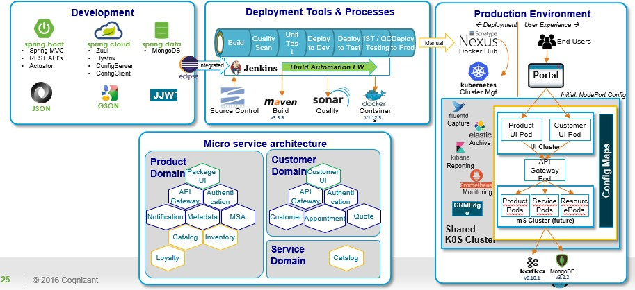

Product Catalog Service

It can be deployed on cloud or on premise as well.

# Test Results (HTML file)

