

TM Forum Open APIs Conformance Certification

**TM Forum Open APIs**

**Conformance Certification**

*Company Name:* ***NTT DATA Corporation***

*Open API Name:* ***TMF670 - Payment Methods***

*Open API Version /Swagger File:* ***R17.5 /v1.0.1***

**Report Date: 03.05.2018**



TM Forum Open APIs Conformance Certification

# What Product or Solution does your API support?

The Digital Telco Lab is NTT DATA environment on which to develop and present the Digital Telco Architecture Vision in a real-world IT-solution built out of the components of the overall NTT Group portfolio to support digital transformation.

It applies the new paradigm for the “Business of IT” to NTT DATA as a Global IT Innovator itself based on “Platform Thinking” in that it provides NTT DATA Know-How and Best Practices “as a Service”, namely on a Cloud-enabled Platform in which this know-how is turned into technology that can be used in sales presentations, solution demos, Proofs of Concept actual project delivery and service and system operations.

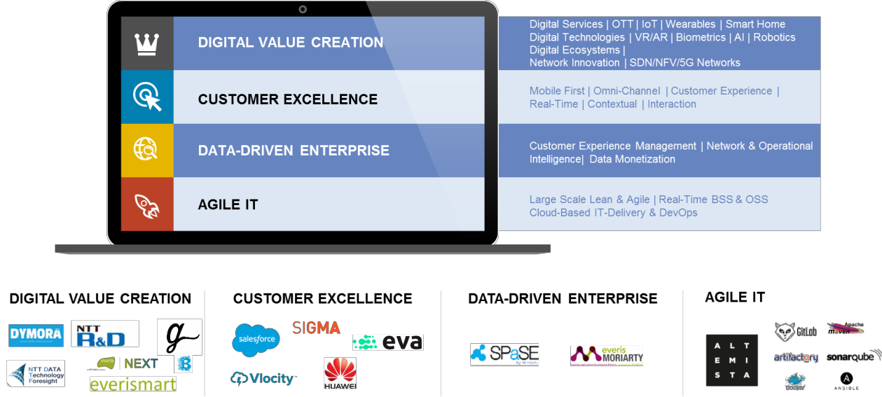

*Figure 1: Capabilities for the Digital Telco*

The Telco Lab combines digital assets from NTT DATA (and Everis) in the areas of cloud, mobile, IoT, etc., and

applications for Digital Customer Engagement. The platform also integrates with NTT DATA’s Analysis and Big Data platform – resting on NTT DATA’s heritage. In addition, it is open for integration of additional NTT DATA R&D partners or start-ups for the creation of references. The Digital Telco Lab is constantly being extended to integrate new solution components and software products.

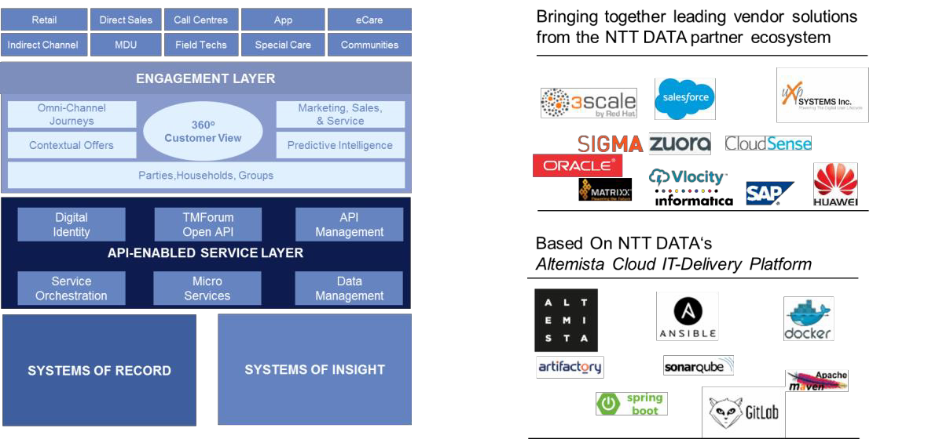

*Figure 2 Digital Telco Architecture and the Digital Telco Lab*



TM Forum Open APIs Conformance Certification

At face value, the Digital Telco Lab is a showcase for the principles of a Digital Telco Architecture. However, it is much more than this:

* It is composed out of cloud-based demo environments for the NTTD portfolio which are provided to the overall platform and consumed as services to create the Digital Telco use case
* It is based on a common platform to share technology know-how across diverse NTT(D) units that are provided on this platform
* In this guise, existing assets at NTTD are reused and put into context and specific partner products can be integrated (e.g. Genesys, Salesforce,…)
* The enablement of the services provided in the Digital Lab is enabled by NTT DATA’s Altemista Cloud, a PaaS-based DevOps infrastructure on top of Kubernetes/Openshift which supports the end-to-end application delivery process which can be re-used for all kinds of projects, whether or not they depend on other lab components.
* Finally, a link to the NTT Communications Enterprise Cloud is created in order to be able to offer a full service portfolio across all layers with internal NTT Services, while at the same time be open to support other cloud environments as well.

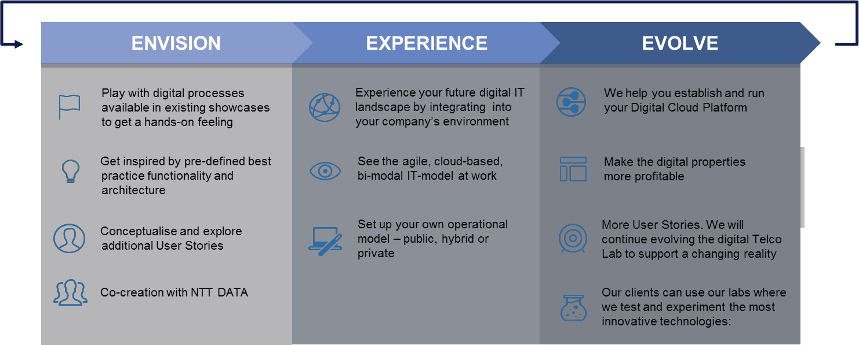

*Figure 3: NTT DATA Digital Telco Lab as a Co-Creation environment*

For that purpose, NTT DATA’s CSP clients and NTT DATA will jointly use the Digital Telco Lab to evaluate technologies and software products, and to co-create new relevant solutions. These may then seamlessly evolve to become Proofs of Concept (PoC) and pilot projects in the concrete context of NTT DATA’s CSP clients, which can be used to transport the future experience to various stakeholders in the enterprise. In addition, there is an option to promote Digital Telco Lab solutions into the regular assembly line for productive systems.

Beyond practically bringing innovation to NTT DATA’s CSP clients in Germany, the Digital Lab allows us to link to innovation initiatives within the overall Telco market. This may especially pertain to NTT DATA’s CSP clients on the global level, and is our central point for innovation initivate, e.g. by launching joint TM Forum Catalyst projects.

TM Forum’s Open APIs are an integral part of NTT DATA’s view on Digital Telco Architecture which we have implemented in our Digital Telco Lab facility in Germany (set-up, live & in-use), within which we have implemented key TM Forum Open APIs.

Through this implementation and integration work, we are actively bringing together leading vendor solutions, partners and clients in a collaborative eco-system of Open API, Open Source and Open Standards development. This has included accelerators and co-creation with clients in the Element & API Enabled Service Layers focused on Chatbots, Voice UI, Natural Language Processing, Predictive Analytics and Intelligent Automation.

A representation of NTT DATA’s Digital Telco Lab, Digital Telco Architecture is shown in the adjacent diagram.



TM Forum Open APIs Conformance Certification

The Digital Telco Lab will provide a foundation and facility provisioned by NTT DATA, through which NTT DATA’s CSP clients can realise and work on their roadmap roadmap to open source Common Service Model APIs, work with other clients across the Telco industry as well as leading solutions vendors to create a focus partner eco-system.

# Overview of Certified API

The Payment Methods API allows the following operations

* Retrieve a list of payment methods stored in a server filtered by a given criteria
* Retrieve a specific payment method
* Delete a specific payment method
* Retrieve a list of payment methods associated to an account filtered by a given criteria

Its main entity is the “PaymentsMethod” Resource which can be used to search and retrieve Payment Methods in

bulk or specifically for a dedicated account.

# Architectural View

The following diagram shows an overall view of components and technologies available in the Digital Telco Lab for use in customer demos, proofs-of-concept and co-creation environments.

Note the central role of the TM Forum Open APIs to enable a mix and match of complementary, overlapping and competitive solutions as a flexible basis for using the Digital Telco Lab: The same use cases can be implemented using different combinations of bespoke and COTS components according to NTT DATA’s CSP clients’ preferences, using the TM Forum Open APIs to provide loose coupling as required for the specific situation.

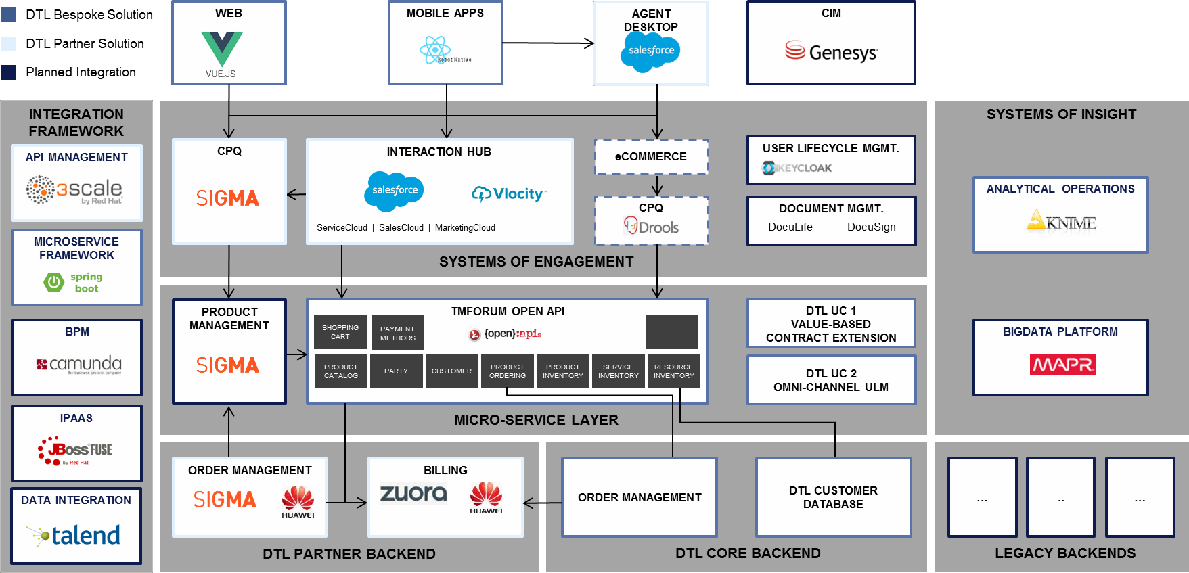

*Figure 4: DTL Architecture Overview*

As an example, for a specific showcase implemented on the Digital Telco Lab, the following diagram shows the architecture of the Omni-Channel User Lifecycle Management Demo in the Digital Telco Lab:



TM Forum Open APIs Conformance Certification

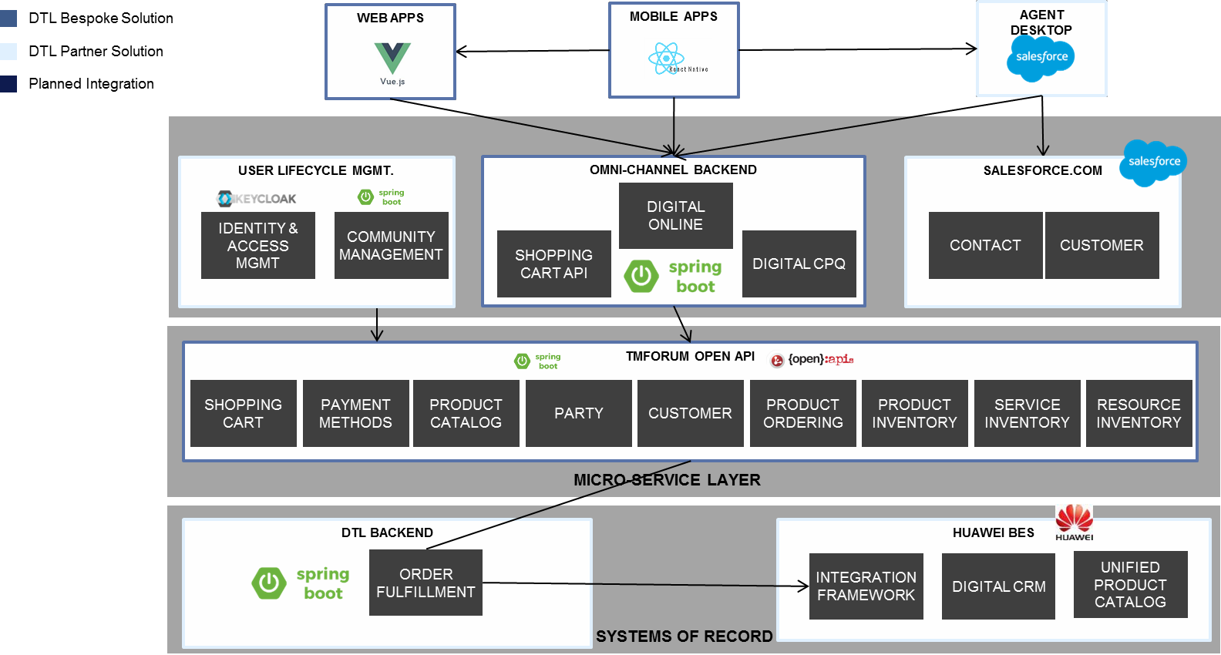

*Figure 5: Architecture Overview for Omni-Channel User Lifecycle Management*

# Test Results (HTML file)

**