**TM Forum Open APIs**

**Conformance Certification**

*Company Name:* ***Netcracker – NEC***

*Open API Name:* ***TMF629 – Customer Management***

*Open API Version /Swagger File:* ***R18.0/v2.0***

**Report Date: 29-Jul-2019**

1. **What Product or Solution does your API support?**

Netcracker’s Industry leading BSS/OSS solutions have globally enabled over 250 customers in their journey towards Business and Digital transformation. Netcracker leverages its comprehensive experience in transformation methodology and technologies in order to provide business value to its customers. With a BSS/OSS suite of products and technologies, that is highly complaint with Industry Standards, Netcracker provides a distinct advantage to its customers in their transformation journey.

Following is Netcracker’s Telecom Operations Management Software Version 12.0 which is a complete BSS/OSS suite with the Product/Components marked to show the relevance of this API being supported:

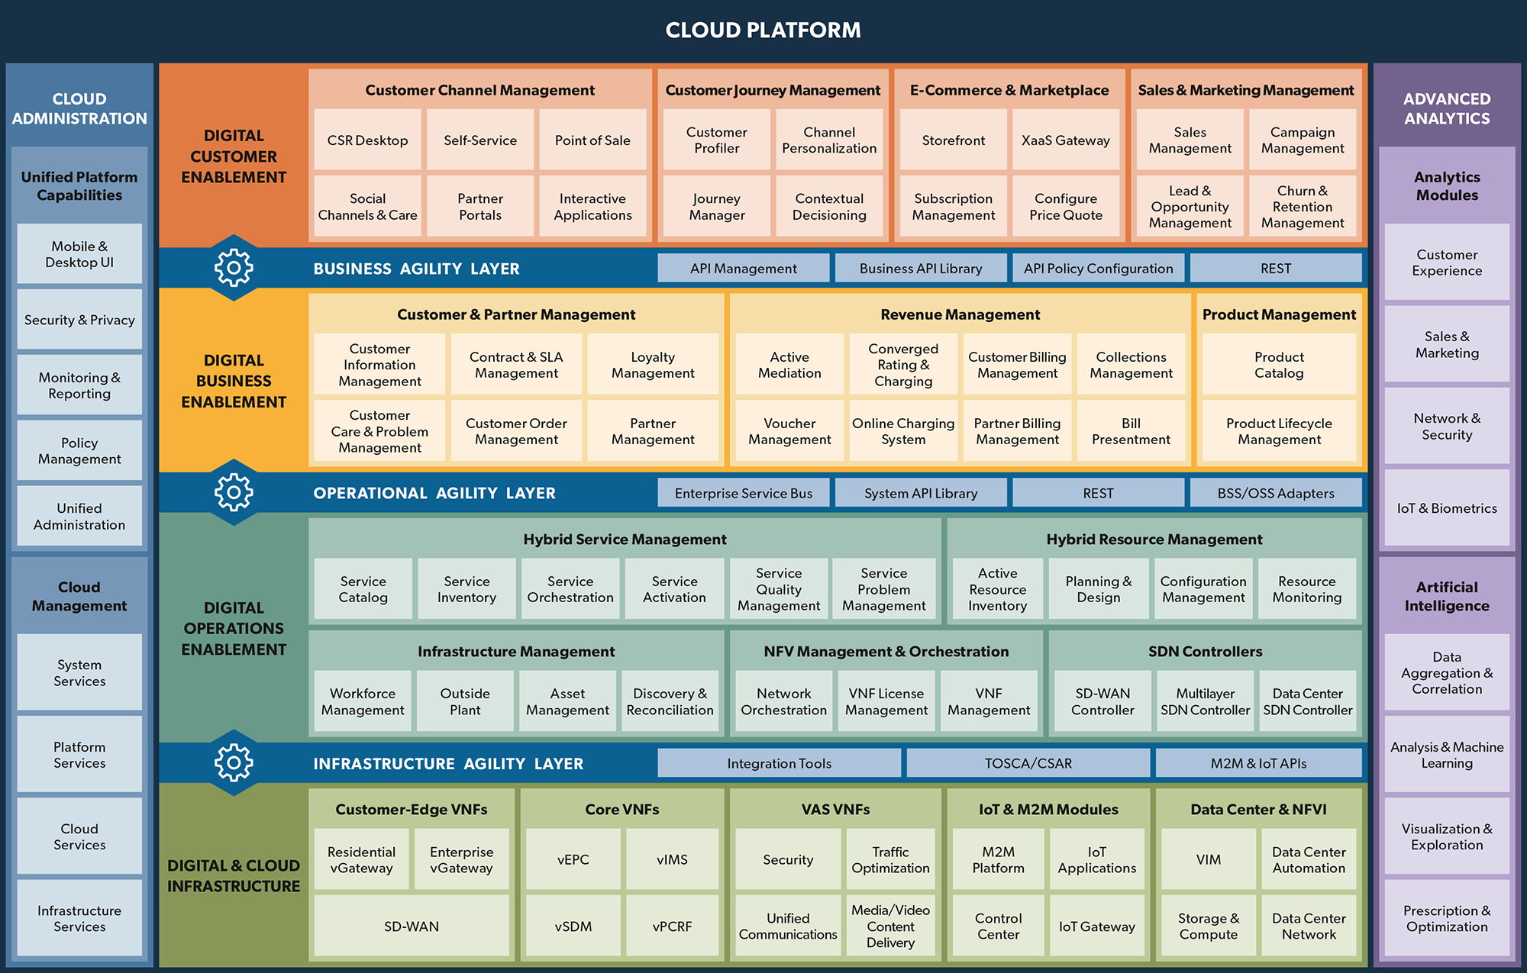

Key Features of Netcracker Customer Information Management:

* Centralized Customer Information
* Contacts
* Billing Accounts
* Payments and Charges
* Sales Orders and Products
* Interaction History
* Customer Relationship Management

Netcracker’s Customer Information Management offering integrates with a wide range of systems, including customer care, billing, service provisioning and CRM platforms, to provide up-to-date contextual customer views. It accumulates multifaceted historical and present-date information about end-user personal, behavioral, buying and spending details. It also provides operators with a better understanding of relationships and policies within customer hierarchies.

Netcracker’s Customer Information Management is used for tracking and monitoring all customer related information and interaction history. Netcracker employs the concept of Customer Accounts to manage information about customers. Products and services purchased by a particular customer are created within and accessed through the corresponding Customer Account.

1. **Overview of Certified API**

TMF629 (Customer Management) API has been implemented as a part of Netcracker’s Telecom Operations Management Suite in a specific component called Telecom Business API (TBAPI) that forms the basis of Business Agility Layer in the product suite.

TBAPI – Customer Management API’s implement TMF629, Release 18.0.

The API’s have been self-certified in a controlled test environment within Netcracker.

1. **Architectural View**

Netcracker's Business, Operations & Infrastructure Agility Layers offer a comprehensive approach to integration and API management. This approach allows us to address integration challenges for business units, IT and partners efficiently without negatively impacting stakeholders.

Following Architecture diagram shows how the TBAPI is integrated with the Netcracker Customer Information Management module

