**TM Forum Open APIs**

**Conformance Certification**

*Company Name:* ***Netcracker – NEC***

*Open API Name:* ***TMF641 – Service Ordering Management***

*Open API Version /Swagger File:****R16.5/v3.0***

**Report Date: 29-Jul-2019**

1. **What Product or Solution does your API support?**

Netcracker’s Industry leading BSS/OSS solutions have globally enabled over 250 customers in their journey towards Business and Digital transformation. Netcracker leverages its comprehensive experience in transformation methodology and technologies in order to provide business value to its customers. With a BSS/OSS suite of products and technologies, that is highly complaint with Industry Standards, Netcracker provides a distinct advantage to its customers in their transformation journey.

Following is Netcracker’s Telecom Operations Management Software Version 12.0 which is a complete BSS/OSS suite with the Product/Components marked to show the relevance of this API being supported:

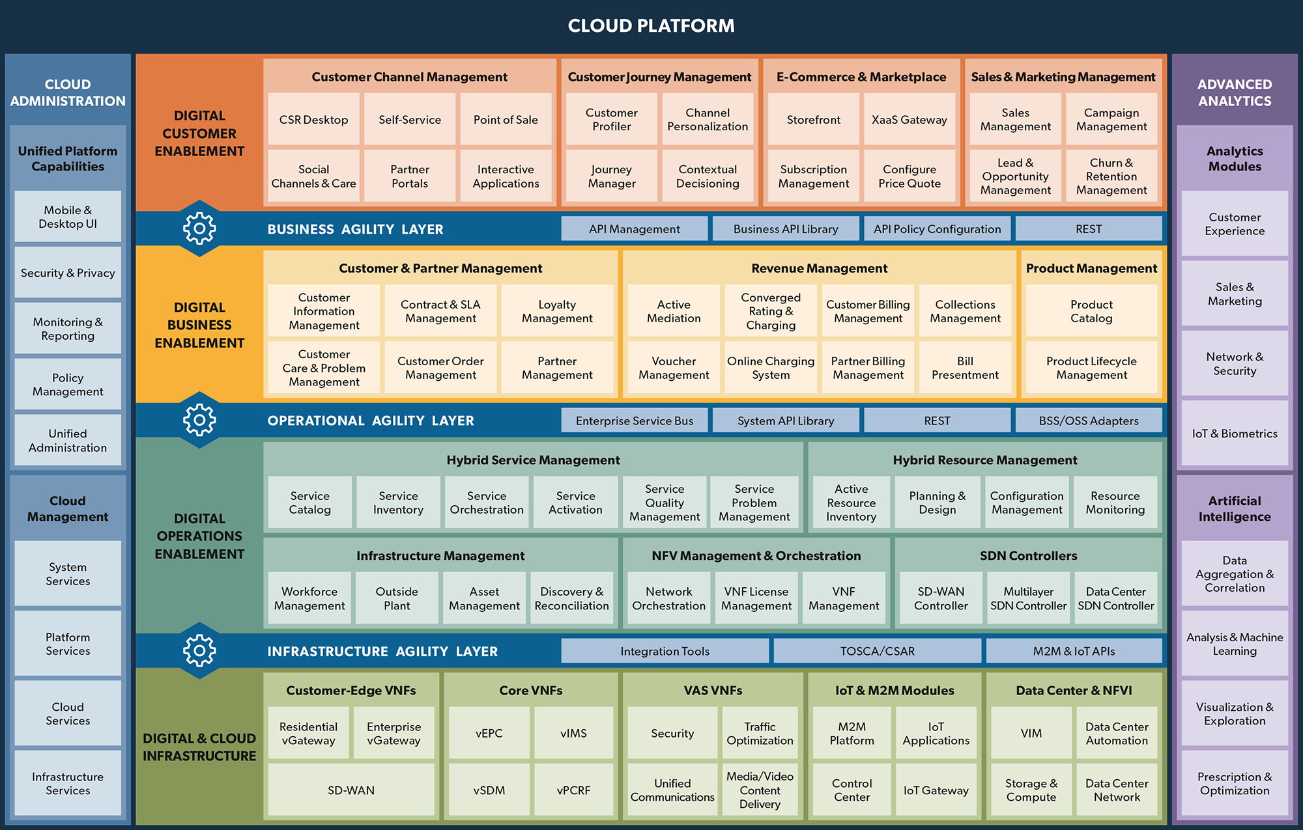

Netcracker Service Orchestration performs end to end service Order Management. The Netcracker’s Service Orchestration system:

* Enables communication providers to automate service provisioning process
* Provides functionality for Service Order decomposition and Order Orchestration
* Streamlines execution of Service provisioning flow
* Facilitates Service Order lifecycle Management
* Provides visibility of End-to-End Service Orders management.

Key Benefits of Netcracker Service Order Management:

* Catalog driven Order decomposition and Order orchestration leading to reduced time to market.
* Streamlined and automated order processing.
* Reduced order fallouts through end to end order lifecycle management transparency.
* Reduced operational cost.

1. **Overview of Certified API**

TMF641 (Service Ordering Management) API has been implemented as a part of Netcracker’s Telecom Operations Management Suite in a specific that forms the basis of Business Agility Layer in the product suite.

Service Order Management API’s implement TMF641, Release 16.5.

The API’s have been self-certified in a controlled test environment within Netcracker.

1. **Architectural View**

Netcracker's Business, Operations & Infrastructure Agility Layers offer a comprehensive approach to integration and API management. This approach allows us to address integration challenges for business units, IT and partners efficiently without negatively impacting stakeholders.

Following Architecture diagram shows how the TBAPI is integrated with the Netcracker Customer Information Management module

