

TM Forum Open APIs Conformance Certification

**TM Forum Open APIs**

**Conformance Certification**

*Company Name:* ***Vlocity Inc.***

*Open API Name:* ***TMF629 - Customer Management***

*Open API Version /Swagger File:* ***R16.5 /v2.0***

**Report Date: April 2018**



TM Forum Open APIs Conformance Certification

# What Product or Solution does your API support?

This API supports customer management within Vlocity’s core CRM and CPQ suite of applications and is available to any Vlocity application that requires customer/account management capabilities.

# Overview of Certified API

A customer entity is at the core of any CRM in general and naturally in Vlocity Industry Cloud CRM as well. The API allows for several customer management related operations as per the API specification and is specifically useful when retrieving customer data, creating or updating an account, as well as many other customer/account related business scenarios.

# Architectural View

The following diagram provides a high-level view of Vlocity’s architecture. Vlocity is built on the Salesforce.com

cloud platform and is 100% native and 100% additive to Salesforce.com. Vlocity’s unique integration layer and APIs

provide omnichannel support out of the box.

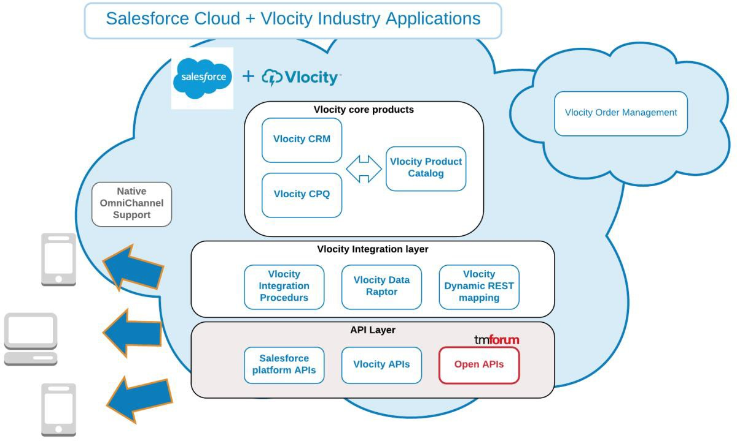

# Test Results (HTML file)

