**TM Forum Open APIs**

**Conformance Certification**

*Company Name:* ***Whale Cloud Technology Co., Ltd.***

*Open API Name:* ***TMF621 - Trouble Ticket API***

*Open API Version /Swagger File:* ***R16.5 /v2.0***

# Report Date: Sep 2018

# What Product or Solution does your API support?

This API supports Trouble Ticket functionality within ZSmart V9 CRM and Network Operation applications, e.g. Network Management, Fault Management, etc. ZSmart V9 is aiming to help Telco transform into Native Digital Player with ecosystem-centric business model, innovative-driven digital platform, loosely-coupled capability centers and off-loaded cloud infrastructure.

# Overview of Certified API

This API supports functionality related to Trouble Ticket Center which is one of the core key capability centers of ZSmart V9.

The Trouble ticketing API provides a standardized client interface to Trouble Ticket Center for creating, tracking and managing trouble tickets among partners as a result of an issue or problem identified by a customer or another system. Examples of Trouble Ticket API clients include CRM applications, network management or fault management systems, or other trouble ticket management systems (e.g. B2B).

The API supports the ability to send requests to create a new trouble ticket specifying the nature and severity of the trouble as well as all necessary related information. The API also includes mechanisms to search for and update existing trouble tickets. Notifications are defined to provide information when a ticket has been updated, including status changes. A basic set of states of a trouble ticket has been specified to handle ticket lifecycle management. The API provides capabilities to create trouble ticket, inquiry trouble ticket by ID, category and urgency, among other capabilities.

# Architectural View

The following diagram shows an overall view of ZSmart V9 cloud native architectural. ZSmart 9 provides full-range APIs to realize unified service registration, flexible API orchestration, and multiple protocols conversion. It brings CSPs with unified multi-channel service access, minimizes customization applications, and shortens the Time-To-Market for new business rollout. In addition, ZSmart V9 provides consolidated product catalog which supports both telecom products and vertical industry products. Architectural diagram on next page:

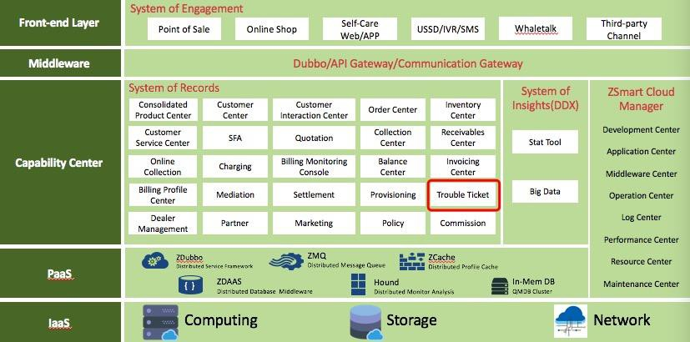

# Test Results (HTML file)

