**TM Forum Open APIs**

**Conformance Certification**

*Company Name:* ***Comviva Technologies Limited***

*TM Forum Open API Name:* ***TMF666– Account Management***

*TM Forum Open API Release Version:* ***R19.0/v4.0***

**Report Date: 16-06-2020**

1. **What Product or Solution does your API support?**

Comviva’s BSS suite is a comprehensive and focused business support system that handles an operator's entire set-up, allowing more efficient management of the operator resources, streamlining operational activities and delivering lifetime support to the operator’s network and subscriber base. Utilizing common unified interface across multiple operational activities, the service provider is able to manage the complete mobile subscriber lifecycle. The single, consolidated view of operations provided by Comviva’s BSS suite enables operators to appropriately prioritize subscriber demands and meet subscriber expectations. Via its centralized repository and flexible workflows, Comviva’s BSS suite effectively handles all manner of queries, enhancing customer services, improving customer satisfaction and ultimately enabling a more focused marketing strategy.

Comviva’s BSS suite is an end-to-end Business Support solution, with ability to integrate with the rating and credit management platform including Intelligent Networks, Service Nodes and Hot Billing solutions. It is designed to provide the capability to leverage creative marketing programs to the full, while maximizing the effectiveness of Customer Care. It is designed as a modular system so it will grow alongside each operators expanding service portfolio and support an increasing subscriber base.

Comviva’s BSS suite can be rapidly deployed at and offers an excellent range of features. Some of the basic dimensions that have been taken into account while designing Comviva’s BSS suite include:

* Scalability of software to support the growth plan of service providers
* Ability to interface seamlessly with existing and new applications, protecting investment
* Minimization of revenue loss
* Rapid deployment
* Ability to cater to a wide spectrum of communication
* Easy to learn and faster to use to cut training costs.

Comviva’s BSS suite solution is a leading edge, Provisioning & Customer Care solution that integrates critical business processes and workflows of prepaid operations. Comviva’s BSS suite empowers the Customer Care personnel with the ability to address customer problems, queries and requests effectively and efficiently

1. **Overview of Certified API**

Account Management is one of key feature of Comviva CRM Product. The Account API provides standardized mechanism for the management of billing and settlement accounts, as well as for financial accounting (account receivable) either in B2B or B2B2C contexts.

It allows creation, update and retrieval of account information. It also allows creation and query of bill items allowing partners or B2B customer to check their invoice.

Through interface following operation can be done for all accounts as well as bill items.

* Operations on API
* List Accounts/Bill items
* This operation list accounts/bill items entities
* Retrieve Accounts/Bill items
* This operation retrieves accounts/bill items entity
* Create Accounts/Bill items
* This operation creates accounts/bill items entity
* Patch Accounts/Bill items
* This operation allows partial updates of accounts/bill items entity
* Delete Accounts/Bill items
* This operation deletes accounts/bill items entity.
* Types of Account
* **Party Account:** This account has monetary balances and can deal with payments.
* **Billing Account:** This account specialization of Party Account that is intended for accounts-receivable, i.e. manages the balances for customers (or other party types) that generally.
* **Settlement Account:** specialization of Party Account that is intended (I believe) for accounts-payable, i.e. manages the balances for suppliers (or other party types) that generally give service to the service provider and expect to be paid in respect of these
* **Financial Account:** This account has monetary balances, but does not deal with payments. Typical usage might be aggregation of other accounts for reporting or other purposes.
* Types of Bill Format
* **Billing Cycle Specification:** This is detailed description of when to initiate a billing cycle and the various sub steps of a billing cycle.
* **Bill Format:** A detailed description of the way in which a bill is presented.
* **Bill Presentation Media:** A mean of communicating a bill, supported by the associated bill format. For example, post mail, email,web page.

1. **Architectural View**

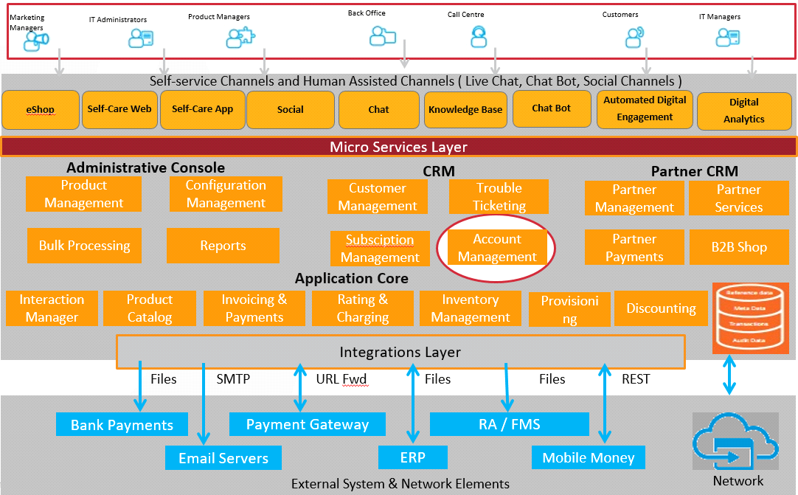

1. **Test Results**

