**TM Forum Open APIs**

**Conformance Certification**

*Company Name:* ***Oracle Corporation***

*TM Forum Open API Name:* ***TMF620 – Product Catalog Management API***

*TM Forum Open API Release Version:* ***R19.0/v4***

**Report Date: 8th of September 2020**

1. **What Product or Solution does your API support?**

Oracle’s data-driven digital experience, called Digital Experience for Communications (DX4C) provides industry specific, complete, omni-channel, contextualized, smart, and connected business and user experiences for Communications and Media service providers.

DX4C enables capabilities such as centralized design time product catalogue, single persistent multi-channel product configuration/shopping cart and centralized order orchestration. Together these provide the speed, agility and insights necessary to deliver contemporary digital experiences all built on a robust, scalable, complete and communications specific platform.

A key component of DX4C is the ***Launch Experience*** SAAS solution – a centralized solution for managing and using catalog entities across BSS/OSS applications, furthering DX4C’s goal of a **connected experience** across all touch points.

DX4C’s Launch Experience Offering is targeted to cater to both the Business and IT persona to deliver a true Faster Time to Market at a reduced Cost to Market. In addition, it aims to provide a platform for Innovation and improved quality across Product Lifecycle Management.

The solution delivers an exceptional business agility, unprecedented automation and orchestration in creation and launch of offers, real-time visibility into the Portfolio performance linked to offer uptake, thereby enabling the Service Providers to deliver the much sought after differentiated and superior Customer Experience.

The *Launch Experience* solution encapsulates Offer *Ideation to Conceptualization to Launch to Retire* life cycle management conformant to TM Forum SID standards that provides component reusability and simplifies Offer creation and launch across a wide range of both traditional and digital offerings for B2C, B2B and B2B2X line of business.

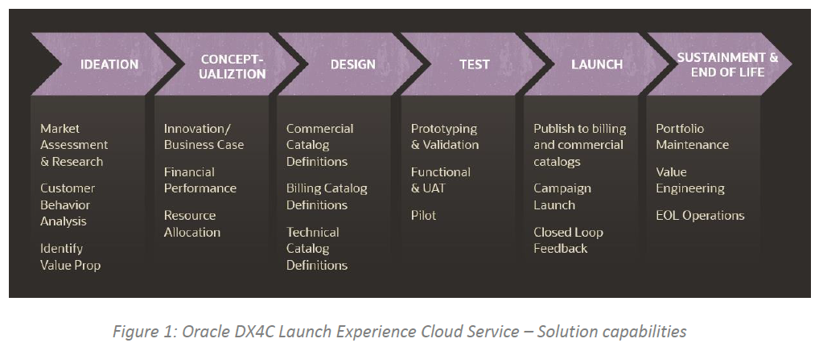

The bedrock Design Principles of the solution include:

* Single solution for Ideation, Conceptualization, Design, Test, Launch, Sustainment and End-of-Life of Products and Services with embedded AI recommendations
* Centralized Design Time Experience for Sales, Billing and Provisioning Catalogs supporting both traditional and digital offerings. Same-day introduction of new offers.
* Business Persona-grade UX to design new offers in a few clicks based on existing configuration. Simplified bundling Experience to assemble and launch Offers rapidly thereby limiting Product Proliferation
* First Class Publishing capability to Oracle’s Sales, Billing and Provisioning Catalogs and Open API based accelerators for publishing to non-Oracle catalogs - both leveraging DX4C Fabric capabilities
* Process Automation and Orchestration for publishing to various catalogs and campaign execution that delivers streamlines processes to provide a consistent and reliable outcome
* TM Forum Standards based unified language thanks to SID-based models and Open API.

Key Solution capabilities include:

* Business Persona first approach empowering business users to release offerings to market in minute
  + No more multiple bespoke applications and excel spreadsheets to work with
  + Controlled by Role Based access control
* Single source for Definition of Products and Services
  + One place of truth when it comes to the Products and Services definitions, its pricing variants, terms & conditions, business rules, marketability
  + Commercial, Billing and Technical view of the definitions
  + Quickly assemble new offers by cloning and modifying existing ones using drag and drop User Interface
* Reduce the age-old issue of Product Proliferation
  + Inculcates high reusability of offers across multiple markets and geographies
  + AI powered recommendations for reusability
* Provides an E2E Product life cycle management process
  + Comes with PLM process automation aligned to TMF product life cycle management
  + Highly configurable and extensible by every customer
* Improve Offer Uptake
  + Enables data driven real time insight at the time of offer ideation, creation and launch with Product simulation and price optimization factoring in Product profitability, addressable market and penetration analysis

1. **Overview of Certified API**

The **TMF620 catalog management API** provides a consistent and standardized mechanism to achieve a faster time to market in a heterogeneous CSP eco system as is an integral part of DX4C’s Launch Experience Cloud Service. It is fully compliant with Release 19.0.0 of the API specification. The API has been self-certified using the both the CTK payload and on implemented solution of the Launch Experience service offering.

1. **Architectural View**

The following diagram provides an architectural overview of DX4C service offering:



1. **Test Results**

 