TM Forum Open APIs

Conformance Certification

Company Name: Incognito Software Systems
TM Forum Open API Name: Service Order Management API - TMF641
TM Forum Open API Release Version: R20.5.0 / v4.0.0

Report Date: 16th October 2020

- What Product or Solution does your API support?

The Service Ordering Management API is used as the entry point for Incognitos Service Activation Center.

Service Activation Center is a modular, productized software platform that automates service activation and streamlines back-end processes to reduce OPEX. By increasing activation speeds, service providers can accelerate customer On-boarding and monetize services faster. It can be deployed and operational in weeks—delivering proven value to global providers.

Key Capabilities include:

- Support for the management, configuration and activation of PNF/VNF services over fixed (fiber, cable, metro ethernet) and wireless (mobile, fixed wireless access), IOT services and more
- Service and device diagnostics
- Support for B2x (B2C and B2B), B2B2x and wholesale customers
- Fully configurable business processes

- Overview of Certified API

The TM Forum Service Order Management API, TMF641 REST API for Service Order Management, provides a standardized mechanism for placing a service order with all of the necessary order parameters. It allows users to create, update & retrieve service orders and manage related notifications.

In Service Activation Center, the implementation of the TMF641 Service Ordering Management API is used to:

    - Create new service orders
    - Retrieve existing orders
    - Update existing orders
    - Delete service orders

Each service order can contain multiple order items. Each order item consists of a service and one of the following actions:

- Add
- Modify
- Delete

This allows services to be created, modified and deleted. These services are associated with accounts (using ‘relatedParty’) and Customer Premise Equipment (using ‘serviceCharacteristic’).

- Architectural View

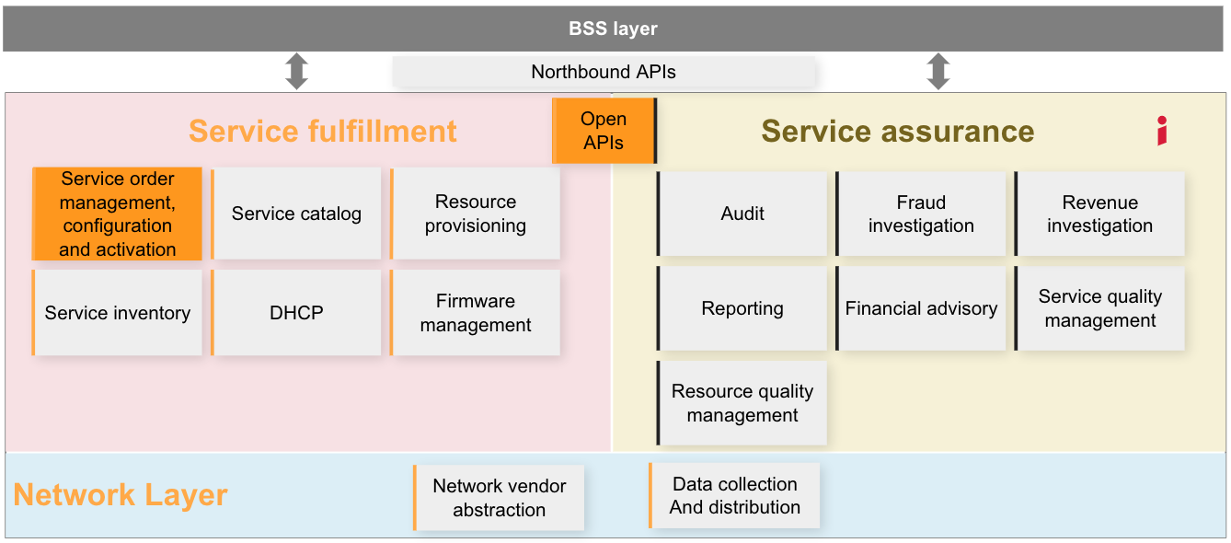

- Test Results

