TM Forum Open APIs
Conformance Certification

Company Name: Comviva Technologies Limited

TM Forum Open API Name: TMF639- Resource Inventory Management API

TM Forum Open API Release Version: R20.5.0 /v4.0.0

Report Date: 19/02/21

- What Product or Solution does your API support?

Comviva’s BSS suite is a comprehensive and focused business support system that handles an operator's entire set-up, allowing more efficient management of the operator resources, streamlining operational activities and delivering lifetime support to the operator’s network and subscriber base. Utilizing common unified interface across multiple operational activities, the service provider is able to manage the complete mobile subscriber lifecycle. The single, consolidated view of operations provided by Comviva’s BSS suite enables operators to appropriately prioritize subscriber demands and meet subscriber expectations. Via its centralized repository and flexible workflows, Comviva’s BSS suite effectively handles all manner of queries, enhancing customer services, improving customer satisfaction and ultimately enabling a more focused marketing strategy.

Comviva’s BSS suite is an end-to-end Business Support solution, with ability to integrate with the rating and credit management platform including Intelligent Networks, Service Nodes and Hot Billing solutions. It is designed to provide the capability to leverage creative marketing programs to the full, while maximizing the effectiveness of Customer Care. It is designed as a modular system so it will grow alongside each operators expanding service portfolio and support an increasing subscriber base.
Comviva’s BSS suite can be rapidly deployed at and offers an excellent range of features. Some of the basic dimensions that have been taken into account while designing Comviva’s BSS suite include:

- Scalability of software to support the growth plan of service providers
- Ability to interface seamlessly with existing and new applications, protecting investment
- Minimization of revenue loss
- Rapid deployment
- Ability to cater to a wide spectrum of communication
- Easy to learn and faster to use to cut training costs.

Comviva’s BSS suite solution is a leading edge, Provisioning & Customer Care solution that integrates critical business processes and workflows of prepaid operations. Comviva’s BSS suite empowers the Customer Care personnel with the ability to address customer problems, queries and requests effectively and efficiently

- Overview of Certified API

Inventory Management is one of key feature of Comviva CRM Product. It is used to maintain the inventory of resources by creating a new resource instance/ updating an existing resource instance in the Resource Inventory.

Comviva CRM supports SIM as a resource which creates the new SIM in iPACS and also update the existing SIM as FREE so that it can be used for another activation.

    - Resource Operations
- List resources
  - This operation list resource entities
- Retrieve resource
  - This operation retrieves a resource entity
- Create resource
  - This operation creates a resource entity
- Patch resource
  - This operation allows partial updates of a resource entity
- Delete resource
  - This operation deletes a resource entity

- Architectural View

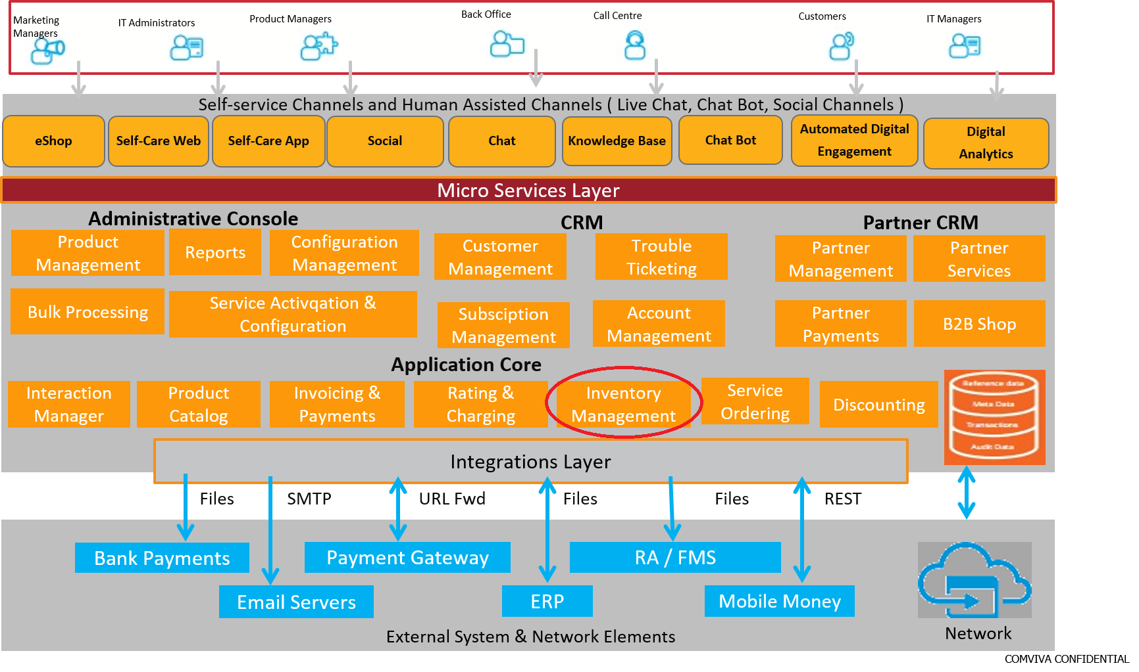

- Test Results

