TM Forum Open APIs
Conformance Certification

Company Name: Comviva Technologies Limited

TM Forum Open API Name: TMF678 – Customer Bill Management API

TM Forum Open API Release Version: R20.5.0 /v4.0.0

Report Date: 19/02/21

- What Product or Solution does your API support?

Comviva’s BSS suite is a comprehensive and focused business support system that handles an operator's entire set-up, allowing more efficient management of the operator resources, streamlining operational activities and delivering lifetime support to the operator’s network and subscriber base. Utilizing common unified interface across multiple operational activities, the service provider is able to manage the complete mobile subscriber lifecycle. The single, consolidated view of operations provided by Comviva’s BSS suite enables operators to appropriately prioritize subscriber demands and meet subscriber expectations. Via its centralized repository and flexible workflows, Comviva’s BSS suite effectively handles all manner of queries, enhancing customer services, improving customer satisfaction and ultimately enabling a more focused marketing strategy.

Comviva’s BSS suite is an end-to-end Business Support solution, with ability to integrate with the rating and credit management platform including Intelligent Networks, Service Nodes and Hot Billing solutions. It is designed to provide the capability to leverage creative marketing programs to the full, while maximizing the effectiveness of Customer Care. It is designed as a modular system so it will grow alongside each operators expanding service portfolio and support an increasing subscriber base.
Comviva’s BSS suite can be rapidly deployed at and offers an excellent range of features. Some of the basic dimensions that have been taken into account while designing Comviva’s BSS suite include:

- Scalability of software to support the growth plan of service providers
- Ability to interface seamlessly with existing and new applications, protecting investment
- Minimization of revenue loss
- Rapid deployment
- Ability to cater to a wide spectrum of communication
- Easy to learn and faster to use to cut training costs.

Comviva’s BSS suite solution is a leading edge, Provisioning & Customer Care solution that integrates critical business processes and workflows of prepaid operations. Comviva’s BSS suite empowers the Customer Care personnel with the ability to address customer problems, queries and requests effectively and efficiently

- Overview of Certified API

This API allows to find and retrieve one or several customer bills (also called invoices) produced for a customer. A customer bill is an electronic document produced at the end of the billing process. The customer bill gathers and displays different items (applied customer billing rates generated during the rating and billing processes) to be charged to a customer. It represents a total amount due for all the products during the billing period and all significant information like dates, bill reference.

The API model support the needs for the two basic billing types:
- Postpaid periodical bill
- Postpaid real-time bill

Comviva CRM generates bill on customer’s demand.

The billing process applies additional charges (recurring charges, one time charges), discounts and taxes to products then aggregate applied rates into bills sent to customers.

This API provides also operations to find and retrieve the details of applied customer billing rates presented on a customer bill. Finally, this API allows to request in real-time a customer bill creation and to manage this request.

    - Customer Bill On Demand Operations
- List Customer Bill On Demand
  - This operation list customer bill on demand entities
- Retrieve Customer Bill On Demand
  - This operation retrieves a customer bill on demand entity
- Create Customer Bill On Demand
  - This operation creates a customer bill on demand entity

    - Customer Bill Operations
- List Customer Bill
  - This operation list customer bill entities
- Retrieve Customer Bill
  - This operation retrieves a customer bill entity
- Patch Customer Bill
  - This operation update a customer bill entity

    - Customer Applied Customer Billing Rate Operations
- List Applied Customer Billing Rate
  - This operation list applied customer billing rate entities
- Retrieve Applied Customer Billing Rate
  - This operation retrieves a applied customer billing rate entity

    - Bill Cycle Operations
- List Bill Cycle
  - This operation list bill cycle entities
- Retrieve Bill Cycle Specification
  - This operation retrieves a bill cycle entity

    - Bill Cycle Specification Operations
- List Bill Cycle Specification
  - This operation list bill cycle specification entities
- Retrieve Bill Cycle Specification
  - This operation retrieves a bill cycle specification entity

- Architectural View

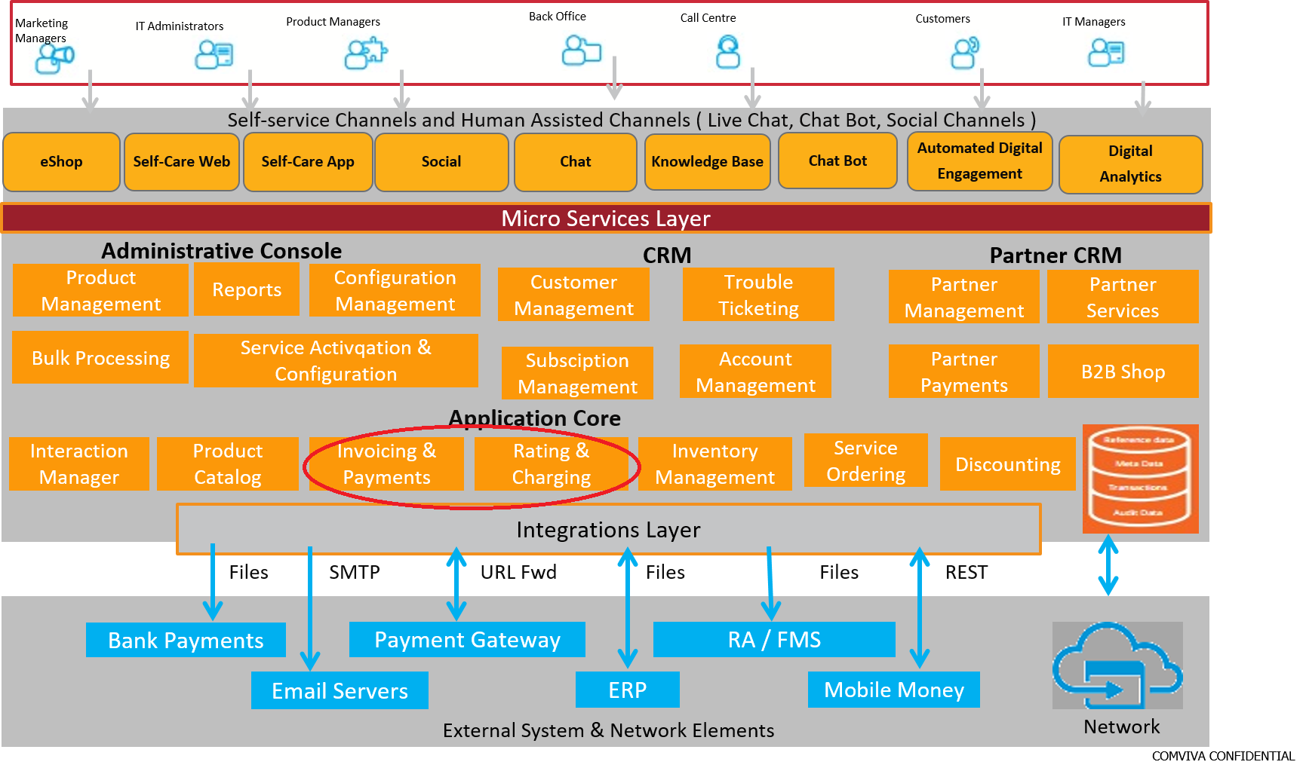

- Test Results

