TM Forum Open APIs
Conformance Certification

Company Name: Comviva Technologies Limited

TM Forum Open API Name: TMF681- Communication Management API

TM Forum Open API Release Version: R20.5.0 /v4.0.0

Report Date: 19/02/21

- What Product or Solution does your API support?

Comviva’s BSS suite is a comprehensive and focused business support system that handles an operator's entire set-up, allowing more efficient management of the operator resources, streamlining operational activities and delivering lifetime support to the operator’s network and subscriber base. Utilizing common unified interface across multiple operational activities, the service provider is able to manage the complete mobile subscriber lifecycle. The single, consolidated view of operations provided by Comviva’s BSS suite enables operators to appropriately prioritize subscriber demands and meet subscriber expectations. Via its centralized repository and flexible workflows, Comviva’s BSS suite effectively handles all manner of queries, enhancing customer services, improving customer satisfaction and ultimately enabling a more focused marketing strategy.

Comviva’s BSS suite is an end-to-end Business Support solution, with ability to integrate with the rating and credit management platform including Intelligent Networks, Service Nodes and Hot Billing solutions. It is designed to provide the capability to leverage creative marketing programs to the full, while maximizing the effectiveness of Customer Care. It is designed as a modular system so it will grow alongside each operators expanding service portfolio and support an increasing subscriber base.
Comviva’s BSS suite can be rapidly deployed at and offers an excellent range of features. Some of the basic dimensions that have been taken into account while designing Comviva’s BSS suite include:

- Scalability of software to support the growth plan of service providers
- Ability to interface seamlessly with existing and new applications, protecting investment
- Minimization of revenue loss
- Rapid deployment
- Ability to cater to a wide spectrum of communication
- Easy to learn and faster to use to cut training costs.

Comviva’s BSS suite solution is a leading edge, Provisioning & Customer Care solution that integrates critical business processes and workflows of prepaid operations. Comviva’s BSS suite empowers the Customer Care personnel with the ability to address customer problems, queries and requests effectively and efficiently

- Overview of Certified API

Communication message means a notification approach in the format of a message which can be dispatched to the certain user by the system with the content which can be felt and understood by the recipient. The user can be either a final customer or a customer service agent. The message can reach the customer in different interaction channels, including: email, short message, mobile app notification.

This API provides a standardized mechanism for Communication management such as creation, update, retrieval, deletion and notification of the system communication events.
This API is used to interact between customer and operator by sending communication message.

Comviva CRM supports following types of interaction level:
- SMS
- EMAIL

    - Communication Messages Operations
- List Communication messages
  - This operation list communication message entities
- Retrieve Communication message
  - This operation retrieves a communication message entity
- Create Communication message
  - This operation creates a communication message entity
- Patch Communication message
  - This operation allows partial updates of a communication message entity
- Delete Communication messages
  - This operation deletes a communication message entity

- Architectural View

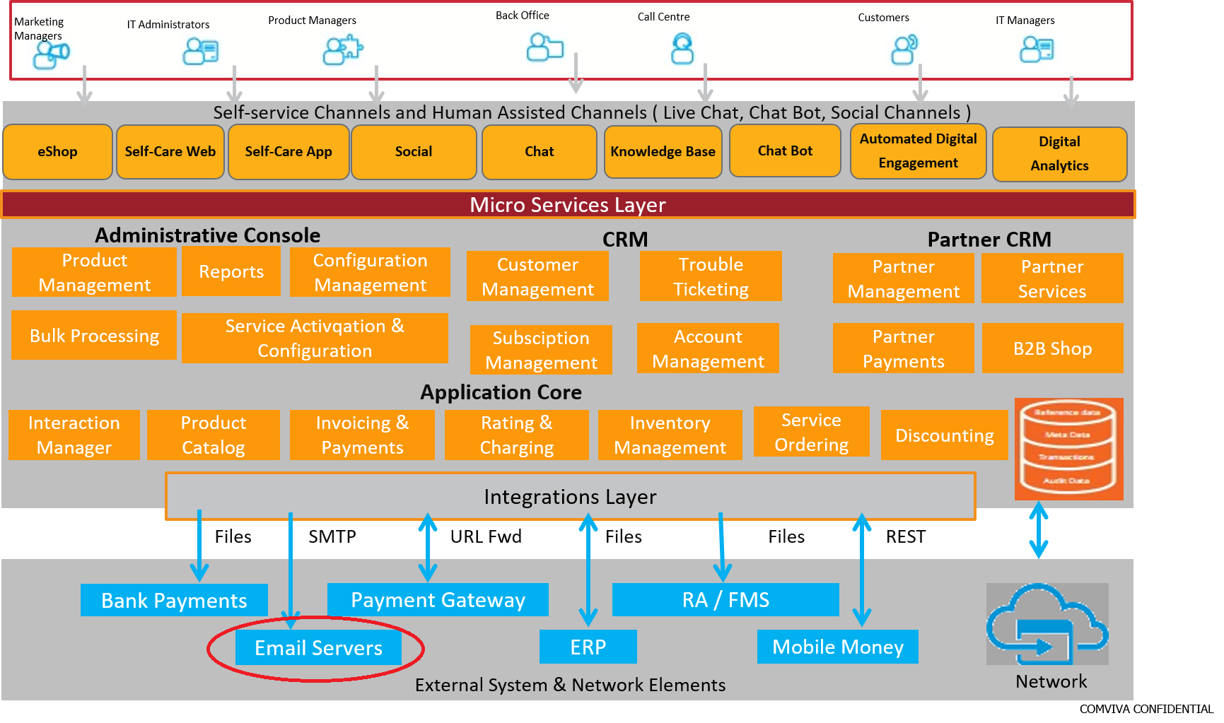

- Test Results

