TM Forum Open APIs
Conformance Certification

Company Name: Inspur Technologies Co. Ltd

TM Forum Open API Name: TMF629 Customer Management API
TM Forum Open API Release Version: R19.0 /v4.0.1

Report Date: 15-03-2021

- What Product or Solution does your API support?

Inspur CRM (Customer Relation Management) support customer-related business process for Telco, accelerate the business innovation. The integrated solution complying TMF standards and applying to various industrial business scenarios. It help operators to improve business management efficiency via qualified and proven technical capabilities of platform, big data, AI and applications.
The core module provides 360-degree customer view and comprehensive customer, subscriber and account management which enabling precise customer analysis and customer services.
CRM detail architecture function are shown as follow:

- Customer Management
- Product Management
- 360-degree customer view
- Account Management
- Order Management
- Campaign

The Customer Management API provides an interaction interface which the external systems and the third-parties can access such capabilities via this exposed API.

- Overview of Certified API

Inspur CRM provides Open APIs in line with TM Forum defined specification, provides customer management such as creation, update, retrieval, deletion and notification of events.

- Customer can be a person, an organization or another service provider who buys products from an DSP/enterprise.
- Customer resource contains information about the customer. Main attributes are customer id, name, status and level, subscriber, description, location, contact info, related customer account, customer credit profile information.
The customer management API performs the following operations:
- List Customers, Retrieve Customer, Create Customer, Patch Customer and Delete Customer

- Architectural View

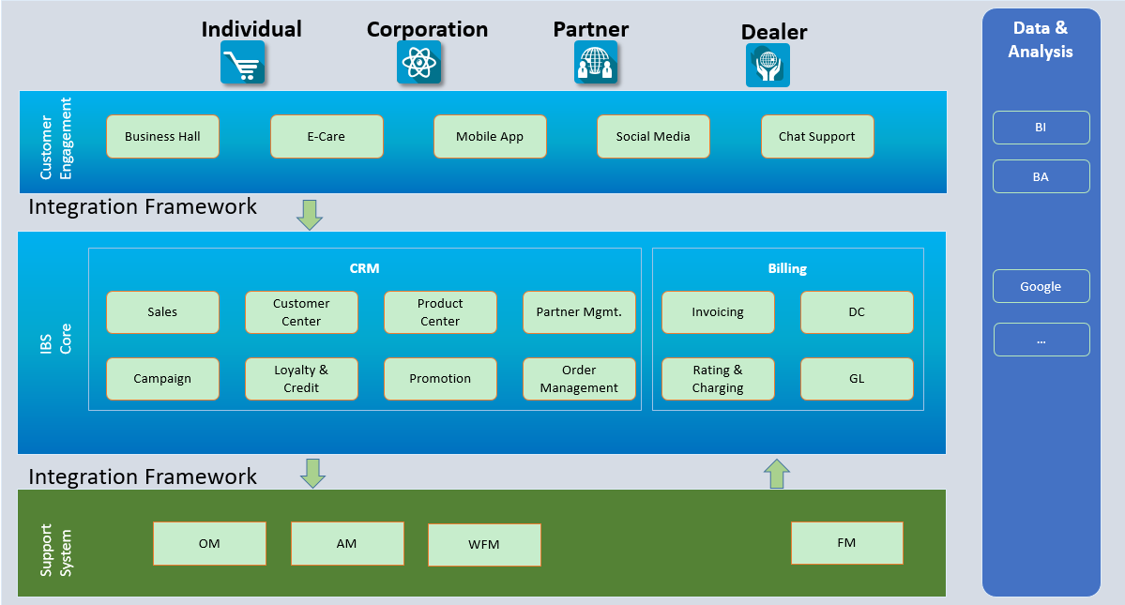

- Test Results

