**TM Forum Open APIs**

**Conformance Certification**

*Company Name:* ***Whale Cloud Technology Co., Ltd.***

*TM Forum Open API Name:*

***TMF622 Product Ordering API***

***TM Forum Open API Release Version:***

***R19.0.1 (v4.0.0)***

**Report Date: 17 December, 2020**

1. **What Product or Solution does your API support?**

ZSmart BSS/OSS Suite, re-organizes the whole system in unified cloud-native architecture, providing fully decoupled capability centers (SaaS), IaaS and PaaS; TMF Open APIs for front end channels, partner and verticals; E2E DevOps pipeline and management tool; and also supporting SaaS commercial model and Greenfield delivery way.

Empowered by Alibaba big data technology, ZSmart BSS/OSS Suite also brings data intelligence into BSS&OSS, to help CSPs to cut cost and to extend revenue, as well as to enhance customer engagement.

As the most expected technology 5G, ZSmart BSS/OSS Suite provides excellent 5G OOTB capabilities, such as multi-dimension charging, SBI interface adaptor, business flow for both SA and NSA mode, as well as the partner onboarding, charging, slicing management, hybrid provisioning, for verticals such as automotive, healthcare, and public transportation.

ZSmart BSS/OSS Suite provides lots of Open APIs, including:

• TMF622 Product Ordering API

1. **Overview of Certified API**

TMF622 Product Ordering API

Provides a standardized mechanism for placing a product order with all of the necessary order parameters. The API consists of a simple set of operations that interact with order management in a consistent manner. A product order is created based on a product offering that is defined in a catalog. The product offering identifies the product or set of products that are available to a customer and includes characteristics such as pricing, product options and market.

1. **Architectural View**

The following Diagram shows the technical architecture of ZSmart BSS/OSS Suite:

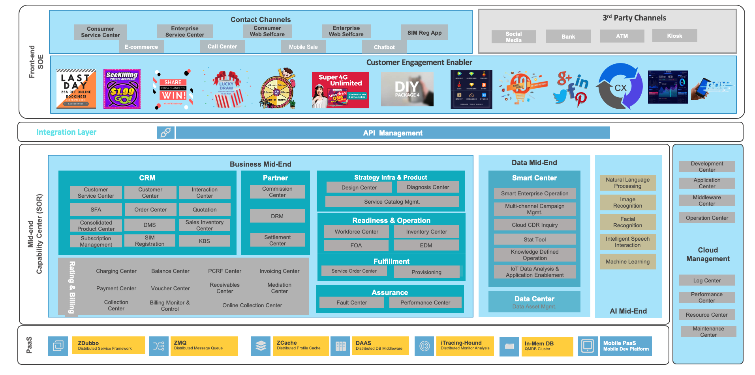

1. **Test Results**

