**TM Forum Open APIs**

**Conformance Certification**

*Company Name:* ***Whale Cloud Technology Co., Ltd.***

*TM Forum Open API Name:*

***TMF666 Account Management API***

*TM Forum Open API Release Version:*

***R19.0.1 (v4.0.0)***

**Report Date: 17 December, 2020**

1. **What Product or Solution does your API support?**

ZSmart BSS/OSS Suite, re-organizes the whole system in unified cloud-native architecture, providing fully decoupled capability centers (SaaS, IaaS and PaaS); TMF Open APIs for front end channels, partner and verticals; E2E DevOps pipeline and management tool; and also supporting SaaS commercial model and Greenfield delivery way.

Empowered by Alibaba big data technology, ZSmart BSS/OSS Suite also brings data intelligence into BSS&OSS, to help CSPs to cut cost and to extend revenue, as well as to enhance customer engagement.

As the most expected technology 5G, ZSmart BSS/OSS Suite provides excellent 5G OOTB capabilities, such as multi-dimension charging, SBI interface adaptor, business flow for both SA and NSA mode, as well as the partner onboarding, charging, slicing management, hybrid provisioning, for verticals such as automotive, healthcare, and public transportation.

ZSmart BSS/OSS Suite provides a diversity of Open APIs, including:

* TMF666 Account Management API

1. **Overview of Certified API**

TMF666 Account Management API

A standardized mechanism for general account management includes operations such as creation, update, deletion and query, as well as for financial accounting (accounts receivable) either in B2C, B2B or B2B2C contexts.

1. **Architectural View**

The following Diagram shows the technical architecture of ZSmart BSS/OSS Suite:

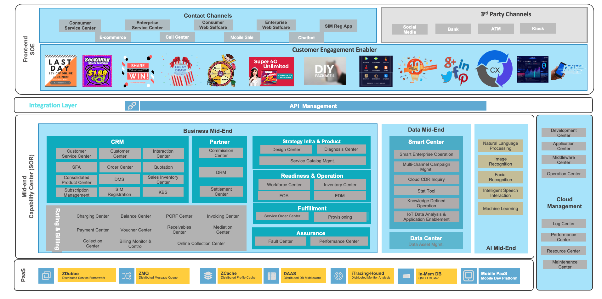

1. **Test Results**

