**TM Forum Open APIs**

**Conformance Certification**

*Company Name:* ***Globetom***

*TM Forum Open API Name:*

***TMF620 Product Catalog Management***

*TM Forum Open API Release Version:* ***19.0.0 – V4.0.0***

**Report Date: 29 April 2021**

# What Product or Solution does your API support?

All of Globetom’s TM Forum Open API implementations can be deployed in any one of the following models (on premise or in the cloud) - as a standalone API implementation on Globetom® ORCHA Digital Integration Hub or in addition, integrated with Globetom’s OSS/BSS platforms or with partner platforms or certified integrations with public cloud platforms.

## TMF620 Standalone Deployment (API + Globetom® ORCHA Digital Integration Hub)

The TMF620 API is deployed as a standalone API with an underpinning Hybrid Integration Platform based on our ORCHA iPaaS that implements the functions depicted in Figure 2 (see Architectural View). In this API deployment model, adopters of Globetom’s implementation are able to integrate their own OSS/BSS applications by using the Hub subscription mechanism and with Globetom’s implementation providing a very high degree of integrity of notifications to Hub subscribers to allow systems to leverage a loosely coupled integration pattern. The standalone deployment includes the following:

1. Deployment under any API gateway using a proxy deployment model.
2. A fully-fledged API backend for TMF620 to which the API calls are routed as part of the Proxy setup.
3. A Hybrid Integration Platform (HIP) that enables seamless decoupling and integration into the BSS/OSS and cloud services ecosystem of CSPs/DSPs.
4. An OLTP object store for all API resources managed using the API that may be used in the customer implementation as part of an overall Master Data Management (MDM) strategy.
5. A fully abstracted Data Integration Hub that certifies the integrity of notifications to subscribers to the API using the standard TM Forum Open API Hub subscription mechanism.

## TMF620 Integrated Deployment with Globetom® REVENUE WEAVER and STACLEO Platforms

In the integrated deployment model, TMF620 is pre-integrated with Globetom’s STACLEO and REVENUE WEAVER platforms.

STACLEO offers real-time fulfilment capabilities based on catalog configuration and provides optional integration with the TM Forum Service and Resource catalog APIs for fulfilment and product, service and resource layers.

REVENUE WEAVER can be used to offer Rating and Charging functions for product fulfilment (provisioning), changes and cancellations and also for usage events.

In this deployment model, the TMF620 resources are stored in the ORCHA Canonical data store as golden records but are then also stored in the Product Catalog of STACLEO using Hub-based catalog change integration. The following resources from the TMF620 resource model are supported:

1. Catalog resource
2. Category resource
3. Product Offering resource
4. Product Offering Price resource
5. Product Specification resource
6. Import Job resource
7. Export Job resource
8. Related: resources including ServiceCandidateRef, ResourceCandidateRef, Agreement Ref, SLARef and others.

A major advantage of Globetom’s TMF620 implementation is that it is natively multi-tenant to match the multi-tenancy of STACLEO. The tenant owning Product Catalog Management resources is identified in production environments from the API security credentials and this enables the use of one TMF620 API deployment to manage multiple service provider TMF620 resources. The solution also incorporates the concept of Catalog Vendor in order to allow partner catalogs to be managed based on API security credentials. This enables a multi-party digital ecosystem to share multiple catalogs from multiple vendors in the ecosystem in a single, standardised catalog.

Figure 1 – Globetom integrated platforms and the use of the TMF620 standard

# Overview of Certified API

The TMF620 Product Catalog Management API allows the full lifecycle management of catalog elements covering the following states:

* In Study
* In design
* In test
* Active
* Launched
* Retired
* Obsolete
* Rejects

It is typically used / consulted in business processes including: Order processing, Campaign Management and Sales Management

The API implementation allows the following operations:

* Operations on Program Product Specs:
  + List / Retrieve Program Product Spec(s) using the GET operation
  + Update partial representation of a Program Product Spec using the PATCH operation
  + Create a Program Product Spec using the POST operation
  + Delete a Program Product Spec using the DELETE operation
* Operations on Catalog
  + List catalogs using the GET operation
  + Retrieve catalog using the GET operation
  + Create catalog using the POST operation
  + Patch catalog using the PATCH operation
  + Delete catalog using the DELETE operation
* Operations on Category
  + List categories using the GET operation
  + Retrieve category using the GET operation
  + Create category using the POST operation
  + Patch category using the PATCH operation
  + Delete category using the DELETE operation
* Operations on Product Offering
  + List product offerings using the GET operation
  + Retrieve product offering using the GET operation
  + Create product offering using the POST operation
  + Patch product offering using the PATCH operation
  + Delete product offering using the DELETE operation
* Operations on Product Offering Price
  + List product offering prices using the GET operation
  + Retrieve product offering price using the GET operation
  + Create product offering price using the POST operation
  + Patch product offering price using the PATCH operation
  + Delete product offering price using the DELETE operation
* Operations on Product Specification
  + List product specifications using the GET operation
  + Retrieve product specification using the GET operation
  + Create product specification using the POST operation
  + Patch product specification using the PATCH operation
  + Delete product specification using the DELETE operation
* Operations on Import Job
  + List import jobs using the GET operation
  + Retrieve import job using the GET operation
  + Create import job using the POST operation
  + Delete import job using the DELETE operation
* Operations on Export Job
  + List export jobs using the GET operation
  + Retrieve export job using the GET operation
  + Create export job using the POST operation
  + Delete export job using the DELETE operation

# Architectural View

## Standalone deployment architectural view

The standalone deployment model architectural view is depicted in Figure 2.

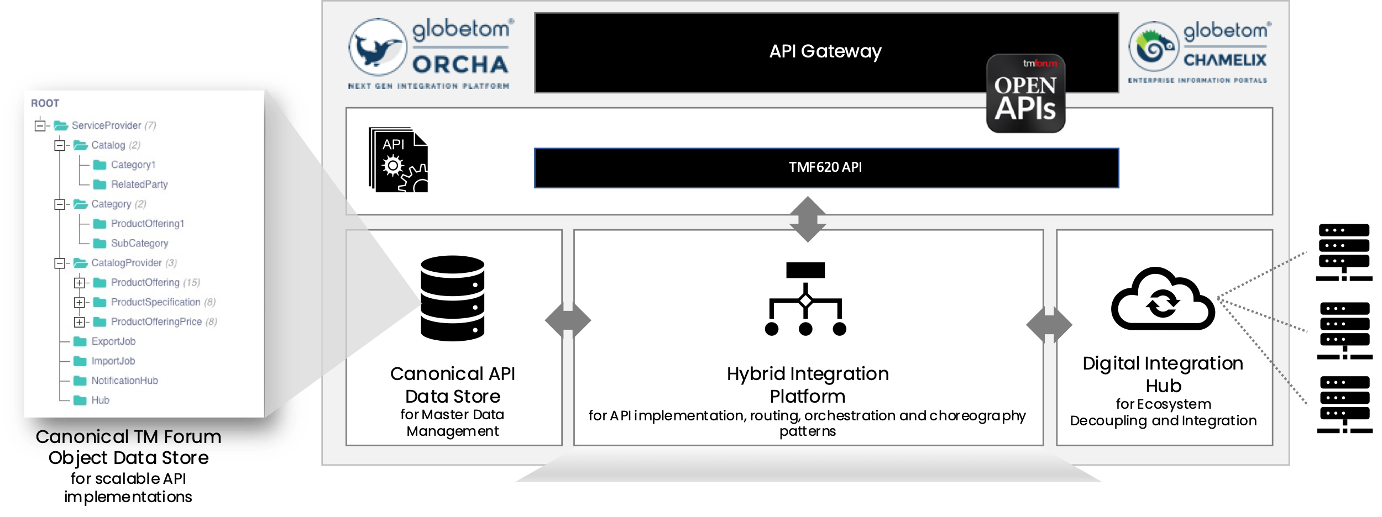

Figure 2 – Globetom’s TM Forum Open API Architecture Context

## Deployment architectural view with pre-integration of REVENUE WEAVER and STACLEO platforms

The architectural view for the deployment model in which Globetom’s REVENUE WEAVER and STACLEO platforms are pre-integrated is depicted in Figure 3.

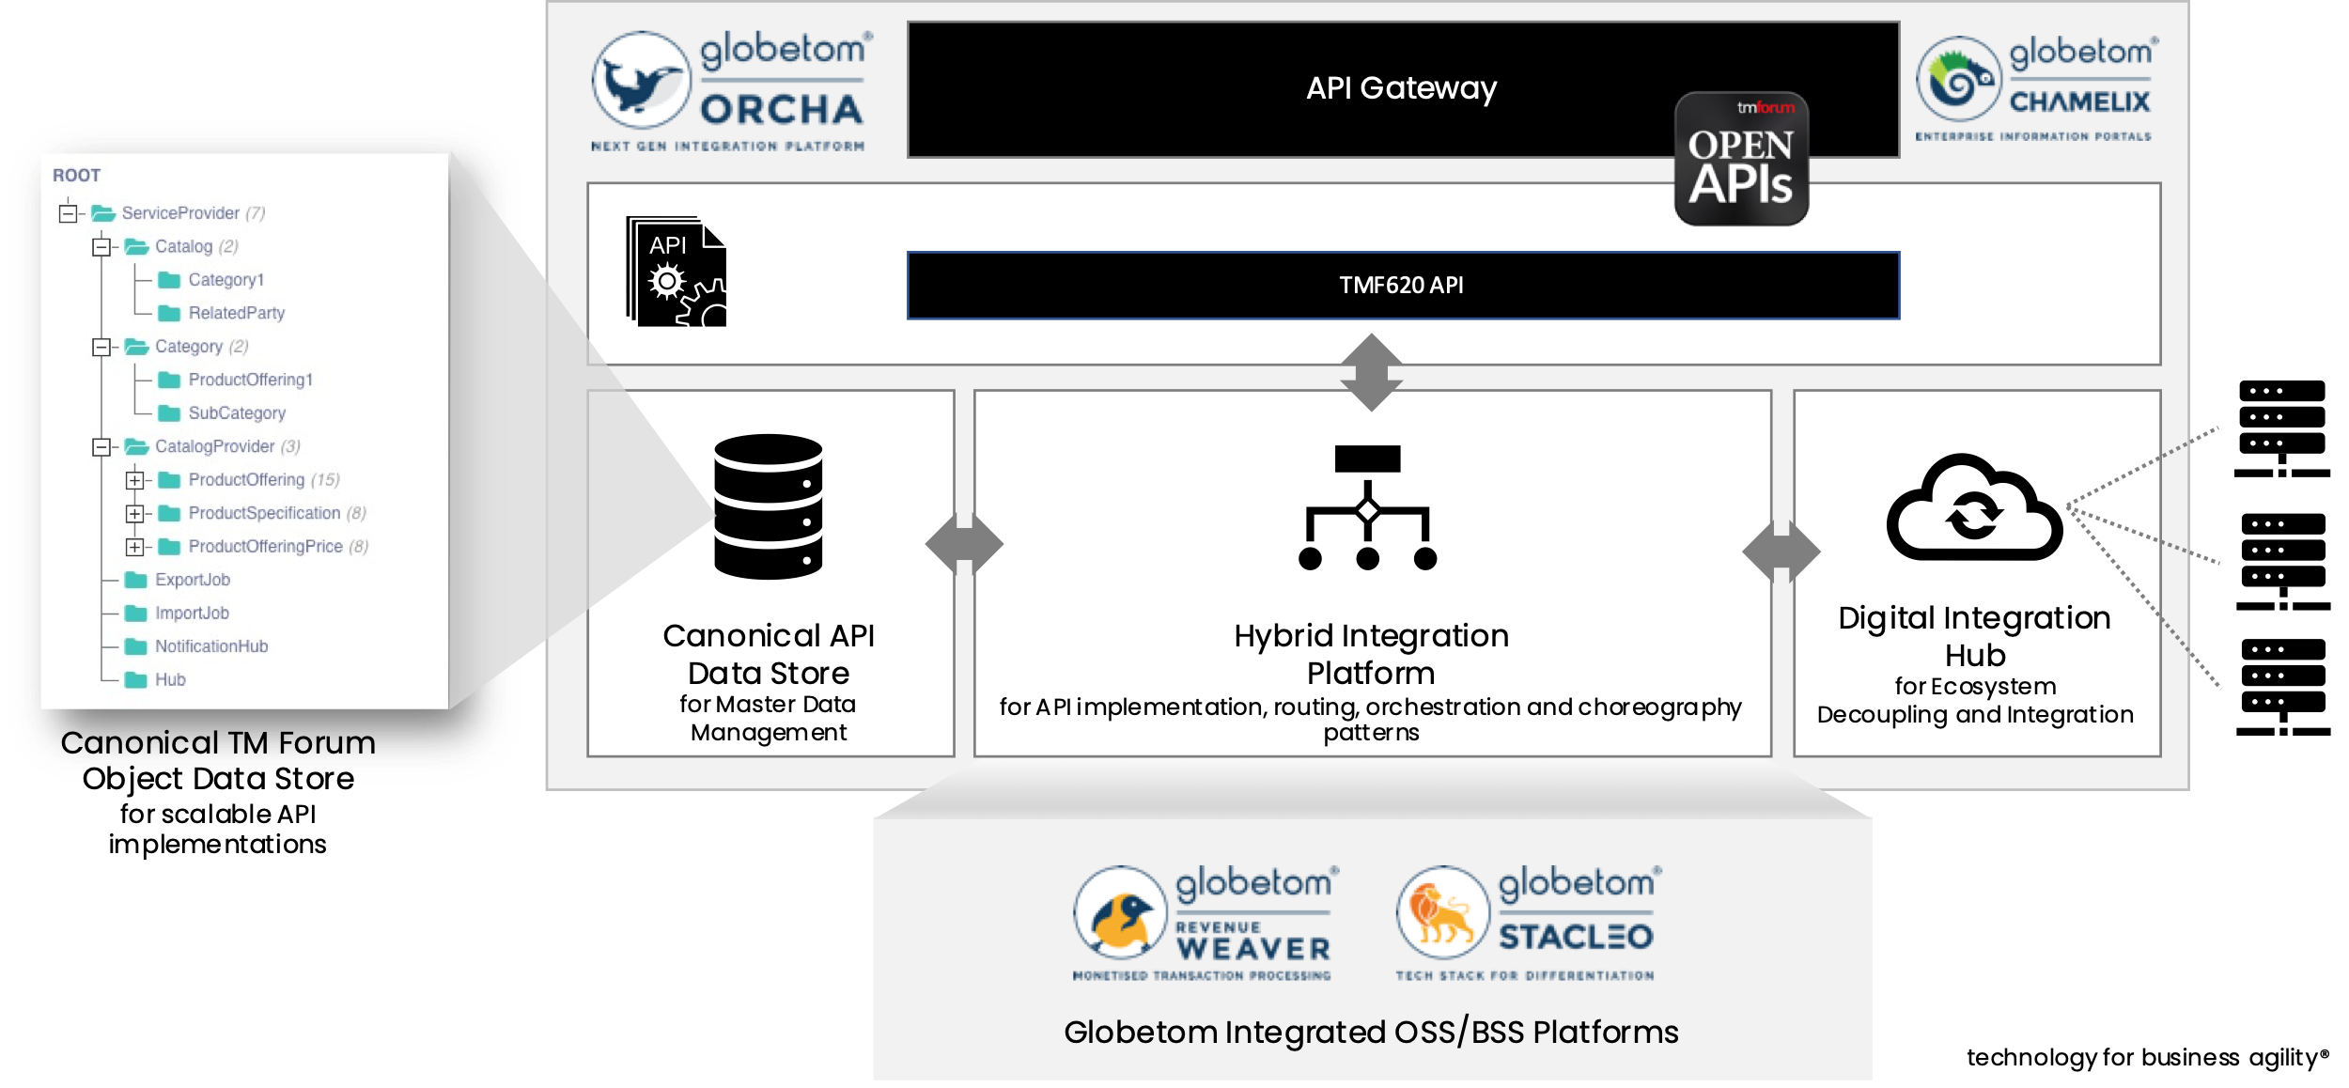

Figure 3 – TMF620 integrated with the Globetom REVENUE WEAVER and STACLEO platforms

# Test Results

