TM Forum Open APIs
Conformance Certification

Company Name: Globetom

TM Forum Open API Name:
TMF621 Trouble Ticket Management

TM Forum Open API Release Version: 19.0.1 – v4.0.0

Report Date: 23 April 2021

What Product or Solution does your API support?
All of Globetom’s TM Forum Open API implementations can be deployed in any one of the following models (on premise or in the cloud) - as a standalone API implementation on Globetom® ORCHA Digital Integration Hub or in addition, integrated with Globetom’s OSS/BSS platforms or with partner platforms or certified integrations with public cloud platforms.

TMF621 Standalone Deployment (API + Globetom® ORCHA Digital Integration Hub)
The TMF621 API is deployed as a standalone API with an underpinning Hybrid Integration Platform based on our ORCHA iPaaS that implements the functions depicted in Figure 1 (see Architectural View). In this API deployment model, adopters of Globetom’s implementation are able to integrate their own OSS/BSS applications by using the Hub subscription mechanism and with Globetom’s implementation providing a very high degree of integrity of notifications to Hub subscribers to allow systems to leverage a loosely coupled integration pattern. The standalone deployment includes the following:
- Deployment under any API gateway using a proxy deployment model.
- A fully-fledged API backend for TMF621 to which the API calls are routed as part of the Proxy setup.
- A Hybrid Integration Platform (HIP) that enables seamless decoupling and integration into the BSS/OSS and cloud services ecosystem of CSPs/DSPs.
- An OLTP object store for all API resources managed using the API that may be used in the customer implementation as part of an overall Master Data Management (MDM) strategy.
- A fully abstracted Data Integration Hub that certifies the integrity of notifications to subscribers to the API using the standard TM Forum Open API Hub subscription mechanism.

TMF621 Integrated Deployment with Atlassian JIRA Service Desk and other Trouble Ticket platforms
In the integrated deployment model, TMF621 is integrated with Atlassian JIRA. The Globetom ORCHA™ iPaaS Hybrid Integration Platform underpinning can be used by customers using the solution to integrate their own Trouble Ticketing platforms with the TMF621 implementation from Globetom. Alternatively, loosely coupled integration can be achieved using the TMF621 Hub to subscribe for Trouble Ticket change events.

Overview of Certified API
The Globetom pre-integrated TMF621 Trouble Ticket Management API is used to manage trouble tickets together with the Related Party and Related Object and other sub-resources associated with the Trouble Ticket.
The API implementation allows the following operations:
- Creation of Trouble Ticket resources using the POST operation
- Modifying of Trouble Ticket resources using the PATCH operation
- Deleting of Trouble Ticket resources using the DELETE operation
- Retrieval of single Trouble Ticket resources using the GET operation
- Retrieval of multiple Trouble Ticket resources using the GET operation and using filtering specification conforming to the TMF630 REST API Design Guidelines Part 1
- Guaranteed notifications to subscribers to the API using the Hub subscription model with guaranteed sequence of notifications retained

Architectural View

Standalone deployment architectural view
The standalone deployment model architectural view is depicted in Figure 1. The API implementation and underlying Hybrid Integration Platform (ORCHA) performs API operations to a canonical master data store and notifies subscribing platforms that subscribed to the Hub of Trouble Ticket changes. This deployment provides a loosely coupled integration model that may be used by consumers of the Globetom TMF621 implementation.
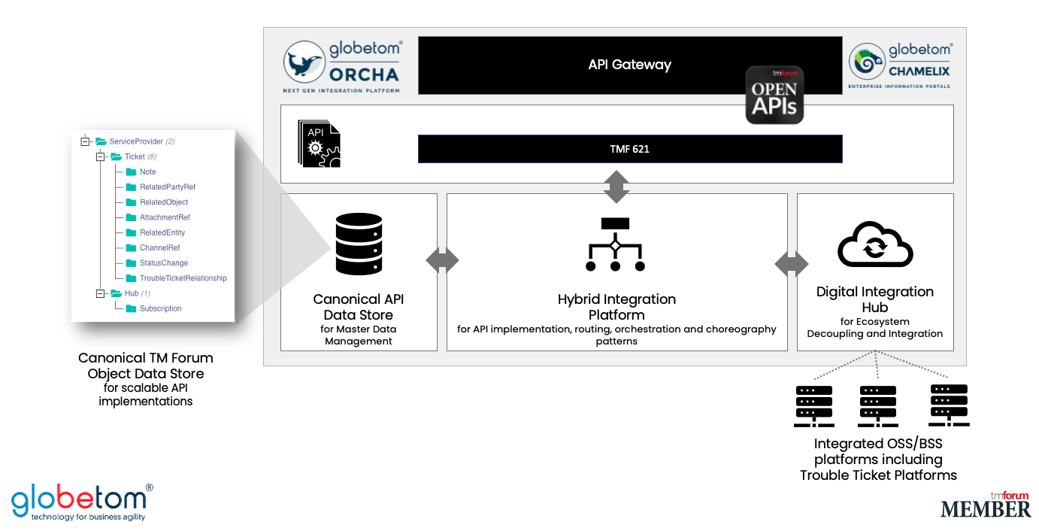
Figure 1 – Globetom’s TMF621 TM Forum Open API Architecture Context for standalone deployments
An example use case for the standalone implementation of TMF621 is to use the implementation during customer authenticated journeys for Trouble Ticket logging. Trouble Tickets are then stored in the ORCHA object store as master data for customer-originating issues. The CSP/DSP customer can then use Hub subscriptions to integrate their underlying Trouble Ticket management platform to receive notifications and to open trouble tickets and to process patch operations originating from customer portals.
In an environment where the underlying Trouble Ticket platform also supports TMF621, bi-directional Hub subscriptions between the Globetom TMF621 standalone implementation and the vendor’s Trouble Ticket management platform can be used to implement a loosely coupled integration pattern in which a co-existence Master Data Management model can be achieved.
The standalone deployment model supports TMF630 filtering which enables real-time access to Trouble Tickets based on filter criteria. These filter requests are serviced from the ORCHA object store without placing load on the underlying Trouble Ticket management system. The ORCHA object store therefore acts as a cache for access to Trouble Tickets.

Trouble Ticket platform integrated deployment architectural view
The architectural view for the deployment model in which Atlassian JIRA is integrated is depicted in Figure 2. In this deployment model, the ORCHA routing and orchestration pattern is used to integrate TMF621 API operations to Atlassian JIRA. New issues are therefore created on JIRA in response to TMF621 POST API calls. In this model, GET operations result in the ORCHA object store data for the Trouble Tickets to be retrieved as well as the issue information from JIRA and the response to the API consumer is decorated with the JIRA information of the Trouble Ticket.

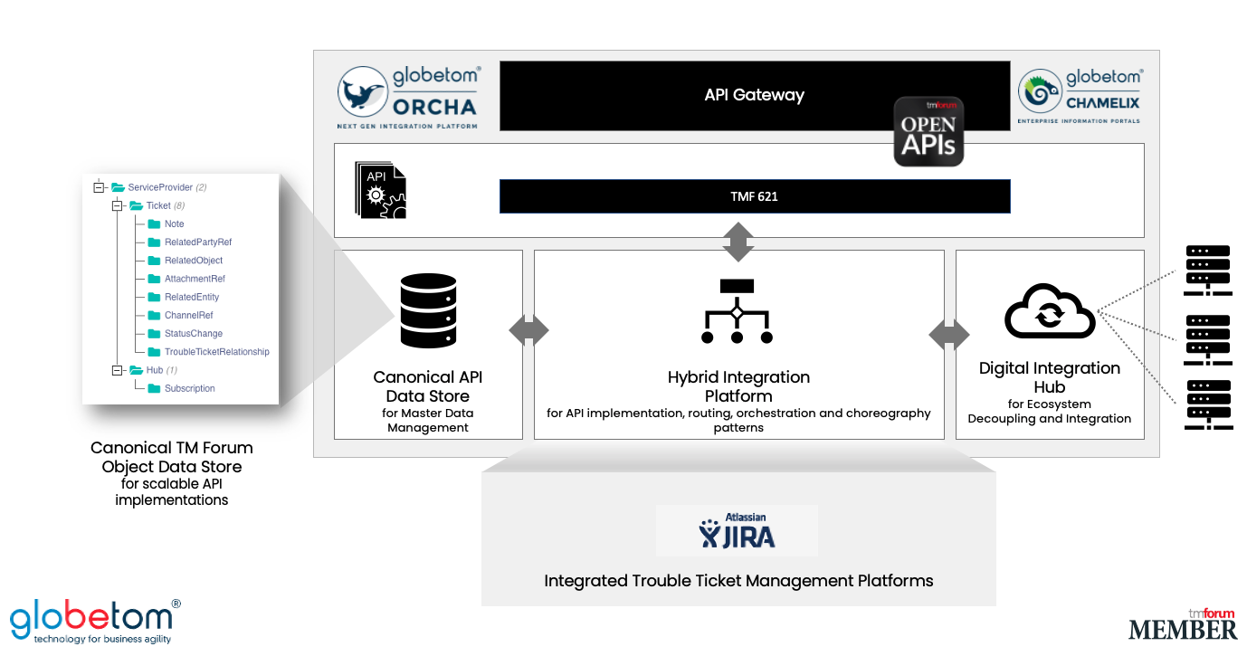
Figure 2 – TMF621 integrated with the Atlassian JIRA

Test Results

