TM Forum Open APIs
Conformance Certification

Company Name: Globetom

TM Forum Open API Name:
TMF632 Party Management

TM Forum Open API Release Version: 19.0.1 – v4.0.0

Report Date: 23 April 2021

What Product or Solution does your API support?
All of Globetom’s TM Forum Open API implementations can be deployed in any one of the following models (on premise or in the cloud) - as a standalone API implementation on Globetom® ORCHA Digital Integration Hub or in addition, integrated with Globetom’s OSS/BSS platforms or with partner platforms or certified integrations with public cloud platforms.

TMF632 Standalone Deployment (API + Globetom® ORCHA Digital Integration Hub)
The TMF632 API is deployed as a standalone API with an underpinning Hybrid Integration Platform based on our ORCHA iPaaS that implements the functions depicted in Figure 2 (see Architectural View). In this API deployment model, adopters of Globetom’s implementation are able to integrate their own OSS/BSS applications by using the Hub subscription mechanism and with Globetom’s implementation providing a very high degree of integrity of notifications to Hub subscribers to allow systems to leverage a loosely coupled integration pattern. The standalone deployment includes the following:
- Deployment under any API gateway using a proxy deployment model.
- A fully-fledged API backend for TMF632 to which the API calls are routed as part of the Proxy setup.
- A Hybrid Integration Platform (HIP) that enables seamless decoupling and integration into the BSS/OSS and cloud services ecosystem of CSPs/DSPs.
- An OLTP object store for all API resources managed using the API that may be used in the customer implementation as part of an overall Master Data Management (MDM) strategy.
- A fully abstracted Data Integration Hub that certifies the integrity of notifications to subscribers to the API using the standard TM Forum Open API Hub subscription mechanism.

TMF632 Integrated Deployment with Globetom® Revenue Weaver Platform
In the integrated deployment model, TMF632 is pre-integrated with Globetom’s Revenue Weaver BSS platform. Revenue Weaver manages real-time transactional processing in Digital Ecosystems and performs real-time rating, charging and revenue assurance functions. The platform relies on accurate profiles for organisations and individuals in B2B2X ecosystems.
In this deployment model, the TMF632 resources (Individual and Organization) are stored in the ORCHA Canonical data store as golden records but are then also integrated with the Revenue Weaver Subscriber Management Function to create entity profiles for Individuals and Organizations using the Revenue Weaver Subscriber Management Function (SMF). The SMF store manages key resources derived from the TMF632 resource model as follows:
- Individual and Organization attributes.
- RelatedParty resources by creating associations using the SMF subscriber association function.
The profiles stored on Revenue Weaver in response to TMF632 API calls also include the href attribute value to enable retrieval of the TMF632 compliant profile from the ORCHA object data store for retrieval.
The Revenue Weaver components and contextualization of the use of TMF632 and the Revenue Weaver Subscriber Management Function is depicted in Figure 1.
A major advantage of Globetom’s TMF632 implementation is that it is natively multi-tenant to match the multi-tenancy of Revenue Weaver. The tenant owning a collection of Individual and Organization resources is identified in production environments from the API security credentials and this enables the use of one TMF632 API deployment to manage multiple consumer’s TMF632 resources.
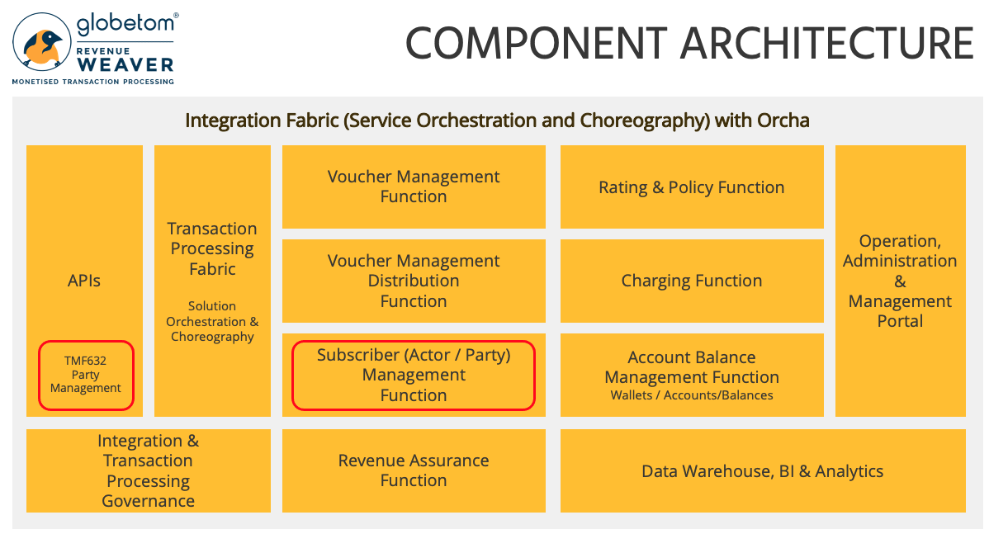
Figure 1 – Globetom Revenue Weaver components and the use of the TMF632 standard

Overview of Certified API
The Globetom pre-integrated TMF632 Party Management API is used to manage parties that are engaged with CSPs/DSPs as Individuals and Organizations. It enables consumers to store detailed information about parties that are engaged in some role/context with the CSP/DSP. After creation, multiple roles can be assigned to Individuals and Organizations to create context of the roles associated with the engagement of the Individual or Organization with the CSP/DSP using the API.
The API implementation allows the following operations:
- Creation of Individual resources using the POST operation
- Creation of Organization resources using the POST operation
- Modifying of Individual resources using the PATCH operation
- Modifying of Organization resources using the PATCH operation
- Deleting of Individual resources using the DELETE operation
- Deleting of Organization resources using the DELETE operation
- Creation of API notification subscriptions using the Hub resource POST operation
- Deletion of API notification subscriptions using the Hub resource DELETE operation
- Retrieval of single Individual resources using the GET operation
- Retrieval of single Organization resources using the GET operation
- Retrieval of multiple Individual resources using the GET operation and using filtering specification conforming to the TMF630 REST API Design Guidelines Part 1
- Retrieval of multiple Organization resources using the GET operation and using filtering specification conforming to the TMF630 REST API Design Guidelines Part 1
- Guaranteed notifications to subscribers to the API using the Hub subscription model with guaranteed sequence of notifications retained

Architectural View

Standalone deployment architectural view
The standalone deployment model architectural view is depicted in Figure 2.
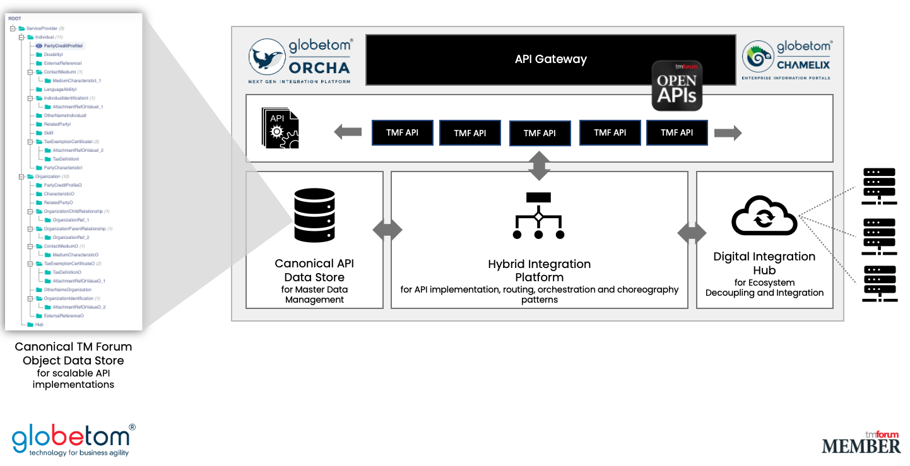
Figure 2 – Globetom’s TM Forum Open API Architecture Context

Revenue Weaver integrated deployment architectural view
The architectural view for the deployment model in which Globetom’s Revenue Weaver platform is pre-integrated is depicted in Figure 3.

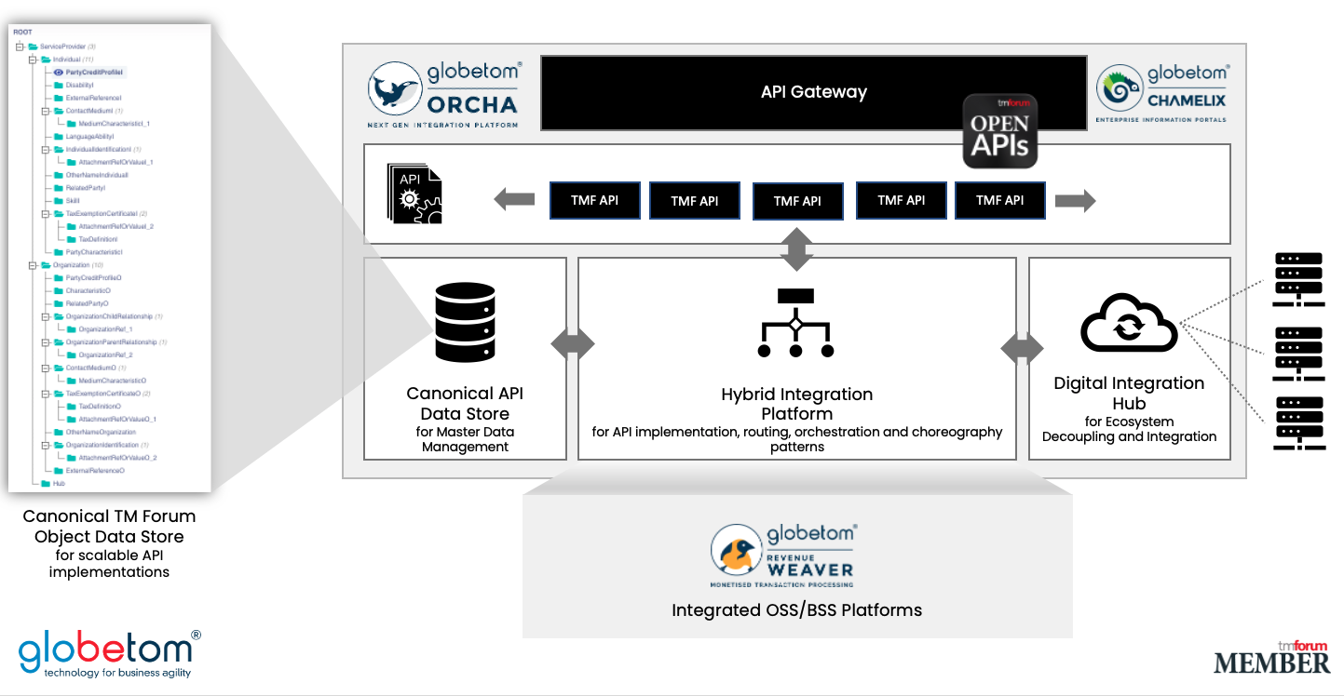
Figure 3 – TMF632 integrated with the Globetom Revenue Weaver BSS platform

Test Results

