TM Forum Open APIs
Conformance Certification

Company Name: Globetom

TM Forum Open API Name: TMF638 Service Inventory Management

TM Forum Open API Release Version: 20.5.0 – v4.0.0

Report Date: 26 April 2021

What Product or Solution does your API support?
All of Globetom’s TM Forum Open API implementations can be deployed in any one of the following models (on premise or in the cloud) - as a standalone API implementation on Globetom® ORCHA Digital Integration Hub or in addition, integrated with Globetom’s OSS/BSS platforms or with partner platforms or certified integrations with public cloud platforms.

TMF638 Standalone Deployment (API + Globetom® ORCHA Digital Integration Hub)
The TMF638 API is deployed as a standalone API with an underpinning Hybrid Integration Platform based on our ORCHA iPaaS that implements the functions depicted in Figure 2 (see Architectural View). In this API deployment model, adopters of Globetom’s implementation are able to integrate their own OSS/BSS applications by using the Hub subscription mechanism and with Globetom’s implementation providing a very high degree of integrity of notifications to Hub subscribers to allow systems to leverage a loosely coupled integration pattern. The standalone deployment includes the following:
- Deployment under any API gateway using a proxy deployment model.
- A fully-fledged API backend for TMF638 to which the API calls are routed as part of the Proxy setup.
- A Hybrid Integration Platform (HIP) that enables seamless decoupling and integration into the BSS/OSS and cloud services ecosystem of CSPs/DSPs.
- An OLTP object store for all API resources managed using the API that may be used in the customer implementation as part of an overall Master Data Management (MDM) strategy.
- A fully abstracted Data Integration Hub that certifies the integrity of notifications to subscribers to the API using the standard TM Forum Open API Hub subscription mechanism.

TMF638 Integrated Deployment with REVENUE WEAVER and other Service Inventory platforms
In the integrated deployment model, TMF638 is integrated with Globetom® REVENUE WEAVER for integrated customer and revenue management. Service subscriptions are managed on Revenue Weaver and the associated service inventory href for subscriptions are stored as subscription attributes in order to provide access to service inventory master data accessible from the TMF638 master data store. This deployment model is depicted in Figure 1.
The Globetom ORCHA™ iPaaS Hybrid Integration Platform underpinning can be used by customers using the solution to integrate their own Service Inventory platforms with the TMF638 implementation from Globetom. Alternatively, loosely coupled integration can be achieved using the TMF638 Hub to subscribe for Service Inventory change events.
REVENUE WEAVER supports party (individual or organisation) provisioning, typically integrated from master customer data stores such as CRM or other BSS platforms. In addition, subscriptions to services are managed on the platform as well. This information is maintained on REVENUE WEAVER typically as slave data integrated using TM Forum Open APIs or other integration mechanisms whereas the customer and service subscription data is available in real-time and at scale to process events for rating, charging and revenue assurance in real-time. REVENUE WEAVER can access service inventory data from the href maintained in the REVENUE WEAVER subscription store and can be retrieved from the Service Inventory Master Data Store implemented as part of Globetom’s TMF638 API implementation.

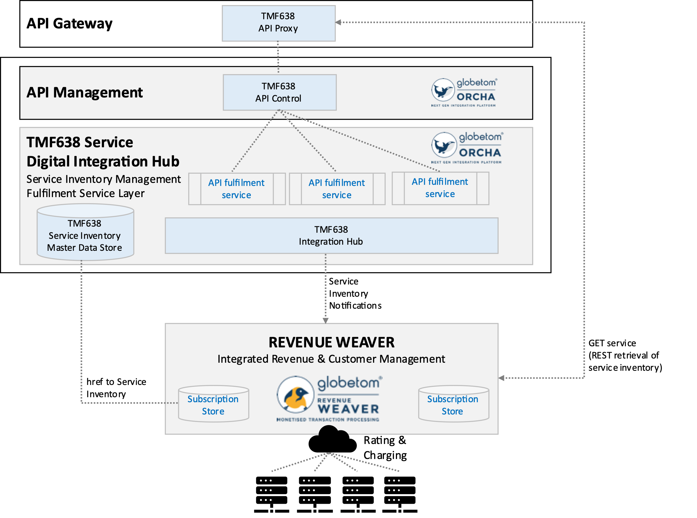
Figure 1 – TMF638 deployed with loosely coupled integration with REVENUE WEAVER

Overview of Certified API
The Globetom pre-integrated TMF638 Service Inventory Management API is used to manage Service Inventory resources together with the Related Party and Related Service Order Items and other sub-resources associated with Service Inventory.
The API implementation allows the following operations:
- Creation of a Service Inventory resource using the POST operation
- Modifying of a Service Inventory resource using the PATCH operation
- Deleting of Service Inventory resource using the DELETE operation
- Retrieval of a Service Inventory resource using the GET operation
- Retrieval of multiple Service Inventory resources using the GET operation and using filtering specification conforming to the TMF630 REST API Design Guidelines Part 1
- Guaranteed notifications to subscribers to the API using the Hub subscription model with guaranteed sequence of notifications retained

Architectural View

Standalone deployment architectural view
The standalone deployment model architectural view is depicted in Figure 2. The API implementation and underlying Hybrid Integration Platform (ORCHA) performs API operations to a canonical master data store and notifies subscribing platforms that subscribed to the Hub for Service Inventory changes. This deployment provides a loosely coupled integration model that may be used by consumers of the Globetom TMF638 implementation.

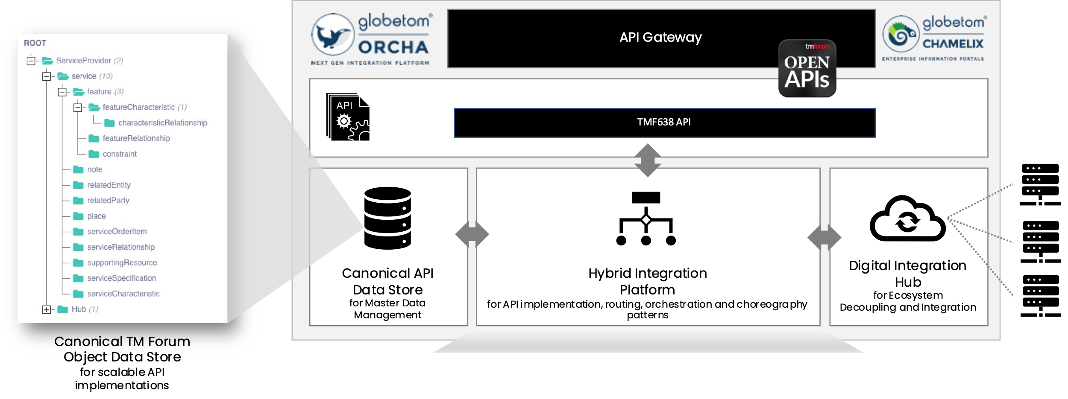
Figure 2 – Globetom’s TMF638 TM Forum Open API Architecture Context for standalone deployments

Service Inventory platform integrated deployment architectural view
The architectural view for the deployment model in which Globetom’s REVENUE WEAVER is integrated is depicted in Figure 3. In this deployment model, the ORCHA routing and orchestration pattern is used to integrate TMF638 API operations to REVENUE WEAVER.
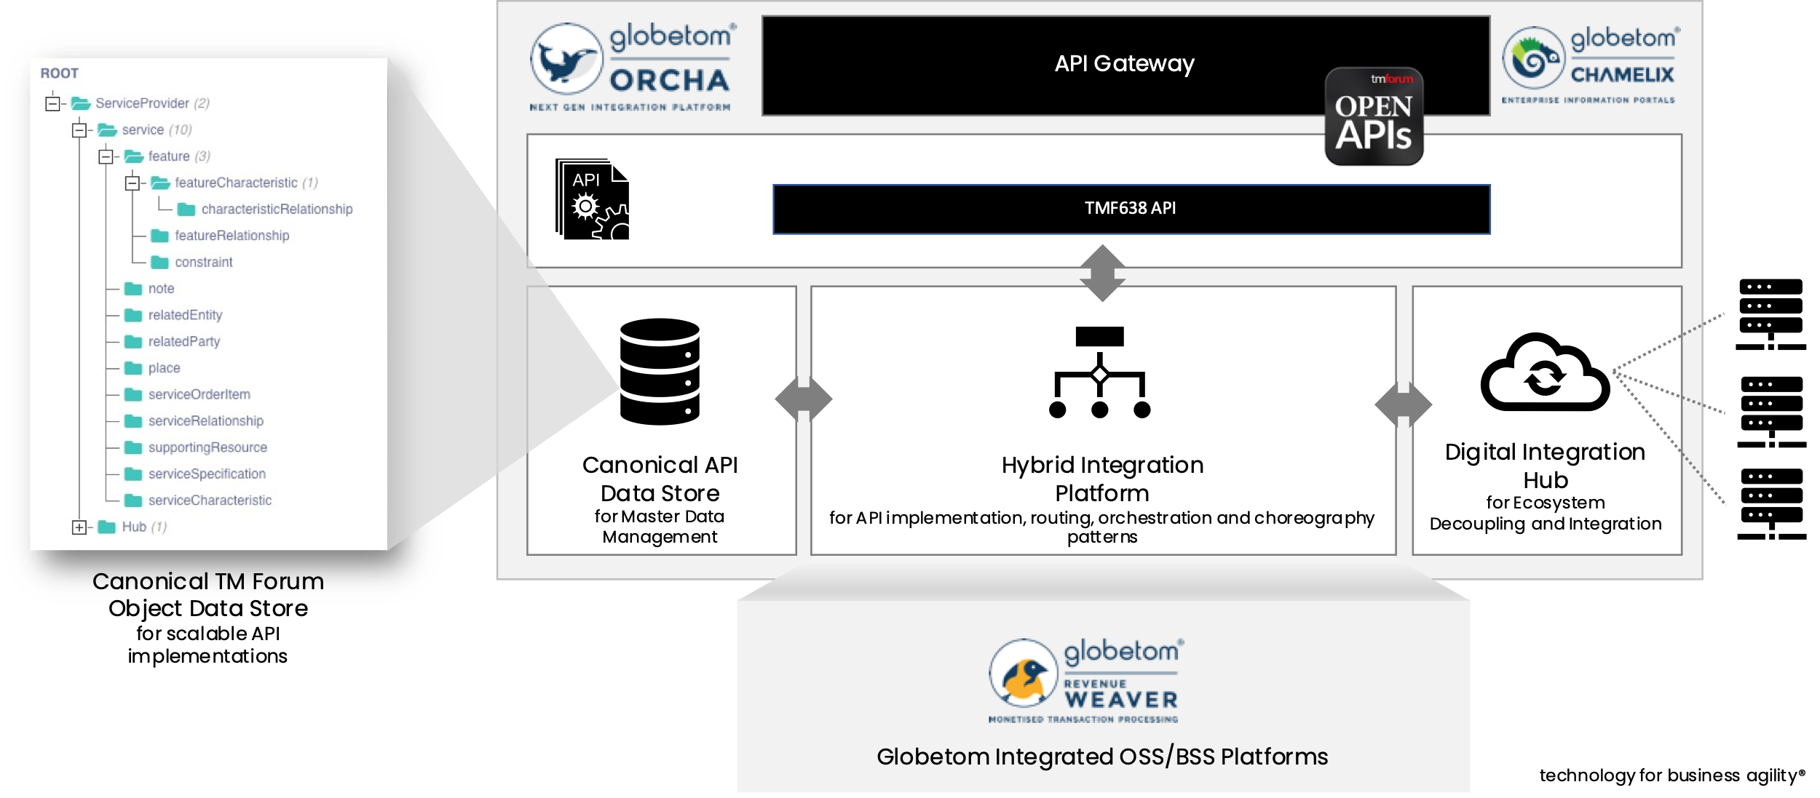
Figure 3 – TMF638 integrated with REVENUE WEAVER

Test Results

