TM Forum Open APIs
Conformance Certification
Company Name:

TM Forum Open API Name: TMF 638 Service Inventory API

TM Forum Open API Release Version: V4.0.0

Report Date: June 11th, 2021

- What Product or Solution does your API support?

Nokia Digital Operations (DO) Center delivers all the lifecycle phases of Design, Deliver and Assure, for a business or network service through a ’Single Pane of Glass’ engagement, across multi-vendor networks.
Service lifecycle phases are shown in picture below:

- Design
- Service design covering aspects of service orchestration as well as service assurance in a coherent manner.
- Service Catalogue life-cycle management.
- Consist of both browser-based User Interface ‘DesignHub’ and SDK(s)
- Deliver
- Service orchestration and fulfillment functionality including also Order Management functionality
- Consists of browser based User Interface ‘OrderHub’ and Nokia Orchestration Center plus a set of APIs to connect to BSS layer
- Assure
- Service assurance monitors e2e services and triggers closed-loop/open-loop actions towards Orchestration via ‘OperationsHub’.
- Provides network and services analytics for advanced troubleshooting, trend analysis, forecasting, etc. via ‘IntelligenceHub’.
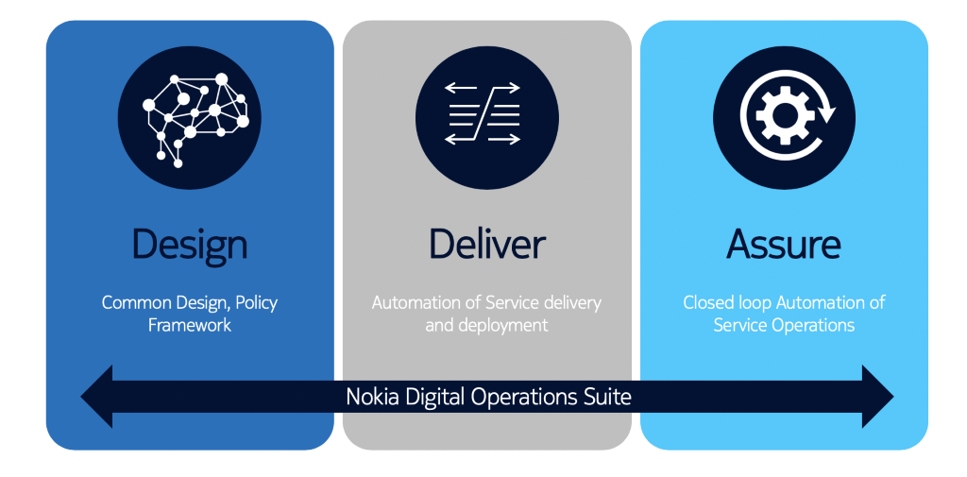

The picture shows the illustration of how the modules of Nokia DO Center map to the lifecycle phases of a service. Service Design phase is shared by both service orchestration and service assurance. Ordering phase is the responsibility of Nokia Orchestration Center and service assurance phase of service lifecycle in turn is the responsibility of Nokia Assurance Center. Service orchestration and service assurance work together through a unified inventory model of UIV. Nokia DO Center integrates on the southbound with Nokia or other vendor domain controllers.
On the northbound, Nokia Orchestration Center integrates with the business support systems (BSS), systems like CRM and CPQ.

- Overview of Certified API

The TMF 638 Service Inventory API can be used to query the service instances for a customer via Self Service Portal, or the Call Centre operator can query the service instances on behalf of the customer while a customer may have a complaint or a query.

- Architectural View

Nokia DO Center consists of 4 modular building blocks:
- NOKIA Orchestration Center - responsible for orchestration of service orders and changes in the network triggered by Assurance processes.
- NOKIA Assurance Center – responsible for ensuring the network and services quality while they are actively running.
- Unified Inventory – responsible for providing a near realtime service view on the active network and services inventory as well as the relations between the service and corresponding NFs and resources.
- Digital Plug-ins – responsible for providing content on top of the application like service templates and Close-loop automation policies and workflows, translating into specific use-cases (e.g. 5G eMBB slice template and respective automation policies and workflows, including as well the required network integrations).
When deployed together these components deliver end-to-end service life-cycle management and automated assurance for Close Loop Automations

The TMF 638 API is supported by UIV – Unified Inventory Module of Nokia Digital Operations

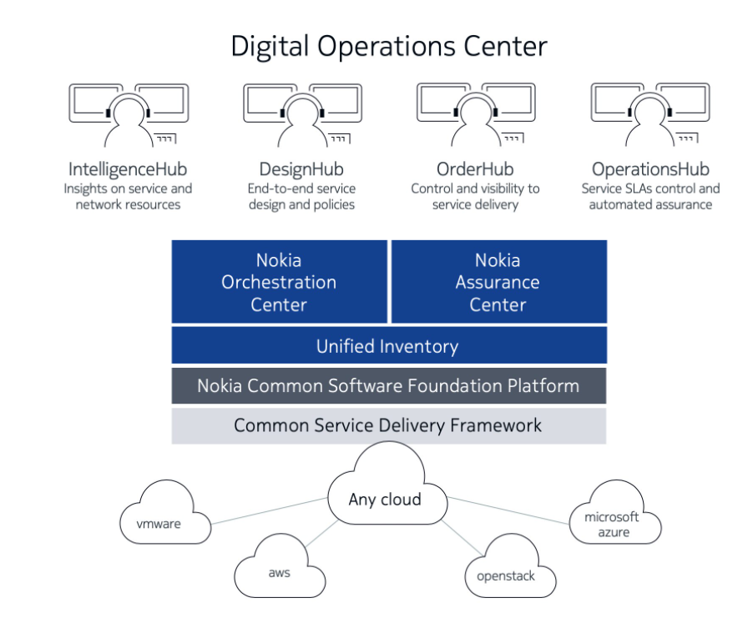
- Test Results

