TM Forum Open APIs
Conformance Certification

Company Name: Oracle Corporation

TM Forum Open API Name:
TMF637 – Product Inventory Management API

TM Forum Open API Release Version: Release 19.0 / 4.0

Report Date: 05-21-2021

- What Product or Solution does your API support?

Digital Experience for Communications Buying Experience provides an API first approach to support digital omni-channel subscription buying and ordering solution for communication and media service providers. The solution simplifies the overall buying process by delivering pre-built and pre-integrated capabilities that covers every aspect of the customers buying journey from unified product catalogs to alignment of commerce experience to subscription management. The comprehensive industry specific processes support both assisted and unassisted buying. Key capabilities include:
- Modern and personalized user experience: Supports contextual customer acquisition journey, personalized catalogs for different markets, and data-driven user experience.
- Digital omni-channel buying experience: Enables consistency across channel journeys, allows subscriber channel hopping, and introduces both traditional and new digital channels.
- Customer 360 and subscription management: Provides context-aware customer 360 dashboards and guided subscription buying experiences.
- Adaptive customer data mastering: Maintains data consistency across applications in a deployment and enables agility.
- TMF Open Digital Architecture: Drives channel engagements and system integrations efficiently and effectively.

- Overview of Certified API

The TMF637 – Product Inventory Management API provides a standardized mechanism for product inventory management, such as retrieval of product with filter criteria. It is fully compliant with Release 19.0.0 version 4.0.0 of the API specification. The API has been self-certified using the both the CTK payload and on implemented solution.

- Architectural View

The following diagram provides an architectural overview of Digital Experience for Communications Buying Experience:

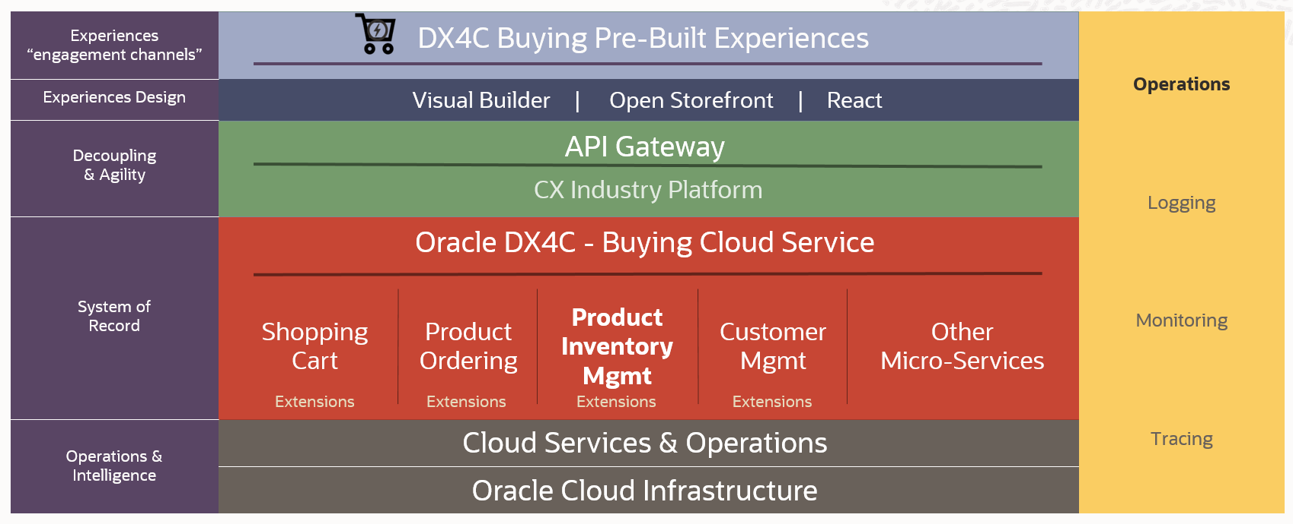

- Test Results

