TM Forum Open APIs
Conformance Certification

Company Name: Totogi

TM Forum Open API Name: Product Catalog Management API TMF620

TM Forum Open API Release Version: 21.0 / 4.1

Report Date: 3rd June 2021
- What Product or Solution does your API support?

Product Catalog management API TMF620 is incorporated into the first deployment of the TM Forum APIs instantiated within the Totogi BSS. With this deployment we will enable a standardized mechanism for the management of the entire lifecycle of the catalog elements, the consultation of catalog elements during several processes such as ordering process, campaign management, sales management.

Communication Service Providers (CSPs) are constantly moulding and adapting their platforms to communicate with each other. Every new service or product that is delivered to the market requires change to a vast number of systems. Launch times lag the market need and revenue opportunities are lost.

Furthermore, the CSPs need to retain customers and excite those customers into buying more services. The range of services is expanding and the CSP has to adopt new content and create a more personalised experience that delights the customer and extends the size of wallet the CSP can target.

As the range of services are extended the CSP is forced to upgrade or change existing systems, processes and channels while adding new, complementary platforms to evolve to a Digital Services Provider (DSP).

To facilitate this move to the DSP model the Totogi product suite leverages the power of the public cloud. Why? Because the Hyperscalers are investing billions in delivering the best development, data management and performance tools. Totogi leverages that investment and delivers webscale performance and availability.

Totogi BSS is the public cloud based platform that enables a CSP to drive its evolution to becoming a DSP. As it evolves it will incorporate all the TM Forum APIs and enable the CSP/DSP to deliver new services by building applications in low-code/no-code tools that use the instantiated APIs.

Data Management: All our APIs store data into a TM Forum compliant data structure. This makes the data available via the public cloud and enables any tool to access information through the API mechanism.

Analytics and Reporting: Using Hyperscaler reporting tools the CSP/DSP can rapidly build dashboards and deep analytics on all aspects of their subscribers and their behaviours.

Public Cloud Architecture: By having the data on the public cloud you automatically gain the advantages of backup and disaster recovery that are built into the Hyperscaler platforms.

Rapid Application Development: The CSP/DSP is now freed from vendor product roadmap lifecycle or internal development backlog that prevents solutions being delivered to meet immediate market need. The Totogi BSS allows the CSP/DSP to solve problems rapidly with low-code/no code tools and writing to open standards.
- Overview of Certified API

The Totogi BSS Product Catalog Management API is part of the core Totogi BSS APIs to indirectly support managing and consultation of catalog elements. The Totogi BSS Product Catalog Management API is compliant with TMF 620 specifications and offers API access to create, update, query and delete catalog: elements; categories; offerings; offering price; and specifications.

# | Resource | API Overview | Operations Supported
1 | catalog | A collection of Product Offerings, intended for a specific DistributionChannel, enhanced with additional information such as SLA parameters, invoicing and shipping details. | - GET  - PATCH  - POST  - DELETE
2 | category | The category resource is used to group product offerings, service and resource candidates in logical containers. Categories can contain other categories and/or product offerings, resource or service candidates. | - GET  - PATCH  - POST  - DELETE
3 | productOffering | Represents entities that are orderable from the provider of the catalog, this resource includes pricing information. | - GET  - PATCH  - POST  - DELETE
4 | productOfferingPrice | Is based on both the basic cost to develop and produce products and the enterprises policy on revenue targets. This price may be further revised through discounting (productOfferPriceAlteration). The price applied for a productOffering may also be influenced by the productOfferingTerm, the customer selected, eg: a productOffering can be offered with multiple terms, like commitment periods for the contract. The price may be influenced by this productOfferingTerm. A productOffering may be cheaper with a 24 month commitment than with a 12 month commitment. | - GET  - PATCH  - POST  - DELETE
5 | productSpecification | Is a detailed description of a tangible or intangible object made available externally in the form of a ProductOffering to customers or other parties playing a party role. | - GET  - PATCH  - POST  - DELETE

- Architectural View
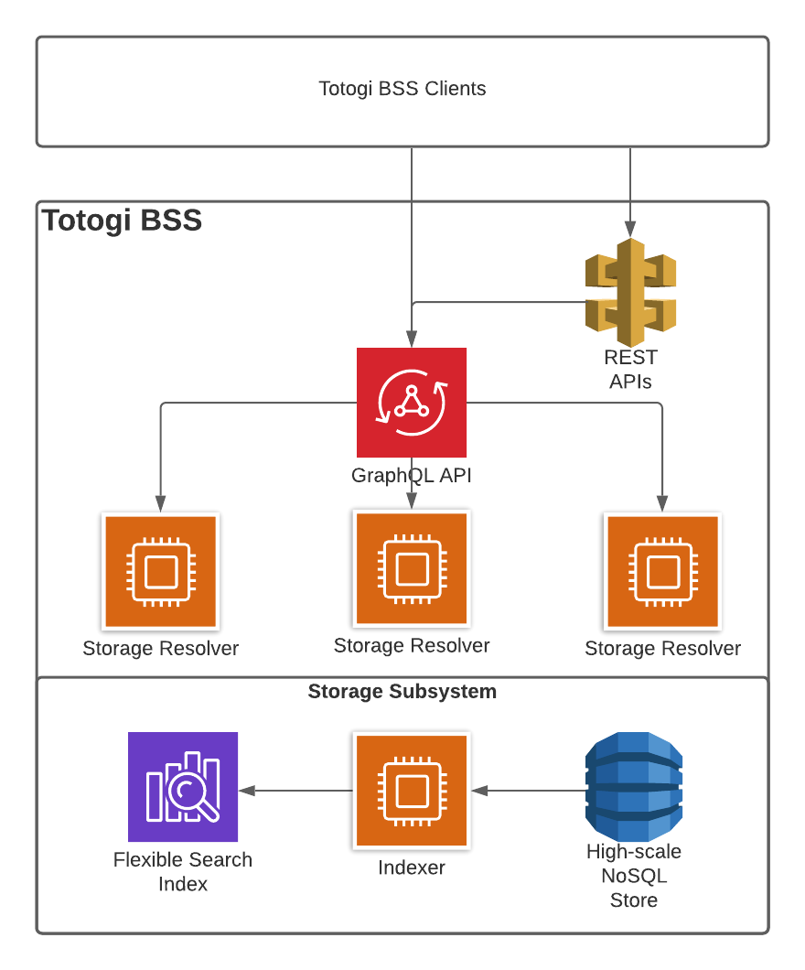

- Test Results

