TM Forum Open APIs
Conformance Certification

Company Name: Totogi

TM Forum Open API Name:
Party management API TMF632

TM Forum Open API Release Version: 19.0 / 4.0

Report Date: 3rd June 2021
- What Product or Solution does your API support?

Party management API TMF632 is the first of the many TM Forum APIs the Totogi BSS has instantiated. With this deployment we will enable the delivery of a standardized mechanism for party management (individual and enterprise and related organisations) including creation, update, retrieval, deletion and notification of events. This functionality is supported by the Totogi BSS platform.

Communication Service Providers (CSPs) are constantly moulding and adapting their platforms to communicate with each other. Every new service or product that is delivered to the market requires change to a vast number of internal systems. Launch times lag the market need and revenue opportunities are lost.

Furthermore, the CSPs need to retain customers and excite those customers into buying more services. The range of services is expanding and the CSP has to adopt new content and create a more personalised experience that delights the customer and extends the size of wallet the CSP can target.

As the range of services are extended the CSP is forced to upgrade or change existing systems, processes and channels while adding new, complementary platforms to evolve to a fully Digital Services Provider (DSP).

To facilitate this move to the DSP model the entire Totogi product suite leverages the power of the public cloud. Why? Because the Hyperscalers are investing billions of dollars in delivering and continually improving the best development, data management and performance tools. Totogi leverages that investment and delivers web scale performance and availability.

Totogi BSS is the public cloud based platform that enables a CSP to drive its evolution to become a DSP. As it evolves, it will incorporate all the TM Forum APIs and enable the CSP/DSP to deliver new services by building applications in low-code/no-code tools that use the instantiated TM Forum APIs.

Data Management: All our APIs store data into a TM Forum compliant data structure. This makes all data available via the public cloud and enables any tool to access information through the published API mechanism.

Analytics and Reporting: Using readily available Hyperscaler reporting tools the CSP/DSP can rapidly build dashboards and perform deep analytics on all aspects of their subscribers and associated behaviours.

Public Cloud Architecture: By having the data on the public cloud the CSP/DSP automatically gains the pre-built advantages of backup and disaster recovery that are inherent in the Hyperscaler platforms.

Rapid Application Development: The CSP/DSP is now freed from vendor product roadmaps or internal development backlog that prevent solutions being delivered to meet immediate market need. The Totogi BSS allows the CSP/DSP to solve problems rapidly, building applications with low-code/no code tools and developing solutions to the TM Forum open standards.

- Overview of Certified API

The Totogi BSS Party Management API is part of the core Totogi BSS APIs to indirectly support managing staff, accounts, subscribers and organizations. In this context, party refers to any individual or organization which has a business relationship with the consumer or business customers. The Totogi BSS Party Management API is compliant with TMF 632 specifications and offers API access to manage individuals and organizations through REST API calls.

# | Resource | API Overview | Operations Supported
1 | individual | Individual represents a single human being (a man, woman or child). The individual can be a customer, an employee or any other person that the organization needs to store information about. | - GET  - PATCH  - POST  - DELETE
2 | organization | Organization represents a group of people identified by shared interests or purpose. Examples include business, department and enterprise. Because of the complex nature of many businesses, both organizations and organization units are represented by the same data. | - GET  - PATCH  - POST  - DELETE
- Architectural View
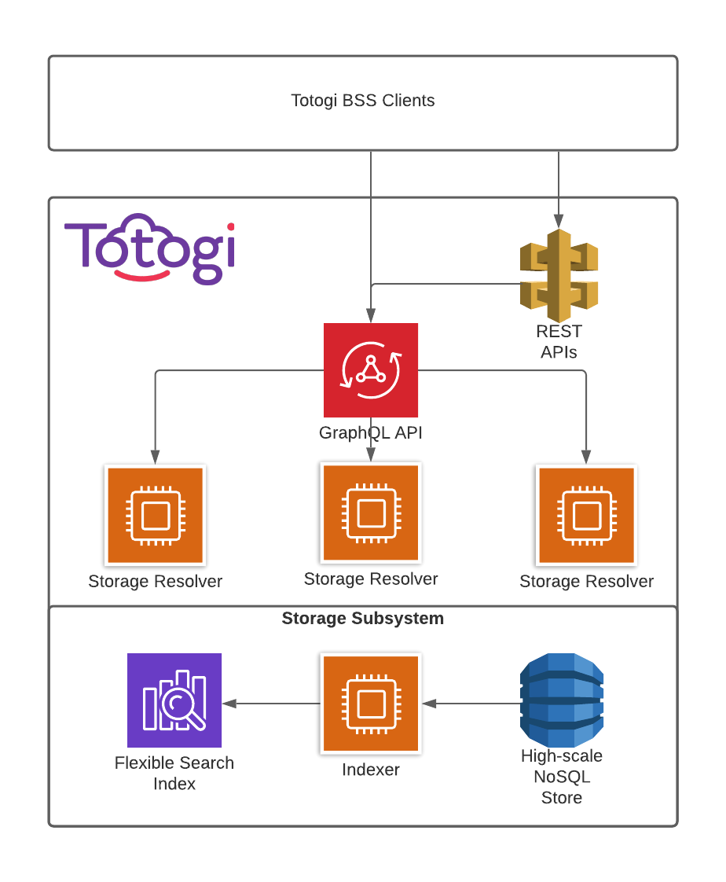

- Test Results

