TM Forum Open APIs
Conformance Certification

Company Name: Totogi

TM Forum Open API Name:
Product Inventory Management API TMF637

TM Forum Open API Release Version: 19.0 / 4.0

Report Date: 3rd June 2021
- What Product or Solution does your API support?

Product Inventory management API TMF637 is delivered as part of the instantiation of the TM Forum APIs in the Totogi BSS Platform. With this deployment we will enable standardized mechanisms for the wider management of product inventory. CSPs are able to exploit the exposed APIs to develop their own specific solutions, based on these open standards.

Communication Service Providers (CSPs) are constantly moulding and adapting their platforms to communicate with each other. Every new service or product that is delivered to the market requires change to a vast number of systems. Launch times lag the market need and revenue opportunities are lost.

Furthermore, the CSPs need to retain customers and excite those customers into buying more services. The range of services is expanding and the CSP has to adopt new content and create a more personalised experience that delights the customer and extends the size of wallet the CSP can target.

As the range of services are extended the CSP is forced to upgrade or change existing systems, processes and channels while adding new, complementary platforms to evolve to a Digital Services Provider (DSP).

To facilitate this move to the DSP model the Totogi product suite leverages the power of the public cloud. Why? Because the Hyperscalers are investing billions in delivering the best development, data management and performance tools. Totogi leverages that investment and delivers webscale performance and availability.

Totogi BSS is the public cloud based platform that enables a CSP to drive its evolution to becoming a DSP. As it evolves it will incorporate all the TM Forum APIs and enable the CSP/DSP to deliver new services by building applications in low-code/no-code tools that use the instantiated APIs.

Data Management: All our APIs store data into a TM Forum compliant data structure. This makes the data available via the public cloud and enables any tool to access information through the API mechanism.

Analytics and Reporting: Using Hyperscaler reporting tools the CSP/DSP can rapidly build dashboards and deep analytics on all aspects of their subscribers and their behaviours.

Public Cloud Architecture: By having the data on the public cloud you automatically gain the advantages of backup and disaster recovery that are built into the Hyperscaler platforms.

Rapid Application Development: The CSP/DSP is now freed from vendor product roadmap lifecycle or internal development backlog that prevents solutions being delivered to meet immediate market need. The Totogi BSS allows the CSP/DSP to solve problems rapidly with low-code/no code tools and writing to open standards.
- Overview of Certified API

The Totogi BSS Product Inventory Management API is incorporated into the core Totogi BSS APIs to manage the procurement of products. In this context, product refers to a product offering acquired by a customer or other interested party playing a party role. A product is realized as one or more service(s) and / or resource(s). The Totogi BSS Product Inventory Management API is compliant with TMF 637 specifications and offers API access to creation, update and retrieval of product resources.

# | Resource | API Overview | Operations Supported
1 | product | A product offering procured by a customer or other interested party playing a party role. A product is realized as one or more service(s) and / or resource(s). | - GET  - PATCH  - POST  - DELETE

- Architectural View
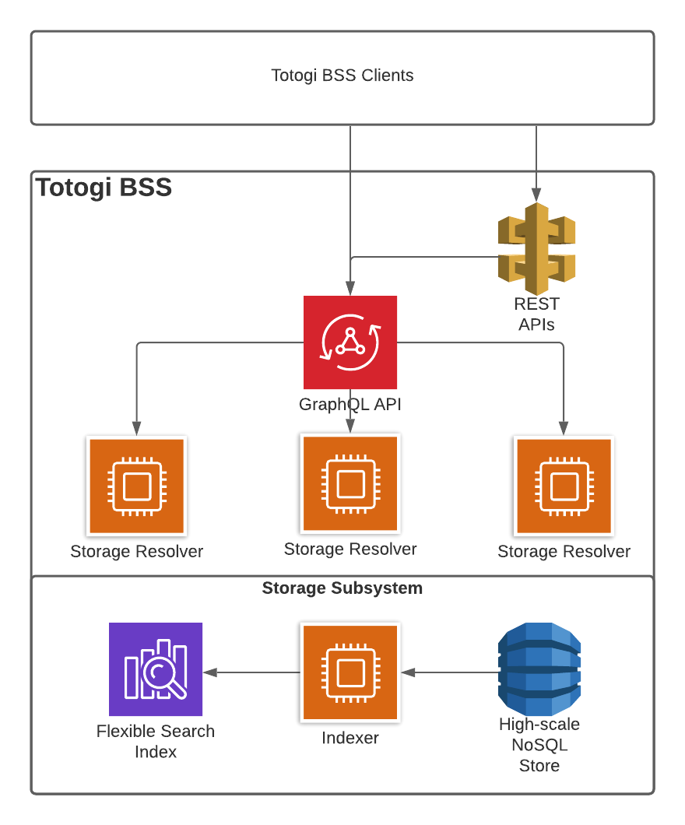

- Test Results

