TM Forum Open APIs
Conformance Certification

Company Name: Totogi

TM Forum Open API Name:
Account Management API TMF666

TM Forum Open API Release Version: 19.0 / 4.0

Report Date: 3rd June 2021
- What Product or Solution does your API support?

The Totogi BSS has encapsulated and instantiated the Account Management API TMF666 within its first deployment of the TM Forum APIs. With this deployment Totogi BSS enables standardized mechanisms for the wider management of billing and settlement accounts, as well as for financial accounting (accounts receivable) either in B2B or B2B2C contexts, across the Totogi family of products.

Communication Service Providers (CSPs) are constantly moulding and adapting their platforms to communicate with each other. Every new service or product that is delivered to the market requires change to a vast number of systems. Launch times lag the market need and revenue opportunities are lost.

Furthermore, the CSPs need to retain customers and excite those customers into buying more services. The range of services is expanding and the CSP has to adopt new content and create a more personalised experience that delights the customer and extends the size of wallet the CSP can target.

As the range of services are extended the CSP is forced to upgrade or change existing systems, processes and channels while adding new, complementary platforms to evolve to a Digital Services Provider (DSP).

To facilitate this move to the DSP model the Totogi product suite leverages the power of the public cloud. Why? Because the Hyperscalers are investing billions in delivering the best development, data management and performance tools. Totogi leverages that investment and delivers webscale performance and availability.

Totogi BSS is the public cloud based platform that enables a CSP to drive its evolution to becoming a DSP. As it evolves it will incorporate all the TM Forum APIs and enable the CSP/DSP to deliver new services by building applications in low-code/no-code tools that use the instantiated APIs.

Data Management: All our APIs store data into a TM Forum compliant data structure. This makes the data available via the public cloud and enables any tool to access information through the API mechanism.

Analytics and Reporting: Using Hyperscaler reporting tools the CSP/DSP can rapidly build dashboards and deep analytics on all aspects of their subscribers and their behaviours.

Public Cloud Architecture: By having the data on the public cloud you automatically gain the advantages of backup and disaster recovery that are built into the Hyperscaler platforms.

Rapid Application Development: The CSP/DSP is now freed from vendor product roadmap lifecycle or internal development backlog that prevents solutions being delivered to meet immediate market need. The Totogi BSS allows the CSP/DSP to solve problems rapidly with low-code/no code tools and writing to open standards.
- Overview of Certified API

The Totogi BSS Account Management API is functionality in the core Totogi BSS APIs to manage various types of accounts like partyAccount, billingAccount etc., as well as billingCycleSpecification, format and presentationMedia. In this context, account refers to any account of an individual or organization which has a business relationship with the consumer or business customers. The Totogi BSS Account Management API is compliant with TMF 666 specifications and offers API access to creation, update and retrieval of account information either in a B2B2C relationship context (creation of mass market customer billing account within a “Billing on Behalf of” process for example) or in a B2B context (creation of a billing/settlement account for a partner or B2B customer). It also allows creation and query of bill items allowing partners or B2B customers to check their invoice(s).

# | Resource | API Overview | Operations Supported
1 | partyAccount | Account used for billing or for settlement purposes concerning a given party (an organization or an individual). It is a specialization of entity Account. | - GET  - PATCH  - POST  - DELETE
2 | billingAccount | A party account used for billing purposes. It includes a description of the bill structure (frequency, presentation media, format and so on). It is a specialization of the entity PartyAccount. | - GET  - PATCH  - POST  - DELETE
3 | settlementAccount | A party account used for settlement purposes. It includes a description of the bill structure (frequency, presentation media, format and so on). It is a specialization of the entity PartyAccount. | - GET  - PATCH  - POST  - DELETE
4 | financialAccount | An account of money owed by a party to another entity in exchange for goods or services that have been delivered or used. A financial (account receivable account/account payable) aggregates the amounts of one or more party accounts (billing or settlement) owned by a given party. It is a specialization of the entity Account. | - GET  - PATCH  - POST  - DELETEGET  - PATCH  - POST  - DELETE
5 | billingCycleSpecification | A detailed description of when to initiate a billing cycle and the various sub steps of a billing cycle. | - GET  - PATCH  - POST  - DELETE
6 | billingFormat | A detailed description of the way in which a bill is presented. | - GET  - PATCH  - POST  - DELETE
7 | billingPresentationMedia | A means of communicating a bill, supported by the associated bill format. For example, post mail, email, web page. | - GET  - PATCH  - POST  - DELETE

- Architectural View
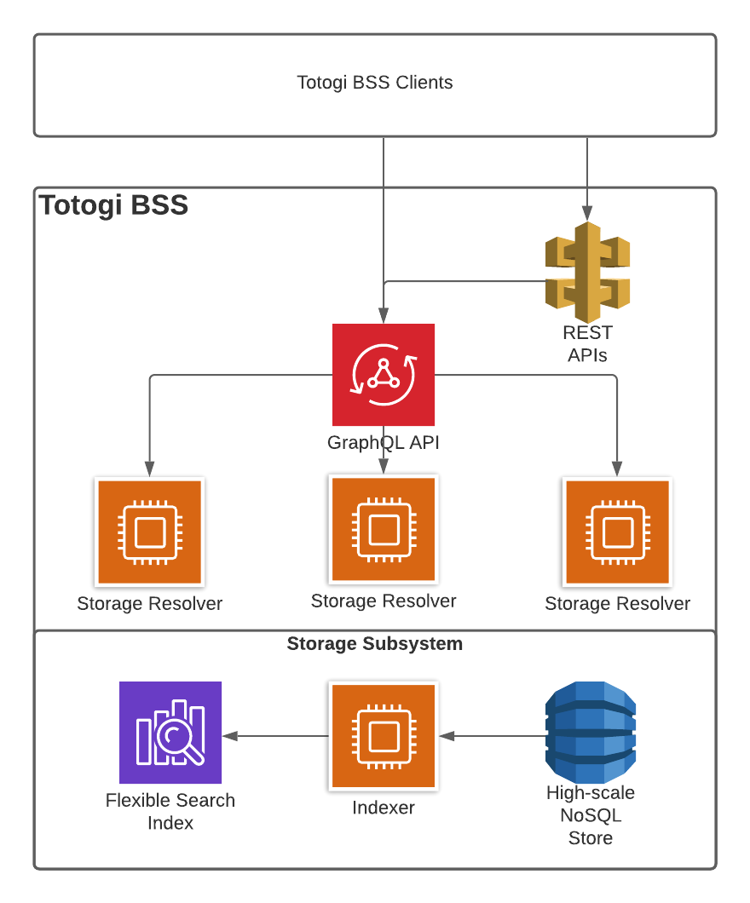

- Test Results

