TM Forum Open APIs
Conformance Certification

Company Name: Totogi

TM Forum Open API Name: Communication API TMF681

TM Forum Open API Release Version: 20.5 / 4.0

Report Date: 3rd June 2021
- What Product or Solution does your API support?

Communication API TMF681 is instantiated within the suite of APIs developed and instantiated in the Totogi BSS. By developing the TM Forum Communication API Totogi BSS enables the standardized mechanisms for the wider management of communication services, enabling the build of OpenAPI compliant applications.

Communication Service Providers (CSPs) are constantly moulding and adapting their platforms to communicate with each other. Every new service or product that is delivered to the market requires change to a vast number of systems. Launch times lag the market need and revenue opportunities are lost.

Furthermore, the CSPs need to retain customers and excite those customers into buying more services. The range of services is expanding and the CSP has to adopt new content and create a more personalised experience that delights the customer and extends the size of wallet the CSP can target.

As the range of services are extended the CSP is forced to upgrade or change existing systems, processes and channels while adding new, complementary platforms to evolve to a Digital Services Provider (DSP).

To facilitate this move to the DSP model the Totogi product suite leverages the power of the public cloud. Why? Because the Hyperscalers are investing billions in delivering the best development, data management and performance tools. Totogi leverages that investment and delivers webscale performance and availability.

Totogi BSS is the public cloud based platform that enables a CSP to drive its evolution to becoming a DSP. As it evolves it will incorporate all the TM Forum APIs and enable the CSP/DSP to deliver new services by building applications in low-code/no-code tools that use the instantiated APIs.

Data Management: All our APIs store data into a TM Forum compliant data structure. This makes the data available via the public cloud and enables any tool to access information through the API mechanism.

Analytics and Reporting: Using Hyperscaler reporting tools the CSP/DSP can rapidly build dashboards and deep analytics on all aspects of their subscribers and their behaviours.

Public Cloud Architecture: By having the data on the public cloud you automatically gain the advantages of backup and disaster recovery that are built into the Hyperscaler platforms.

Rapid Application Development: The CSP/DSP is now freed from vendor product roadmap lifecycle or internal development backlog that prevents solutions being delivered to meet immediate market need. The Totogi BSS allows the CSP/DSP to solve problems rapidly with low-code/no code tools and writing to open standards.

- Overview of Certified API

The Totogi BSS Communication API is a core component of the Totogi BSS APIs, built on the corresponding TM Forum OpenAPI specification, to manage communication services. In this context, communication refers to a capability to create and send communications, notifications, and instructions to Parties, Individuals, Organizations or Users. The Totogi BSS Communication API is compliant with TMF 681 specifications and offers API access to creation, update and retrieval of communication message resources.

# | Resource | API Overview | Operations Supported
1 | communicationMessage | Communication message means a notification approach in the format of a message which can be dispatched (sent) to the certain user by the system with the content which can be felt and understood by the recipient. The user can be either a final customer or a customer service agent. The message can reach the customer in different interaction channels, including: email, short message, mobile app notification (push). | - GET  - PATCH  - POST  - DELETE

- Architectural View
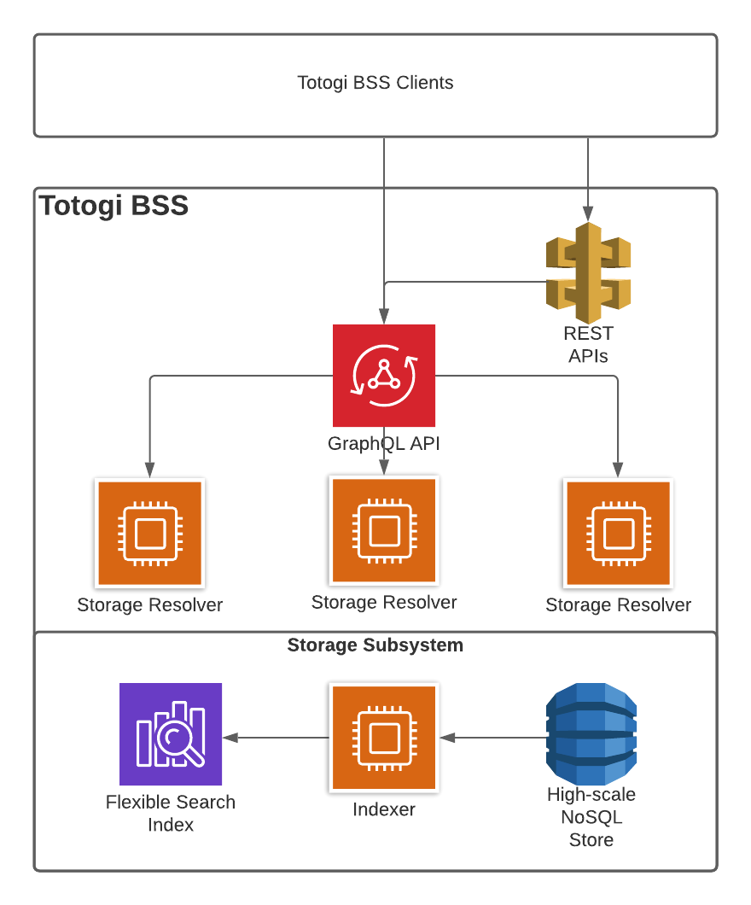

- Test Results

