TM Forum Open APIs
Conformance Certification

Company Name: Comviva Technologies Limited

TM Forum Open API Name: TMF632-PartyManagement API

TM Forum Open API Release Version: R19.0.1/v4.0

Report Date: 22-07-2021

- What Product or Solution does your API support?

Comviva’s BSS suite is a comprehensive and focused business support system that handles an operator's entire set-up, allowing more efficient management of the operator resources, streamlining operational activities and delivering lifetime support to the operator’s network and subscriber base. Utilizing common unified interface across multiple operational activities, the service provider is able to manage the complete mobile subscriber lifecycle. The single, consolidated view of operations provided by Comviva’s BSS suite enables operators to appropriately prioritize subscriber demands and meet subscriber expectations. Via its centralized repository and flexible workflows, Comviva’s BSS suite effectively handles all manner of queries, enhancing customer services, improving customer satisfaction and ultimately enabling a more focused marketing strategy.

Comviva’s BSS suite is an end-to-end Business Support solution, with ability to integrate with the rating and credit management platform including Intelligent Networks, Service Nodes and Hot Billing solutions. It is designed to provide the capability to leverage creative marketing programs to the full, while maximizing the effectiveness of Customer Care. It is designed as a modular system so it will grow alongside each operators expanding service portfolio and support an increasing subscriber base.
Comviva’s BSS suite can be rapidly deployed at and offers an excellent range of features. Some of the basic dimensions that have been taken into account while designing Comviva’s BSS suite include:
- Scalability of software to support the growth plan of service providers
- Ability to interface seamlessly with existing and new applications, protecting investment
- Minimization of revenue loss
- Rapid deployment
- Ability to cater to a wide spectrum of communication
- Easy to learn and faster to use to cut training costs.

Comviva’s BSS suite solution is a leading edge, Provisioning & Customer Care solution that integrates critical business processes and workflows of prepaid operations. Comviva’s BSS suite empowers the Customer Care personnel with the ability to address customer problems, queries and requests effectively and efficiently

- Overview of Certified API

This API provides a standardized mechanism for party management such as creation, update, retrieval, deletion and notification of events.
Party can be an individual or an organization that has any kind of relationship with the enterprise.

It will be used as Partner Management in IPACS which includes creation of partner (e.g. dealer, retailer) which helps in selling all inventories to the end customers.

    - Individual Operations
- List individuals
  - This operation list individuals entities
- Retrieve individual
  - This operation retrieves a individual entity
- Create individual
  - This operation creates a individual entity
- Patch individual
  - This operation allows partial updates of a individual entity

    - Organization Operations
- List organizations
  - This operation list organizations entities
- Retrieve organization
  - This operation retrieves a organization entity
- Create organization
  - This operation creates a organization entity
- Patch organization
  - This operation allows partial updates of a organization entity

- Architectural View

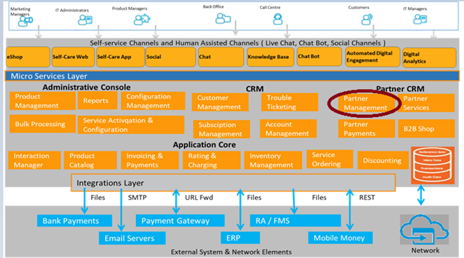

- Test Results

