TM Forum Open APIs
Conformance Certification

Company Name: Oracle Corporation

TM Forum Open API Name:
TMF676 – Payment Management API

TM Forum Open API Release – v20.5 / 4.0

Report Date: 19th July 2021

- What Product or Solution does your API support?

Oracle’s REST Services Manager API product provides various TMF based APIs to interact with BRM (Billing and Revenue Management). BRM is a charging, billing, and revenue management system for communications service providers.

- Overview of Certified API
The TMF676 – Payment Management API provides the standardized client interface to Payment Systems for notifying about performed payments or refunds. It provides API related to creates payments, retrieves payment information, creates refunds and retrieves refund information.

- Architectural View
The following diagram provides an architectural overview of BRM REST Service Manager:

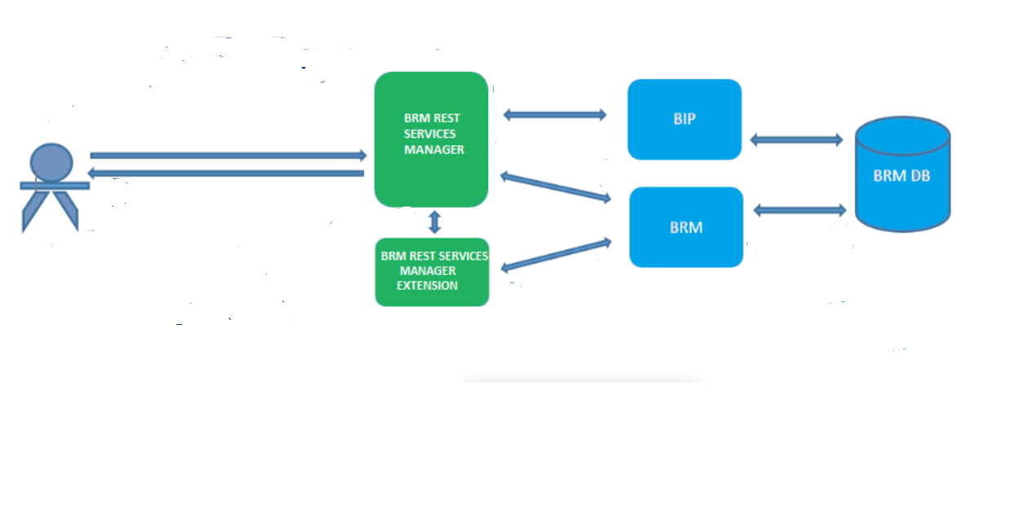

- Test Results

