TM Forum Open APIs
Conformance Certification

Company Name: SATEC

TM Forum Open API Name: Service Catalog - TMF633

TM Forum Open API Release Version: 21.0 / v4.0

Report Date: 14/07/2021

- What Product or Solution does your API support?

Alvatross digital platform is a modular, flexible, cloud-native Open Digital OSS Framework that allows a faster definition and delivery of traditional telco services as well as OTT, Cloud, and IoT services in a converged CSP.

Seamless unify both fixed-line and mobile businesses, ending current constraints that result from non-convergent management of key business objects (clients, products, packages, network resources).

- Ensuring end-to-end integration of the eTOM process defined by the customer, in line with industry operational optimization best practices.
- Service and technology agnostic platform. It allows provisioning orders completion from any channel, across any system stack and any network. From traditional telco services to digitalization challenges, and from classical technologies to new tendencies such as NVF, SDN, IoT.
- Applying open architecture solutions that adhere to industry standards: TM Forum’s Business Process Framework (eTOM) and Information Framework (SID). All our interfaces are aligned with TMF Open API, enabling a simple and fast integration in the CSP ecosystem.
- “Best of Breed” IT Components, from SATEC or its long-term partners. DevOps approach and microservices-based architecture to achieve agile delivery and fast time-to-market.

Components

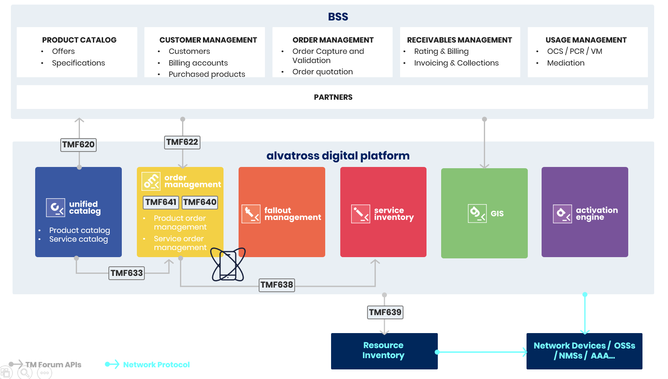

- Unified Catalog: Unified Catalog is a realization of the Cross-domain Catalog Management application in the Service Domain, which allows managing relationships with entities of the customer domain.
- Order Management: Order management gives complete support to the sales/post-sales order fulfillment process by receiving, validating, decomposing, orchestrating, and executing product and service orders.
- Service Inventory: Service inventory keeps and maintains information regarding the service instances. More specifically, it stores and manages both, Customer Facing Services (CFS) and Resource Facing Services (RFS), service relationships, resources in use by the services, service order items related with the services and relationships between services, and products.
- Fallout Management: The Fallout Management application ensures early detection of order failures, which leads to an early correction and provisioning time improvement.
- Activation Engine: Activation engine is the next-generation fully scalable system enabling fast deployment and activation of convergent services including telephony, multimedia delivery, and network access, as well as hybrid domains.
- GIS: GIS is an add-on that complements our fulfillment portfolio and can intervene in the service feasibility phase and can be invoked from the BSS or the order management.
- Resource Inventory: Resource inventory manages the network objects as resources and relations. Resource types can model any network element, both physical and logical. For example, a device, a port, vlan, circuit, or a site are resources and can be managed as resource types in the inventory. Objects have attributes to maintain all information required as part of the model.

- Overview of Certified API

The Alvatross Unified Catalog application owns the Service Catalog Data with its technical details and the relationships with the Product Catalog. This allows the fulfilment and orchestration of service orders guided by the Catalog configuration. To do so, it provides the TMF633 Open API to be consumed by any external system, but mostly used by the Service Order Management component during the service order fulfilment process.

The actions available in the Unified Catalog application through the TMF633 API are the following:

- Create service specifications.
- Update service specifications.
- Search and enquiry service specifications.
- Delete service specifications.

- Architectural View

Alvatross digital platform has been architected to be driven by the company’s catalog, integrated, and built on open standards technology, emphasising collaborative tools that allow product managers, fulfilment designers, and others to collectively work on the master model and fulfilment strategies.

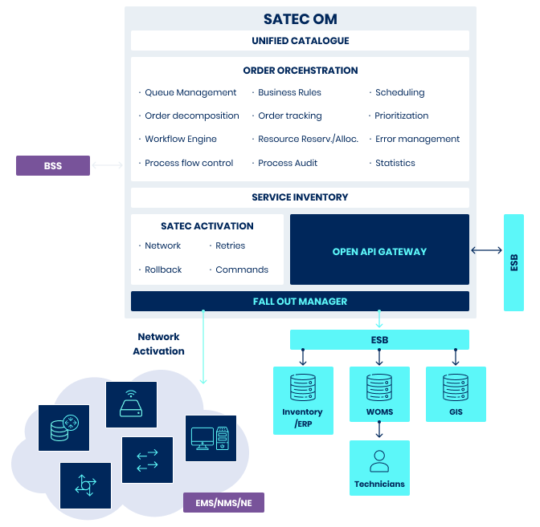

The key characteristics of a truly next-generation OSS platform are:
- Service and technology agnostic Enterprise Catalog-driven solution that enables service providers to build complex service bundles.
- Comprehensive catalog to ensure that the business rules for products, services, and resources (whether commercial or technical) are accurately utilized during fulfilment.
- Unified end-to-end product, service, and resource Catalog model along with associated fulfilment configurations from a single application.
- The product catalog can be used in read-only mode, based on the integration with third-party product Catalogs and product inventory (typically CRM systems).
- It enables collaboration between Product Managers, Fulfilment Designers, and Network Specialists.
- Providing full-service life cycle modelling, validation, decomposition. Order decomposition in CFS/RFSs and order execution plan based on catalog definition and business rules.
- Definition and orchestration of the provisioning flow for every service.
- Accessing the orchestration flows graphically from a web interface for consultation or modification. The easy-to-maintain library of processes can be managed by the technical team, which makes Alvatross digital platform a non-vendor-locking solution.
- Full end-to-end visualization of provisioning orders, from the business (product, offers) to the network (activation commands).
- Service activation via activation engine that can access the network elements and NMSs or work in a proxy mode by sending the activation orders to third-party activators for network element provisioning.
- Services inventory results from provisioning orders consolidation. It provides a 360º view of the customer services, from the business (product order) to the network (assigned resources).
- Compliant to industry standards like:
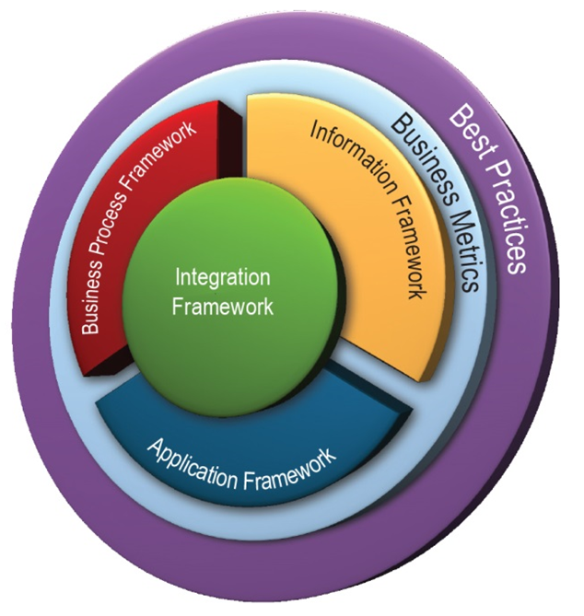
  - TM Forum Frameworx, including Business Process (eTOM), Information model (SIT), and Application (TAM).
  - OMG Business Process Modelling & Notation (BPMNv2) in all workflow modelling for both business and technical workflows.
  - Conformant with TM Forum Open APIs.

- Modern microservices cloud-native architecture, available both on-premise and on private/public cloud, brings, among others, the following benefits:
- Rapid deployment and set-up (weeks vs months).
- Modular and flexible, it allows fast and simple integration in the CSP ecosystem through an extensive repository of Open APIs.
- Highly scalable and performant, it supports large quantities and complex daily orders, including real-time scalability, to manage increased volumes. Completely automatic fulfilment workflows can run in just seconds.
- Cost-efficient and automated business processes reduce overall operational costs and back-office intervention.

- Test Results

