TM Forum Open APIs
Conformance Certification

Company Name: Inspur Technologies Co. Ltd

TM Forum Open API Name:
Party Management API

TM Forum Open API Release Version: 19.0 / 4.0

Report Date: 08-Sept-2021

- What Product or Solution does your API support?

Inspur IBS (Intelligent Business System) support customer-related business process for Telco, accelerate the business fulfillment. The integrated solution complying TMF standards and applying to various industrial business scenarios. It help operators to improve business management efficiency via qualified and proven technical capabilities of platform, big data, AI and applications.

The core module provides Account Management, Offer Management, Billing Management, and Payment Management
IBS detail architecture function are shown as follow:

- Rating & Charging Management
- Balance Management
- SLA Management
- Billing Management
- Payment Management
- Offer Management
- Custom Account Management
- Party Management

The Customer Management API provides an interaction interface which the external systems and the third-parties can access such capabilities via this exposed API.

- Overview of Certified API

Operations on Service: List individuals, Retrieve individual, Create individual, Patch individual, Delete individual.

- Architectural View

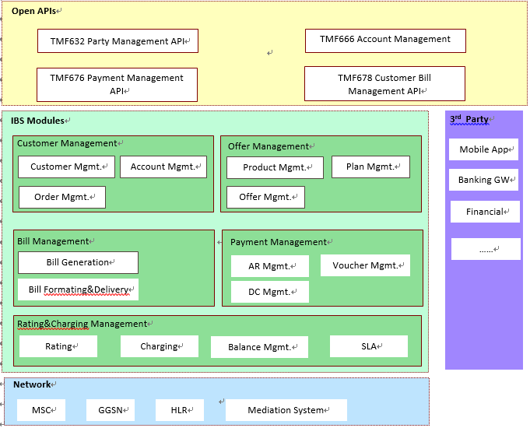

- Test Results

