s
TM Forum Open APIs
Conformance Certification

Company Name: Comviva Technologies Limited

TM Forum Open API Name:
TMF620-Product Catalog Management API

TM Forum Open API Release Version: 21.0 / 4.1

Report Date: 24 September, 2021

- What Product or Solution does your API support?

Comviva’s BSS suite is a comprehensive and focused business support system that handles an operator's entire set-up, allowing more efficient management of the operator resources, streamlining operational activities and delivering lifetime support to the operator’s network and subscriber base. Utilizing common unified interface across multiple operational activities, the service provider is able to manage the complete mobile subscriber lifecycle. The single, consolidated view of operations provided by Comviva’s BSS suite enables operators to appropriately prioritize subscriber demands and meet subscriber expectations. Via its centralized repository and flexible workflows, Comviva’s BSS suite effectively handles all manner of queries, enhancing customer services, improving customer satisfaction and ultimately enabling a more focused marketing strategy.

Comviva’s BSS suite is an end-to-end Business Support solution, with ability to integrate with the rating and credit management platform including Intelligent Networks, Service Nodes and Hot Billing solutions. It is designed to provide the capability to leverage creative marketing programs to the full, while maximizing the effectiveness of Customer Care. It is designed as a modular system so it will grow alongside each operators expanding service portfolio and support an increasing subscriber base.
Comviva’s BSS suite can be rapidly deployed at and offers an excellent range of features. Some of the basic dimensions that have been taken into account while designing Comviva’s BSS suite include:

- Scalability of software to support the growth plan of service providers
- Ability to interface seamlessly with existing and new applications, protecting investment
- Minimization of revenue loss
- Rapid deployment
- Ability to cater to a wide spectrum of communication
- Easy to learn and faster to use to cut training costs.

Comviva’s BSS suite solution is a leading edge, Provisioning & Customer Care solution that integrates critical business processes and workflows of prepaid operations. Comviva’s BSS suite empowers the Customer Care personnel with the ability to address customer problems, queries and requests effectively and efficiently

- Overview of Certified API

Product Catalog Management API will be used in iPACS to create and retrieve Service and Commercial Product Offers into central catalogue as well as distributed catalogues hosted by systems such as billing, OCS, PCRF, Partner systems.

The catalogue API can push the complete product offer to channels and create the individual system price list in distributed catalogues. Partners can also control the lifecycle and product details through this API through use of this API.

    - Operations on Catalog
- List catalogs
  - This operation list catalogs entities
- Retrieve catalog
  - This operation retrieves a catalog entity
- Create catalog
  - This operation creates a catalog entity
- Patch catalog
  - This operation allows partial updates of a catalog entity
- Delete catalog
  - This operation deletes a catalog entity

    - Operations on Category
- List categories
  - This operation list categories entities
- Retrieve category
  - This operation retrieves a category entity
- Create category
  - This operation creates a category entity
- Patch category
  - This operation allows partial updates of a category entity
- Delete category
  - This operation deletes a category entity

    - Operations on Product Offering
- List product offerings
  - This operation list product offerings entities
- Retrieve product offering
  - This operation retrieves a product offering entity
- Create product offering
  - This operation creates a product offering entity
- Patch product offering
  - This operation allows partial updates of a product offering entity
- Delete product offering
  - This operation deletes a product offering entity

    - Operations on Product Offering Price
- List product offering prices
  - This operation list product offering prices entities
- Retrieve product offering price
  - This operation retrieves a product offering price entity
- Create product offering price
  - This operation creates a product offering price entity
- Patch product offering price
  - This operation allows partial updates of a product offering price entity
- Delete product offering price
  - This operation deletes a product offering price entity

    - Operations on Product Specification
- List product specifications
  - This operation list product specifications entities
- Retrieve product specification
  - This operation retrieves a product specification entity
- Create product specification
  - This operation creates a product specification entity
- Patch product specification
  - This operation allows partial updates of a product specification entity
- Delete product specification
  - This operation deletes a product specification entity

    - Operations on Import Job
- List import jobs
  - This operation list import jobs entities
- Retrieve import job
  - This operation retrieves a import job entity
- Create import job
  - This operation creates a import job entity
- Patch import job
  - This operation allows partial updates of a import job entity
- Delete import job
  - This operation deletes a import job offering entity

    - Operations on Export Job
- List export jobs
  - This operation list export jobs entities
- Retrieve export job
  - This operation retrieves a export job entity
- Create export job
  - This operation creates a export job entity
- Patch export job
  - This operation allows partial updates of a export job entity
- Delete export job
  - This operation deletes a export job offering entity

- Architectural View

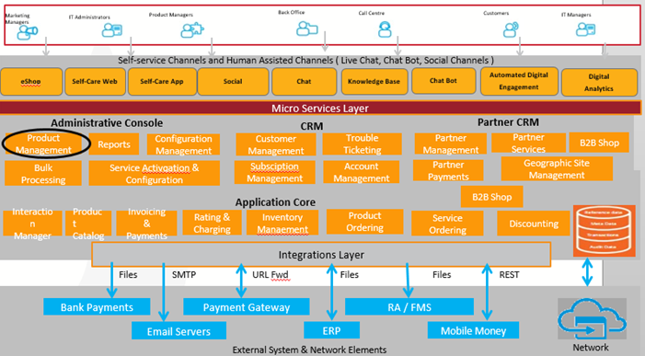

- Test Results

