TM Forum Open APIs
Conformance Certification

Company Name: Tata Consultancy Services

TM Forum Open API Name:
Product Inventory Management – TMF637

TM Forum Open API Release Version: 19.0 / 4.0

Report Date: 22-SEP-2021

- What Product or Solution does your API support?

TCS HOBS is a platform for new age digital services as well as traditional telco services. The cloud-ready platform is secure and scalable. It covers key business processes across multi-channel engagement, product management, selling, assurance, revenue management, partner management, and enterprise management. Our platform is catalog-centric, metadata-driven, and modular, which helps companies leverage modules and capabilities, based on business requirements

- Overview of Certified API
The Product Inventory GET API retrieves the product resources. A product is any instance of product offering subscribed by a customer. The api retrieves the products, configuration characteristics and other pricing information.

- Architectural View

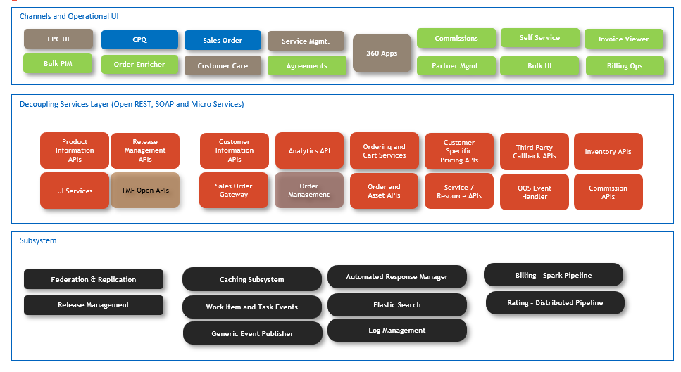

- Test Results

