TM Forum Open APIs
Conformance Certification

Company Name: Tata Consultancy Services

TM Forum Open API Name:
Customer Bill Management - TMF678

TM Forum Open API Release Version: 20.5 / 4.0

Report Date: 29 September, 2021

- What Product or Solution does your API support?

TCS HOBS is a platform for new age digital services as well as traditional telco services. The cloud-ready platform is secure and scalable. It covers key business processes across multi-channel engagement, product management, selling, assurance, revenue management, partner management, and enterprise management. Our platform is catalog-centric, metadata-driven, and modular, which helps companies leverage modules and capabilities, based on business requirements

- Overview of Certified API

This API allows to find and retrieve one or several customer bills (also called invoices) produced for a customer. It represents a total amount due for all the products during the billing period and all significant information like dates, bill reference. The API model support the needs for the three basic billing types : postpaid periodical bill, postpaid real-time bill and prepaid real-time bill.
This API also provides operations to find and retrieve the details of applied customer billing rates presented on a customer bill. This API also allows to request in real-time a customer bill creation and to manage this request.

- Architectural View
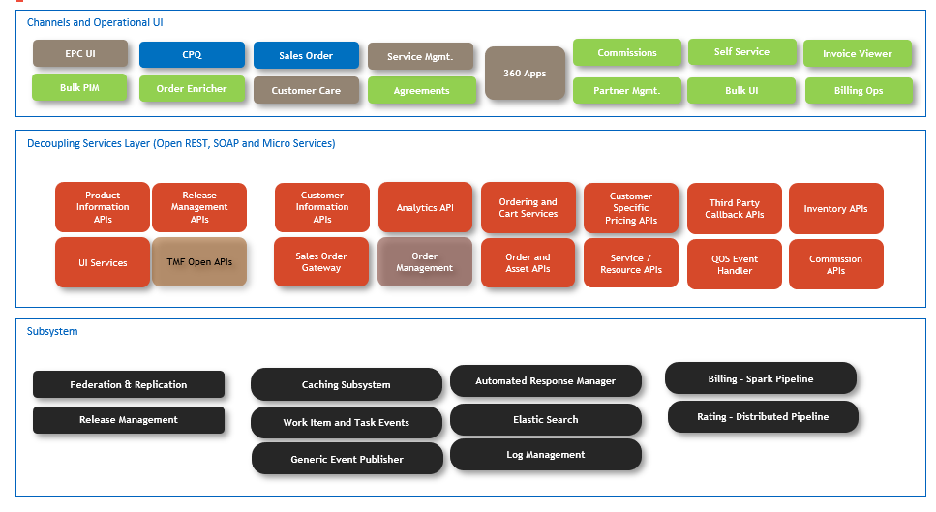

- Test Results

