TM Forum Open APIs
Conformance Certification

Company Name: Totogi

TM Forum Open API Name:
Usage Management API TMF635

TM Forum Open API Release Version: 20.5 / 4.0

Report Date: September 1, 2021
- What Product or Solution does your API support?

Usage Management API TMF635 is one of the TM Forum APIs the Totogi BSS has instantiated. With this deployment Totogi BSS delivers a standard mechanism for management of both rated and non-rated usages retrieved from or provided to partners, integrating with the Totogi Charging Engine, our web-scale real-time convergent charging engine designed and engineered from the ground up to leverage public cloud.

Communication Service Providers (CSPs) are constantly moulding and adapting their platforms to communicate with each other. Every new service or product that is delivered to the market requires change to a vast number of systems. Launch times lag the market need and revenue opportunities are lost.

Furthermore, the CSPs need to retain customers and excite those customers into buying more services. The range of services is expanding and the CSP has to adopt new content and create a more personalised experience that delights the customer and extends the size of wallet the CSP can target.

As the range of services are extended the CSP is forced to upgrade or change existing systems, processes and channels while adding new, complementary platforms to evolve to a Digital Services Provider (DSP).

To facilitate this move to the DSP model the Totogi product suite leverages the power of the public cloud. Why? Because the Hyperscalers are investing billions in delivering the best development, data management and performance tools. Totogi leverages that investment and delivers webscale performance and availability.

Totogi BSS is the public cloud based platform that enables a CSP to drive its evolution to becoming a DSP. As it evolves it will incorporate all the TM Forum APIs and enable the CSP/DSP to deliver new services by building applications in low-code/no-code tools that use the instantiated APIs.

Data Management: All our APIs store data into a TM Forum compliant data structure. This makes the data available via the public cloud and enables any tool to access information through the API mechanism.

Analytics and Reporting: Using Hyperscaler reporting tools the CSP/DSP can rapidly build dashboards and deep analytics on all aspects of their subscribers and their behaviours.

Public Cloud Architecture: By having the data on the public cloud you automatically gain the advantages of backup and disaster recovery that are built into the Hyperscaler platforms.

Rapid Application Development: The CSP/DSP is now freed from vendor product roadmap lifecycle or internal development backlog that prevents solutions being delivered to meet immediate market need. The Totogi BSS allows the CSP/DSP to solve problems rapidly with low-code/no code tools and writing to open standards.

- Overview of Certified API

The Totogi BSS Usage Management API provides a standardized mechanism for management of both rated and non-rated usages allowing the service provider:
- To retrieve usage generated by a partner service platform in order to rate it.
- To provide rated usages to a partner for their consumption.

The Totogi BSS Usage Management API is compliant with TMF635 specification and offers API access to creation, update, retrieval, import and export of a usage as well as the usage specification that describes the characteristics of a particular usage.

# | Resource | API Overview | Operations Supported
1 | Usage | An occurrence of employing a Product, Service, or Resource for its intended purpose, which is of interest to the business and can have charges applied to it. It is comprised of characteristics, which represent attributes of usage. | - GET  - PATCH  - POST  - DELETE
2 | Usage Specification | A detailed description of a usage event that is of interest to the business and can have charges applied to it. It is comprised of characteristics, which define all attributes known for a particular type of usage. | - GET  - PATCH  - POST  - DELETE

- Architectural View
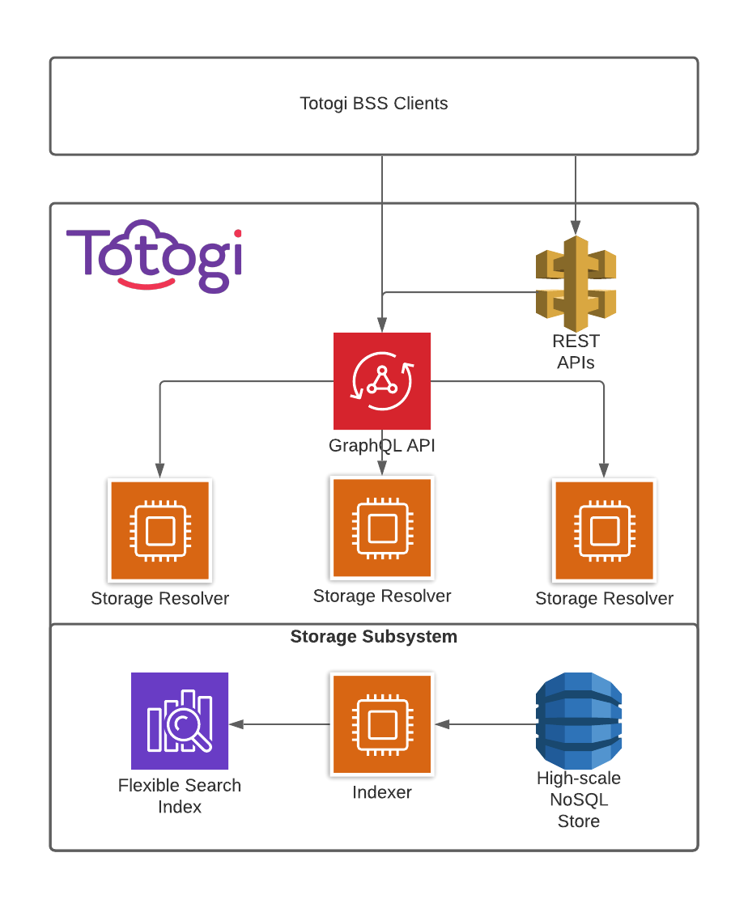

- Test Results

