TM Forum Open APIs
Conformance Certification

Company Name: Totogi

TM Forum Open API Name:
Prepay Balance Management API TMF654

TM Forum Open API Release Version: 20.5 / 4.0

Report Date: September 6, 2021
- What Product or Solution does your API support?

Prepay Balance Management API TMF654 is one of the TM Forum APIs the Totogi BSS has instantiated. With this deployment Totogi BSS delivers a standard mechanism for management and tracking of balances required by Prepay users to use services. Totogi BSS integrates with the Totogi Charging Engine, our web-scale real-time convergent charging engine designed and engineered from the ground up to leverage public cloud, to perform the required set of actions on top of the balances.

Communication Service Providers (CSPs) are constantly moulding and adapting their platforms to communicate with each other. Every new service or product that is delivered to the market requires change to a vast number of systems. Launch times lag the market need and revenue opportunities are lost.

Furthermore, the CSPs need to retain customers and excite those customers into buying more services. The range of services is expanding and the CSP has to adopt new content and create a more personalised experience that delights the customer and extends the size of wallet the CSP can target.

As the range of services are extended the CSP is forced to upgrade or change existing systems, processes and channels while adding new, complementary platforms to evolve to a Digital Services Provider (DSP).

To facilitate this move to the DSP model the Totogi product suite leverages the power of the public cloud. Why? Because the Hyperscalers are investing billions in delivering the best development, data management and performance tools. Totogi leverages that investment and delivers webscale performance and availability.

Totogi BSS is the public cloud based platform that enables a CSP to drive its evolution to becoming a DSP. As it evolves it will incorporate all the TM Forum APIs and enable the CSP/DSP to deliver new services by building applications in low-code/no-code tools that use the instantiated APIs.

Data Management: All our APIs store data into a TM Forum compliant data structure. This makes the data available via the public cloud and enables any tool to access information through the API mechanism.

Analytics and Reporting: Using Hyperscaler reporting tools the CSP/DSP can rapidly build dashboards and deep analytics on all aspects of their subscribers and their behaviours.

Public Cloud Architecture: By having the data on the public cloud you automatically gain the advantages of backup and disaster recovery that are built into the Hyperscaler platforms.

Rapid Application Development: The CSP/DSP is now freed from vendor product roadmap lifecycle or internal development backlog that prevents solutions being delivered to meet immediate market need. The Totogi BSS allows the CSP/DSP to solve problems rapidly with low-code/no code tools and writing to open standards.

- Overview of Certified API

The Totogi BSS Prepay Balance Management API provides a standardized mechanism for management of balances of Prepay users. The Totogi BSS Prepay Balance Management API is compliant with TMF654 specification and offers API access to creation, update, retrieval and deletion of bucket and balance resources.

# | Resource | API Overview | Operations Supported
1 | Bucket | A bucket represents and tracks a quantity of usage (remaining or consumed). It could be either a quantity or an amount in a currency. It can represent a fixed number of SMS,MMS,call minutes, quantity of data and so on. | - GET  - POST  - DELETE
2 | Top Up Balance | Represents a detailed description of a recharge operation requested over a bucket (defined by a specific product or reference to a product (i.e.: a commercial id such as an msisidn and a service type). | - GET  - PATCH  - POST  - DELETE
3 | Adjust Balance | The AdjustBalance resource allows adjustments to be made to the original BalanceTopup e.g. increment the amount, alter the recharge periodicity. | - GET  - PATCH  - POST  - DELETE
4 | Reserve Balance | The ReserveBalance resource allows adjustments to be made to the original BalanceTopup e.g., increment the amount, alter the recharge periodicity. | - GET  - PATCH  - POST  - DELETE

- Architectural View
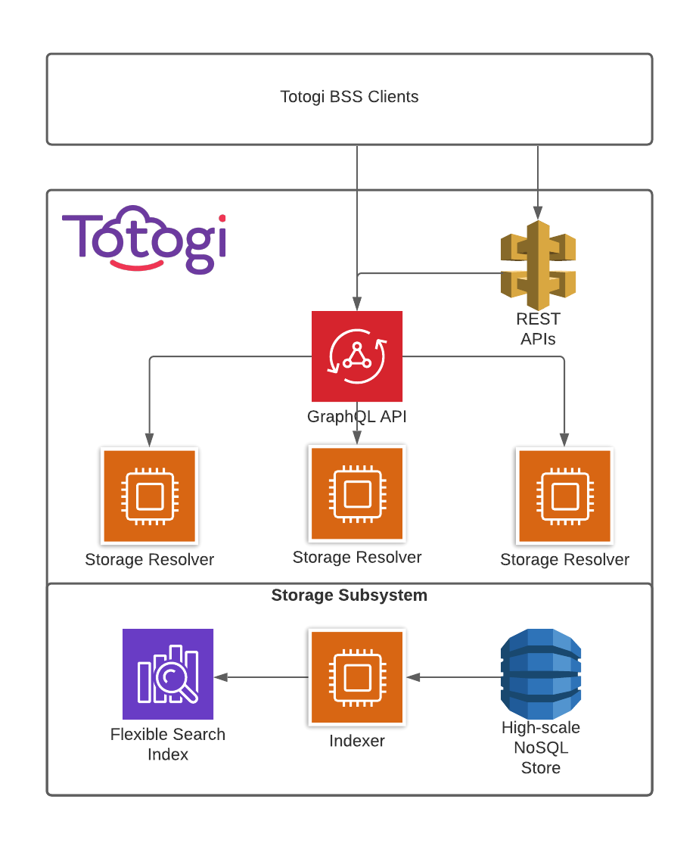

- Test Results

