TM Forum Open APIs
Conformance Certification

Company Name: Totogi

TM Forum Open API Name:
Stock Management API TMF687

TM Forum Open API Release Version: 21.0 / V4.0

Report Date: 2nd September 2021
- What Product or Solution does your API support?

The Totogi BSS has encapsulated and instantiated the Stock Management API TMF687 enabling standardized mechanisms for the wider management of stock.

Communication Service Providers (CSPs) are constantly moulding and adapting their platforms to communicate with each other. Every new service or product that is delivered to the market requires change to a vast number of systems. Launch times lag the market need and revenue opportunities are lost.

Furthermore, the CSPs need to retain customers and excite those customers into buying more services. The range of services is expanding and the CSP has to adopt new content and create a more personalised experience that delights the customer and extends the size of wallet the CSP can target.

As the range of services are extended the CSP is forced to upgrade or change existing systems, processes and channels while adding new, complementary platforms to evolve to a Digital Services Provider (DSP).

To facilitate this move to the DSP model the Totogi product suite leverages the power of the public cloud. Why? Because the Hyperscalers are investing billions in delivering the best development, data management and performance tools. Totogi leverages that investment and delivers webscale performance and availability.
Totogi BSS is the public cloud based platform that enables a CSP to drive its evolution to becoming a DSP. As it evolves it will incorporate all the TMForum APIs and enable the CSP/DSP to deliver new services by building applications in low-code/no-code tools that use the instantiated APIs.

Data Management: All our APIs store data into a TM Forum compliant data structure. This makes the data available via the public cloud and enables any tool to access information through the API mechanism.

Analytics and Reporting: Using Hyperscaler reporting tools the CSP/DSP can rapidly build dashboards and deep analytics on all aspects of their subscribers and their behaviours.

Public Cloud Architecture: By having the data on the public cloud you automatically gain the advantages of backup and disaster recovery that are built into the Hyperscaler platforms.

Rapid Application Development: The CSP/DSP is now freed from vendor product roadmap lifecycle or internal development backlog that prevents solutions being delivered to meet immediate market need. The Totogi BSS allows the CSP/DSP to solve problems rapidly with low-code/no code tools and writing to open standards.

- Overview of Certified API

The Totogi BSS Stock Management API is functionality in the core Totogi BSS APIs to provide a standardized mechanism for product stock management. The Totogi BSS Stock Management API is compliant with TMF687 specification and offers API access to creation, update and retrieval of a product stock or reservation, query and adjustment of it.

# | Resource | API Overview | Operations Supported
1 | Product Stock | ProductStock is a base class for defining a product (or configured product with values characteristic) stock level. | - GET  - POST  - PATCH  - DELETE
2 | Adjust Product Stock | AdjustProductStock is used to log and execute on or several Product Stock level changes. | - GET  - POST
3 | Check Product Stock | CheckProductStock is used to log and execute checks about product stock availability. | - GET  - POST
4 | Reserve Product Stock | ReserveProductStock is used to request a product stock reservation. | - GET  - POST
5 | Query Product Stock | QueryProductStock is used to query product stock availability. | - GET  - POST

- Architectural View
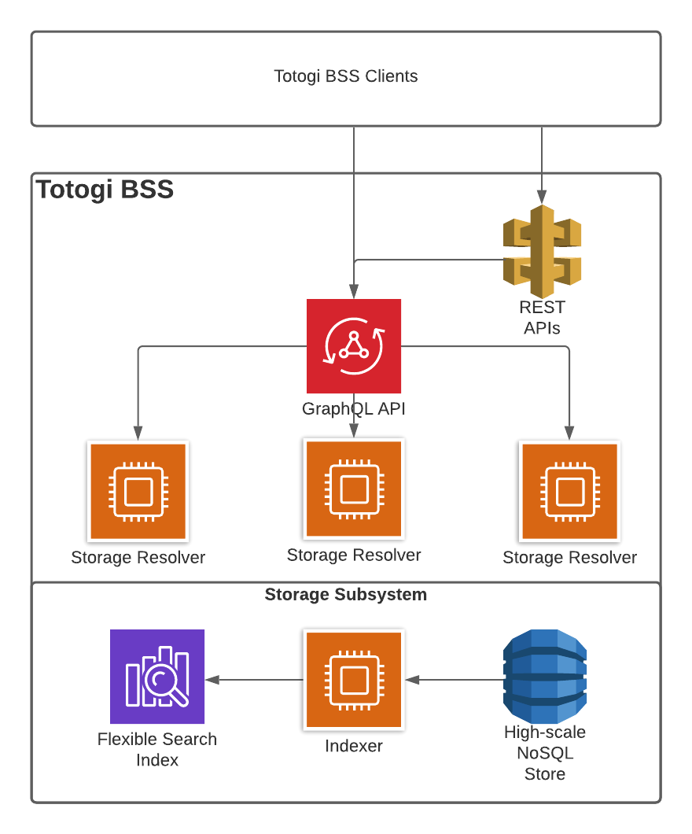

- Test Results

