TM Forum Open APIs
Conformance Certification

Company Name: Totogi

TM Forum Open API Name:
AI Management API TMF915

TM Forum Open API Release Version: 20.5 / 4.0

Report Date: 1st September, 2021
- What Product or Solution does your API support?

The Totogi BSS has encapsulated and instantiated the AI Management API TMF915 enabling standardized mechanisms for the wider management of AI Use Cases.

Communication Service Providers (CSPs) are constantly moulding and adapting their platforms to communicate with each other. Every new service or product that is delivered to the market requires change to a vast number of systems. Launch times lag the market need and revenue opportunities are lost.

Furthermore, the CSPs need to retain customers and excite those customers into buying more services. The range of services is expanding and the CSP has to adopt new content and create a more personalised experience that delights the customer and extends the size of wallet the CSP can target.

As the range of services are extended the CSP is forced to upgrade or change existing systems, processes and channels while adding new, complementary platforms to evolve to a Digital Services Provider (DSP).

To facilitate this move to the DSP model the Totogi product suite leverages the power of the public cloud. Why? Because the Hyperscalers are investing billions in delivering the best development, data management and performance tools. Totogi leverages that investment and delivers webscale performance and availability.
Totogi BSS is the public cloud based platform that enables a CSP to drive its evolution to becoming a DSP. As it evolves it will incorporate all the TM Forum APIs and enable the CSP/DSP to deliver new services by building applications in low-code/no-code tools that use the instantiated APIs.

Data Management: All our APIs store data into a TM Forum compliant data structure. This makes the data available via the public cloud and enables any tool to access information through the API mechanism.

Analytics and Reporting: Using Hyperscaler reporting tools the CSP/DSP can rapidly build dashboards and deep analytics on all aspects of their subscribers and their behaviours.

Public Cloud Architecture: By having the data on the public cloud you automatically gain the advantages of backup and disaster recovery that are built into the Hyperscaler platforms.

Rapid Application Development: The CSP/DSP is now freed from vendor product roadmap lifecycle or internal development backlog that prevents solutions being delivered to meet immediate market need. The Totogi BSS allows the CSP/DSP to solve problems rapidly with low-code/no code tools and writing to open standards.

- Overview of Certified API

The Totogi BSS AI Management API is functionality in the core Totogi BSS APIs to provide a mechanism for management of in-life aspects of AI and in particular on the management of ‘model contracts’. The Totogi BSS AI Management API is compliant with TMF915 Specification.

# | Resource | API Overview | Operations Supported
1 | Ai Contract Specification | A template of an agreement that can be used when establishing partnerships. | - GET  - PATCH  - POST  - DELETE
2 | AI Model | AiModel is a base class for defining the AiModel hierarchy. | - GET  - PATCH  - POST  - DELETE
3 | Ai Model Specification | AiModelSpecification is a class that offers characteristics to describe a type of service. Functionally, it acts as a template by which Services may be instantiated. By sharing the same specification, these services would therefore share the same set of characteristics. | - GET  - PATCH  - POST  - DELETE
4 | Ai Contract | An Ai Contract represents a contract or arrangement, either written or verbal and sometimes enforceable by law, such as a service level agreement or a customer price agreement. An agreement involves a number of other business entities, such as products, services, and resources and/or their specifications. | - GET  - PATCH  - POST  - DELETE
5 | Ai Contract Violation | Ai Contract Violation Resource | - GET  - PATCH  - POST  - DELETE
6 | Alarm | This resource represents an alarm supporting the information model defined in ITU-T X.733. | - GET  - PATCH  - POST  - DELETE
7 | Rule | Rule Resource | - GET  - PATCH  - POST  - DELETE

- Architectural View
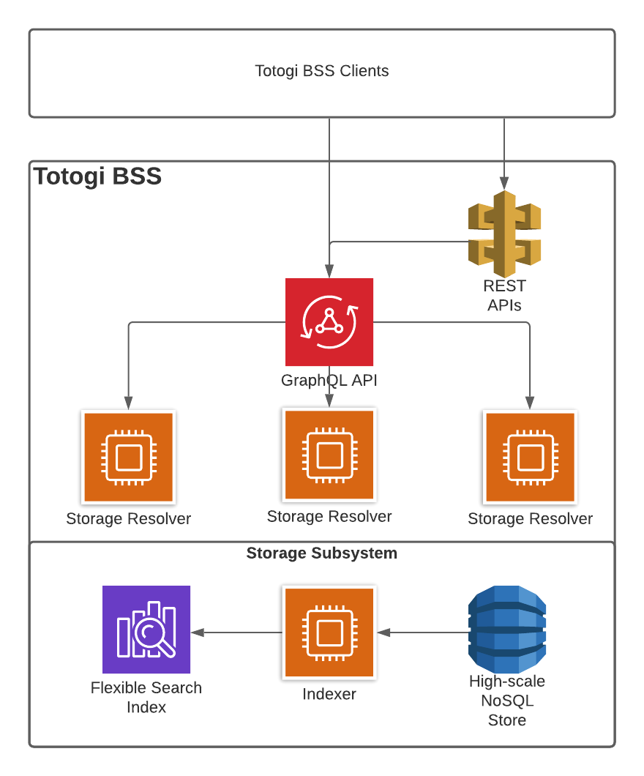

- Test Results

