TM Forum Open APIs
Conformance Certification

Company Name: commercetools

TM Forum Open API Name:
Product Catalog Management

TM Forum Open API Release Version: 21.0 / 4.1

Report Date: 21 Oct 2021

- What Product or Solution does your API support?

This API is part of the commerce API platform allowing products to be added to an existing product catalog.

- Overview of Certified API

Provides a standardized solution for rapidly adding partners’ products to an existing Catalog. It brings the capability for Service Providers to directly feed partners systems with the technical description of the products they propose to them.

- Architectural View

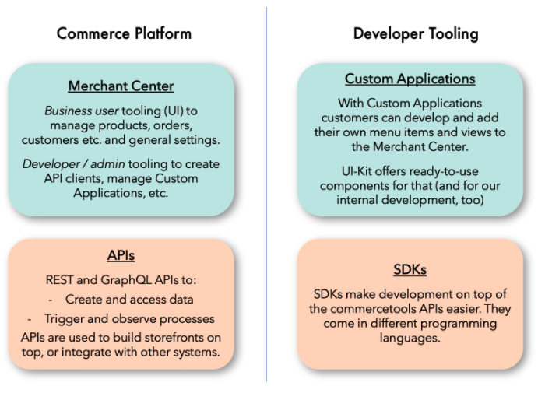
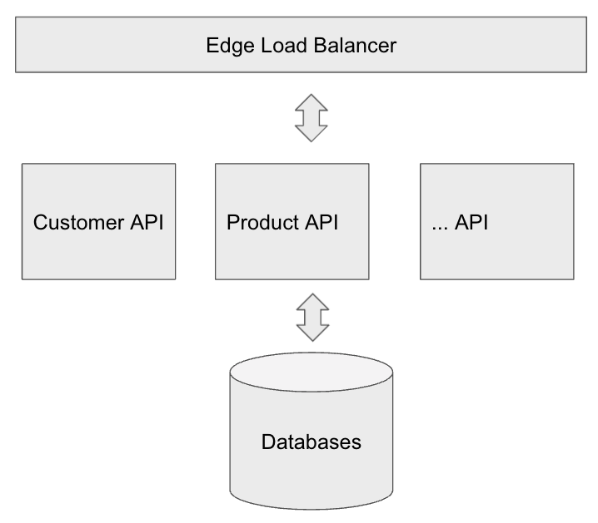

- Test Results

