TM Forum Open APIs
Conformance Certification

Company Name: commercetools

TM Forum Open API Name:
Product Inventory Management

TM Forum Open API Release Version: 19.0 / 4.0

Report Date: 21 Oct 2021

- What Product or Solution does your API support?

This API is part of the commerce API platform allowing product inventory or product lifecycle information about any product to be called/displayed for any use case.

- Overview of Certified API

Provides standardized mechanism for product inventory management such as creation, partial or full update and retrieval of the representation of a product in the inventory. It also allows the notification of events related to product lifecycle.

- Architectural View

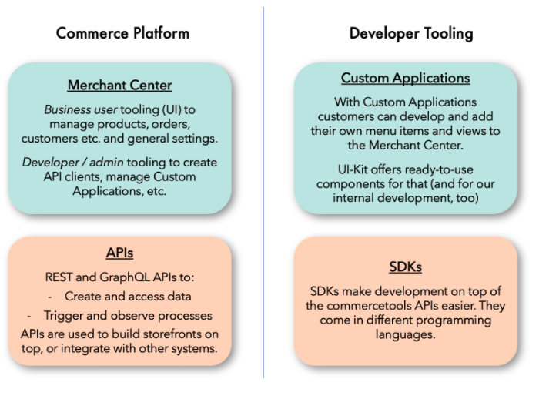
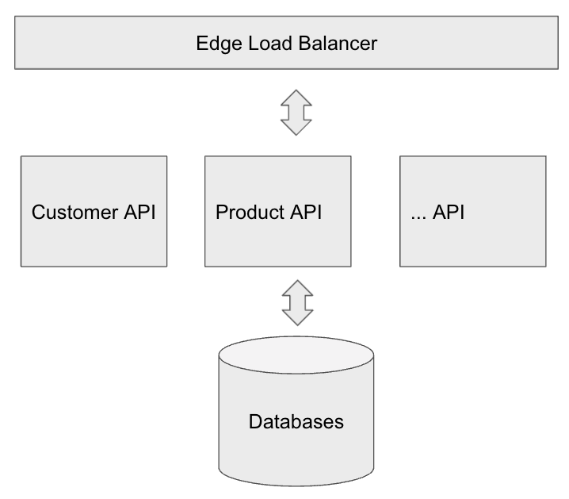

- Test Results

