TM Forum Open APIs
Conformance Certification

Company Name: commercetools

TM Forum Open API Name:
Shopping Cart API

TM Forum Open API Release Version: 19.0 / 4.0

Report Date: 21 Oct 2021

- What Product or Solution does your API support?

This API is part of the commerce API platform allowing shopping carts to be managed as a temporary state before the cart becomes an order.

- Overview of Certified API

A standardized mechanism for the management of shopping carts. Including creation, update, retrieval, deletion and notification of an event. Shopping Cart entity is used for the temporary selection and reservation of product offerings in e-commerce and retail purchase.

- Architectural View

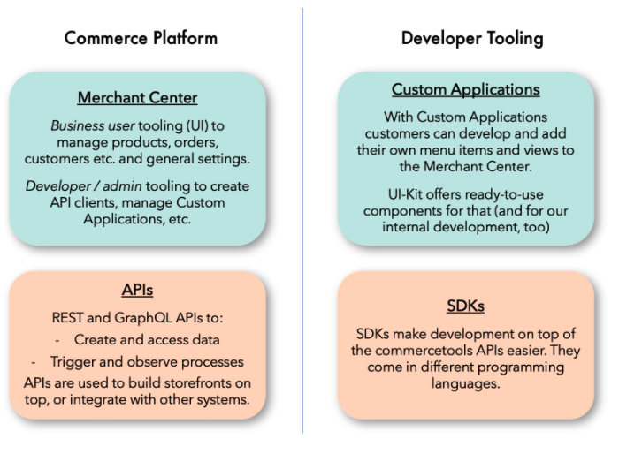
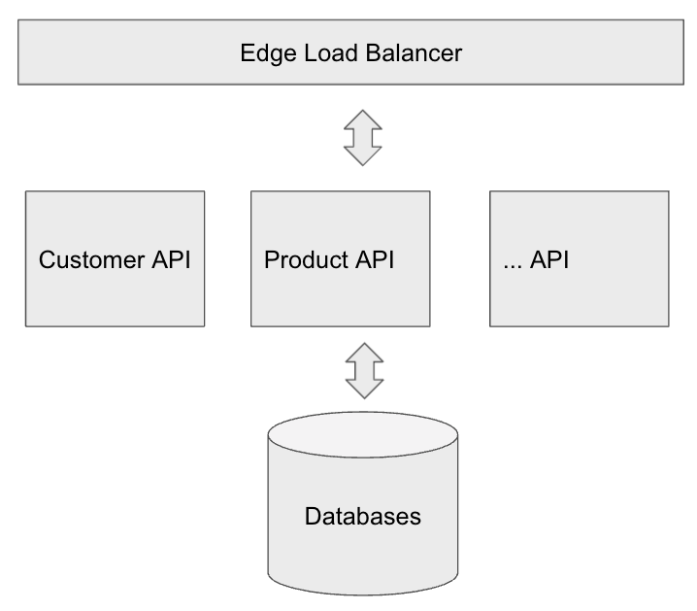

- Test Results

