TM Forum Open APIs
Conformance Certification

Company Name: Comviva Technologies Limited

TM Forum Open API Name:
TMF648 Quote Management API

TM Forum Open API Release Version: 19.0 / 4.0

Report Date: 13-10-2021

- What Product or Solution does your API support?

Comviva’s BSS suite is a comprehensive and focused business support system that handles an operator's entire set-up, allowing more efficient management of the operator resources, streamlining operational activities and delivering lifetime support to the operator’s network and subscriber base. Utilizing common unified interface across multiple operational activities, the service provider is able to manage the complete mobile subscriber lifecycle. The single, consolidated view of operations provided by Comviva’s BSS suite enables operators to appropriately prioritize subscriber demands and meet subscriber expectations. Via its centralized repository and flexible workflows, Comviva’s BSS suite effectively handles all manner of queries, enhancing customer services, improving customer satisfaction and ultimately enabling a more focused marketing strategy.

Comviva’s BSS suite is an end-to-end Business Support solution, with ability to integrate with the rating and credit management platform including Intelligent Networks, Service Nodes and Hot Billing solutions. It is designed to provide the capability to leverage creative marketing programs to the full, while maximizing the effectiveness of Customer Care. It is designed as a modular system so it will grow alongside each operators expanding service portfolio and support an increasing subscriber base.
Comviva’s BSS suite can be rapidly deployed at and offers an excellent range of features. Some of the basic dimensions that have been taken into account while designing Comviva’s BSS suite include:

- Scalability of software to support the growth plan of service providers
- Ability to interface seamlessly with existing and new applications, protecting investment
- Minimization of revenue loss
- Rapid deployment
- Ability to cater to a wide spectrum of communication
- Easy to learn and faster to use to cut training costs.

Comviva’s BSS suite solution is a leading edge, Provisioning & Customer Care solution that integrates critical business processes and workflows of prepaid operations. Comviva’s BSS suite empowers the Customer Care personnel with the ability to address customer problems, queries and requests effectively and efficiently

- Overview of Certified API

This API can be used to negotiate service and product acquisition or modification between a customer and a service provider. Quote contain list of quote items, a reference to customer (party Role), a list of product Offering and attached prices and conditions.

As a part of B2B offerings for complex services like ICT, SDWAN, or Managed Connectivity, there is a quote process needed that allows operator business teams to customize the Commercial as well as service aspect of catalogue to convert a B2B lead into a B2B account.

Quote Management API will be add-on for Product Catalogue API so that B2B specific offers and quote offer versions can be created.

    - Operations on Quotes

- List quotes
  - This operation list quotes entities
- Retrieve quote
  - This operation retrieves a quote entity
- Create quote
  - This operation creates a quote entity
- Patch quote
  - This operation allows partial updates of a quote entity
- Delete quote
  - This operation deletes a quote entity

- Architectural View

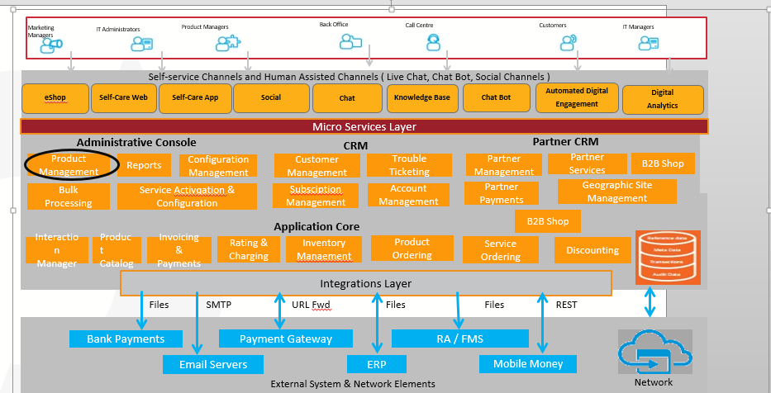

- Test Results

