TM Forum Open APIs
Conformance Certification

Company Name: Inspur Technologies Co. Ltd

TM Forum Open API Name:
Alarm Management API - TMF642

TM Forum Open API Release Version: 21.5 / 4.0

Report Date: 22-10-2021

- What Product or Solution does your API support?

Inspur Fault Manager (hereinafter referred to as the FM System) manages alarms of network devices across vendors and domains in a centralized way. Through the FM System you can monitor all the alarms generated on the network in a centralized manner.

The FM System is designed with a series of functions that satisfy the requirements of carriers for centralized network O&M across vendors. These functions greatly reduces duplicated and derived alarms, thus helping users locate root faults of alarms and enabling users to process alarms in time.
FM detail architecture function are shown as follow:

- Collecting Alarms
- Analyzing Alarms
- Presenting Alarms
- Query Alarms
- Dispatching Trouble Tickets
- Forward Alarms

- Overview of Certified API
Operations on Service: List individuals, Retrieve individual, Create individual, Patch individual, Delete individual.

- Architectural View

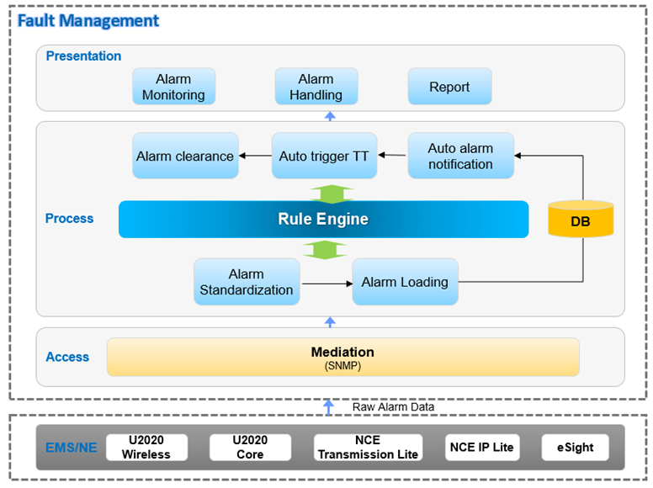

- Test Results

