TM Forum Open APIs
Conformance Certification

Company Name: Jio Platforms Limited

TM Forum Open API Name:
Product Catalog Management API TMF620

TM Forum Open API Release Version: 21.0 / 4.1

Report Date: 26-Sep-2021

- What Product or Solution does your API support?

The Jio Product Catalogue helps create new products and services from reusable product, service and resource components. One can assemble offerings, drive sales and manage fulfillment processes with lower costs and better reliability. Product teams can define new product offerings and specifications quickly by leveraging pre-defined technical specifications and provisioning processes. Product Catalogue is used for provisioning of Reference Data Services like Tax Model, Discount, Geographic Location, Sales Channel and Plan Specification, Composite Price, Plan Offer Services with required mappings of these Services.

- Overview of Certified API

Product Catalog Management

This API is implemented to provide a consistent/standardized mechanism to query and manipulate the Product Catalog. The Product Catalog consists of sub modules to enable provisioning of reference data services, plan creation, price module, price data list modules, plan specification as well as plan offering and mapping. Following are the key features that this API supports:
- Dashboard view of all the plans
- Customer review and ratings
- Wish list plans
- Subscription list
- View and edit account information
- Access management
- Filtering of plans
- Scalable solution
- Improved user experience

- Architectural View
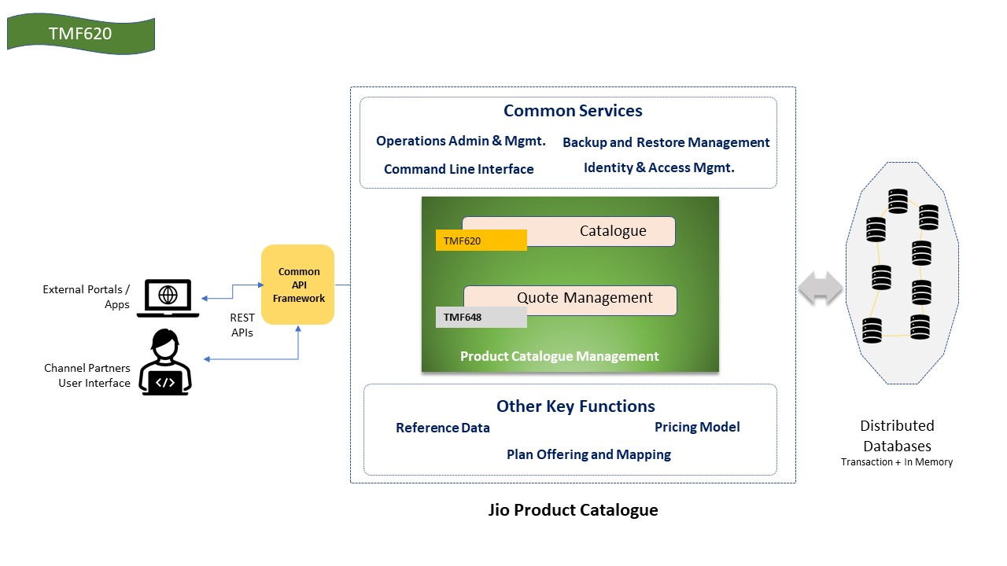

- Test Results

