TM Forum Open APIs
Conformance Certification

Company Name: Jio Platforms Limited

TM Forum Open API Name:
TMF621 Trouble Ticket Management

TM Forum Open API Release Version: 19.0 / 4.0

Report Date: 26-Sep-2021

- What Product or Solution does your API support?

This API supports 2 Products:

- Jio SE Marketplace and CRM Lite

Jio’s Converged Subscription, Marketplace and CRM Lite Solution is a micro service-based solution with multi cloud deployment support. It also provides Open API based integrations with other solutions in the ecosystem.

Amongst the various solutions, this API supports the Jio CRM Lite which helps to store Enterprise Customer details and enables easy integration with Jio OSS FMS. It stores the state of customer order journey which helps the customer track the order status. This includes the model definition as well as available operations. The possible actions are creating, updating and retrieving individuals or organizations including filtering option. The custom milestones can be created in the order completion journey. CRM Lite also integrates with OSS FMS to provision the devices according to the order submitted by the customer. It enables construction of unique and personalized customer relations CRM Lite also provides superior services, respond promptly to incoming orders and inquiries, and include personalized products in your offer thanks to a complete 360-degree customer view run in real time and always in context. The Party is created to record an individual or an organization before the assignment of any role.

- Jio Network Management System (NMS)

Jio Network Management System (NMS) is a critical piece in the overall telecommunications-management solution. It is the sole mediator for monitoring and managing the FCAPS data of the network elements and provides a single pane of glass for the Network Operations Centre. It is fully integrated with AI and ML capabilities, leading to “light touch” operations. This cloud native and 5G ready management system comes with features such as Micro service based, Multi cloud, Unified, Standard compliant and Containers with an interactive user interface for smooth accessibility and visualization of the various functions it brings to the market.

- Overview of Certified API

Trouble Ticket Management

This API is implemented to provide a systematic mechanism for the management for creating and tracking of the trouble tickets created to address an issue or fault identified by the system. Examples of Trouble Ticket API clients include CRM applications, network management or fault management systems, or other trouble ticket management systems (e.g. B2B or C2B). The API performs the following operations:

- Create a new trouble ticket
- Track the progress of a trouble ticket
- Prioritize a trouble ticket with respect to the severity of an issue
- Escalate a trouble ticket
- Resolve a trouble ticket
- Delete a trouble ticket
- Update/ modify a trouble ticket with respect to its progress
- View information of a trouble ticket
- Notifications of a trouble ticket with status of progress or resolution

- Architectural View
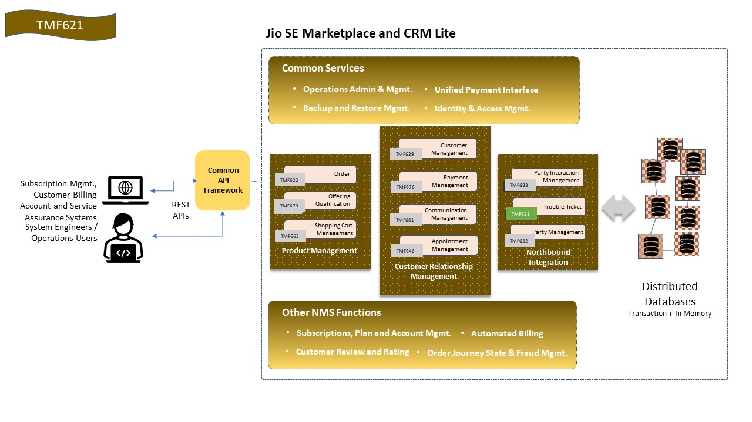
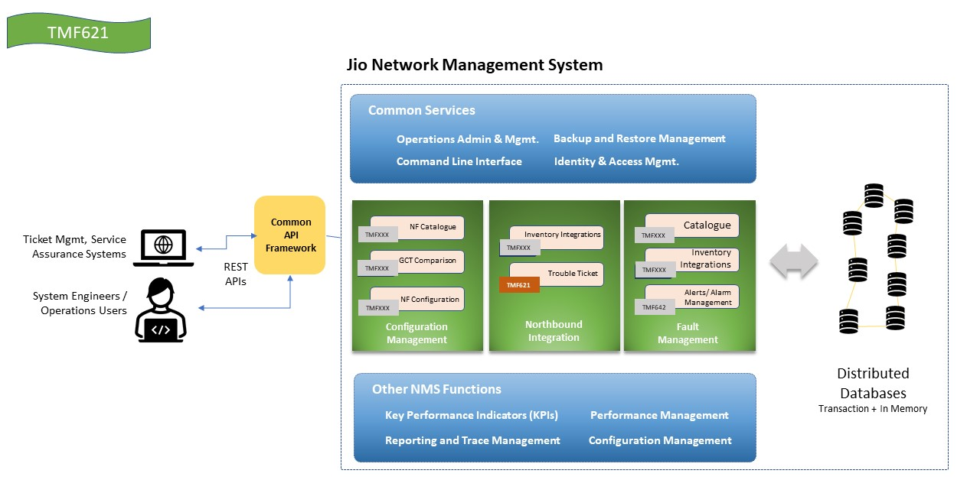
- Test Results

- For Jio SE Marketplace and CRM Lite

- For Jio Network Management System (NMS)

