**TM Forum Open APIs**

**Conformance Certification**

*Company Name:* ***Jio Platforms Limited***

*TM Forum Open API Name:*

***Product Ordering API TMF622***

*TM Forum Open API Release Version:* ***19.0 / 4.0***

**Report Date: 26-Sep-2021**

1. **What Product or Solution does your API support?**

This API supports 2 Products:

1. **Jio SE Marketplace and CRM Lite**

Jio’s Converged Subscription, Marketplace and CRM Lite Solution is a micro service-based solution with multi cloud deployment support. It also provides Open API based integrations with other solutions in the ecosystem.

Amongst the various solutions, this API supports the Jio CRM Lite which helps to store Enterprise Customer details and enables easy integration with Jio OSS FMS. It stores the state of customer order journey which helps the customer track the order status. This includes the model definition as well as available operations. The possible actions are creating, updating and retrieving individuals or organizations including filtering option. The custom milestones can be created in the order completion journey. CRM Lite also integrates with OSS FMS to provision the devices according to the order submitted by the customer. It enables construction of unique and personalized customer relations CRM Lite also provides superior services, respond promptly to incoming orders and inquiries, and include personalized products in your offer thanks to a complete 360-degree customer view run in real time and always in context. The Party is created to record an individual or an organization before the assignment of any role.

1. **Jio OSS Fulfillment Management System (OSS FMS)**

This API also support the Jio OSS Fulfilment Management System Platform (OSS FMS); it is a next generation workflow orchestration, provisioning, and activation platform. This 5G Ready Fulfilment Management System comes with features such as Micro Service Based, Multi Cloud, LoB Agnostic, Open APIs, and Containers which help to create a frictionless digital service delivery by readily accelerating time to market

1. **Overview of Certified API**

**Product Ordering API REST Specification**

This API is implemented to provide a systematic mechanism for a product order placement in compliance with the parameters of ordering. The API interacts with the product to perform a set of standard operations in order to manage the ordering feature. A product order is acts as an identifier to be used in order to place an order for a service constituting an engagement between the customer and the service provider or the other way round. The following few operations are performed by this API for a ordering a product:

* Order creation
* Order modification/ update
* Order removal/ deletion
* Order notification
* Order status viewing

1. **Architectural View**

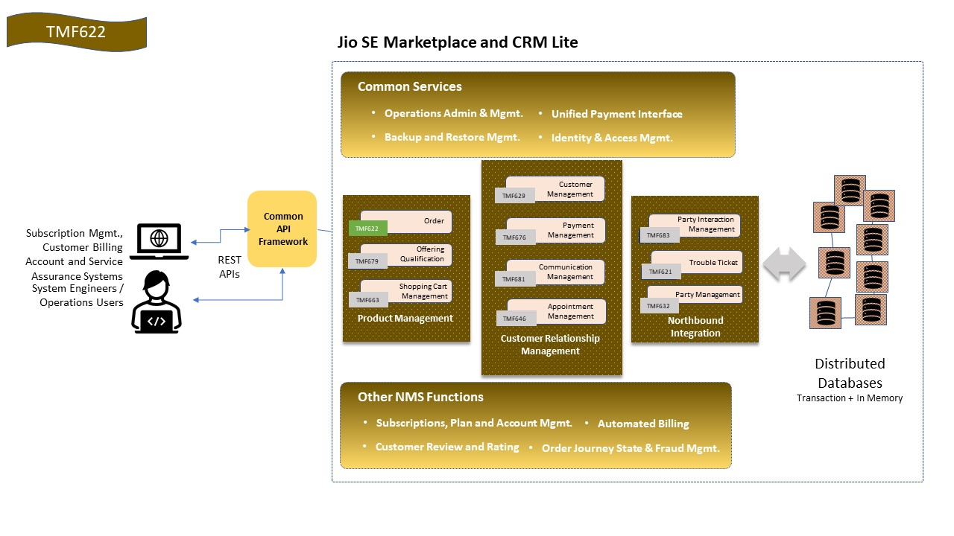

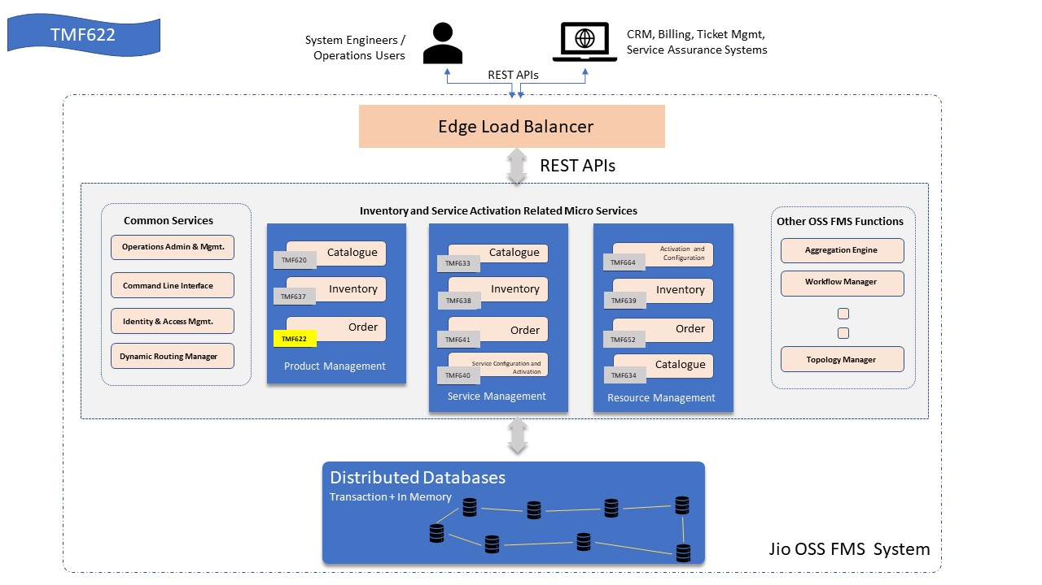

1. **Test Results**
2. **For Jio SE Marketplace and CRM Lite**



1. **Jio OSS Fulfillment Management System (OSS FMS)**

