**TM Forum Open APIs**

**Conformance Certification**

*Company Name:* ***Jio Platforms Limited***

*TM Forum Open API Name:*

***Customer Management API TMF629***

*TM Forum Open API Release Version:* ***19.0 / 4.0***

**Report Date: 26-Sep-2021**

1. **What Product or Solution does your API support?**

Jio’s Converged Subscription, Marketplace and CRM Lite Solution is a micro service-based solution with multi cloud deployment support. It also provides Open API based integrations with other solutions in the ecosystem.

Amongst the various solutions, this API supports the Jio CRM Lite which helps to store Enterprise Customer details and enables easy integration with Jio OSS FMS. It stores the state of customer order journey which helps the customer track the order status.This includes the model definition as well as available operations. The possible actions are creating, updating and retrieving individuals or organizations including filtering option. The custom milestones can be created in the order completion journey. CRM Lite also integrates with OSS FMS to provision the devices according to the order submitted by the customer. It enables construction of unique and personalized customer relations CRM Lite also provides superior services, respond promptly to incoming orders and inquiries, and include personalized products in your offer thanks to a complete 360-degree customer view run in real time and always in context. The Party is created to record an individual or an organization before the assignment of any role.

1. **Overview of Certified API**

**Customer Management**

This API is implemented to provide a systematic mechanism for the management of customers in the product. It enables the process of managing the relationship between an organization, its people and the customers in specific intervals of time. A customer can be an individual or a business purchasing or subscribing to the products and services offered and more. This API created holds information and performs an operation for customer and its account management such as that of creation, modification, deletion, viewing, notification or data retrieval.

1. **Architectural View**

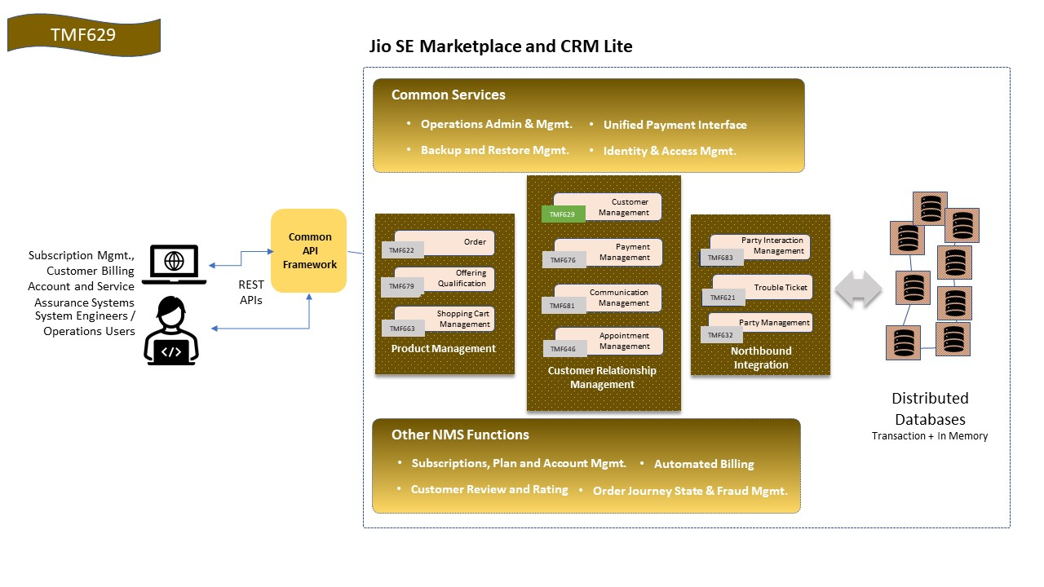

1. **Test Results**

