TM Forum Open APIs
Conformance Certification

Company Name: Jio Platforms Limited

TM Forum Open API Name:
Party Management API TMF632

TM Forum Open API Release Version: 19.0 / 4.0

Report Date: 26-Sep-2021

- What Product or Solution does your API support?

Jio’s Converged Subscription, Marketplace and CRM Lite Solution is a micro service-based solution with multi cloud deployment support. It also provides Open API based integrations with other solutions in the ecosystem.

Amongst the various solutions, this API supports the Jio CRM Lite which helps to store Enterprise Customer details and enables easy integration with Jio OSS FMS. It stores the state of customer order journey which helps the customer track the order status.This includes the model definition as well as available operations. The possible actions are creating, updating and retrieving individuals or organizations including filtering option. The custom milestones can be created in the order completion journey. CRM Lite also integrates with OSS FMS to provision the devices according to the order submitted by the customer. It enables construction of unique and personalized customer relations CRM Lite also provides superior services, respond promptly to incoming orders and inquiries, and include personalized products in your offer thanks to a complete 360-degree customer view run in real time and always in context. The Party is created to record an individual or an organization before the assignment of any role.

- Overview of Certified API

Party Management

The Party Management API manages and records the data of an individual or organization that has any kind of relation with the enterprise. The individual can be a customer, an employee or any other person that the organization needs to store information about. . It helps to stay connected to customers, streamline processes and improve profitability. Organization represents a group of people identified by shared interests or purpose. Examples include business, department and enterprise. After entering the mandatory information, a unique identification number will be generated for the Party.

The main operations that are performed by Party Management API are:

- Retrieval of an individual or an organization
- List a collection of individuals or organization depending on filter criteria
- Partial update of an individual or an organization
- Creation of an individual or an organization
- Deletion of an individual or an organization
- Notification of events relating to an individual or an organization.
- Architectural View

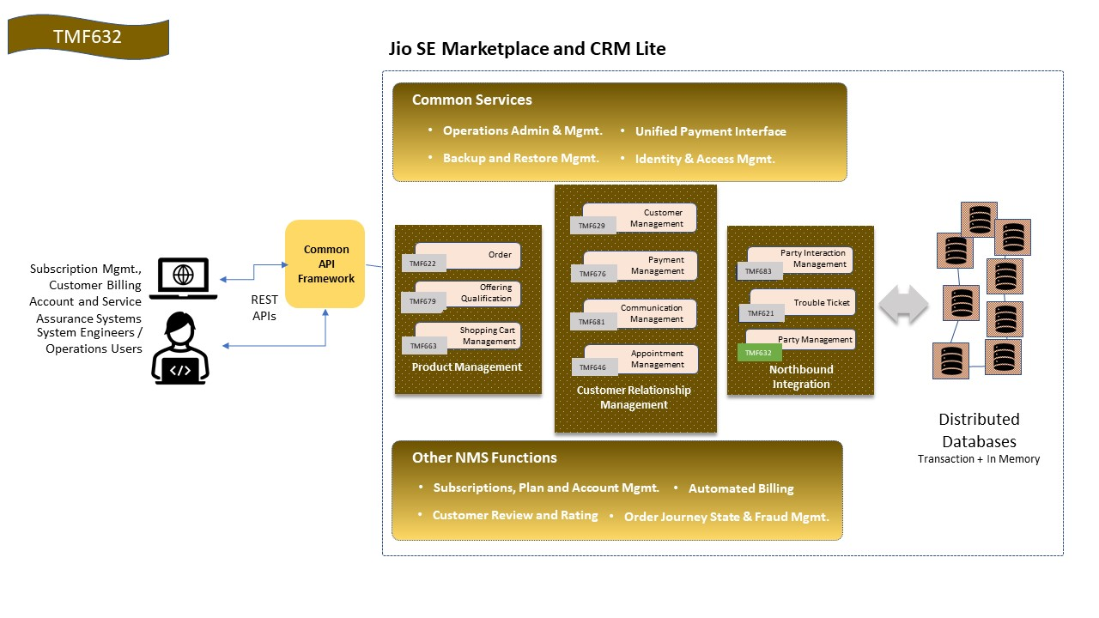

- Test Results

