TM Forum Open APIs
Conformance Certification

Company Name: Jio Platforms Limited

TM Forum Open API Name:
Service Catalog Management API TMF633

TM Forum Open API Release Version: 21.0 / 4.0

Report Date: 26-Sep-2021

- What Product or Solution does your API support?

The Jio OSS Fulfilment Management System Platform (OSS FMS) is a next generation workflow orchestration, provisioning, and activation platform. This 5G Ready Fulfilment Management System comes with features such as Micro Service Based, Multi Cloud, LoB Agnostic, Open APIs, and Containers which help to create a frictionless digital service delivery by readily accelerating time to market.

- Overview of Certified API

Service Catalog Management

This API is implemented to provide information regarding all the services belonging to the service catalog of the product along with its management. This managerial task may happen during an ordering process or any other process part of the catalog. It takes care of creation and maintenance of the service catalog by providing correct and updated information.

- Architectural View

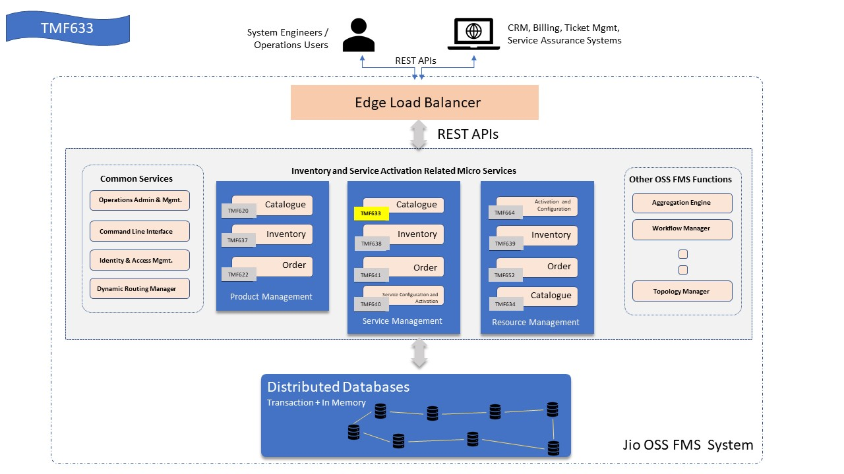

- Test Results

