TM Forum Open APIs
Conformance Certification

Company Name: Jio Platforms Limited

TM Forum Open API Name:
Usage Management API TMF635

TM Forum Open API Release Version: 20.0 / 4.0

Report Date: 26-Sep-2021

- What Product or Solution does your API support?

The JIO Total Charge is a complete charging solution of 2G/3G, 4G, 5G and IMS network. It fulfills the billing, invoicing, rating and statistics requirements of all types of services offered by an operator. The system is built using the state of the art techniques such as micro-service based, N-way active, resilient and DR support, dynamic service provisioning and processing, containerized etc. It can be deployed and integrated with any operator network seamlessly.

- Overview of Certified API

Usage Management

This API is implemented to provide a systematic mechanism for usage management for both rated as well as non-rated usages. It allows management via basic operations such as creation, update, retrieval and tracking of usages in near real time. Usage may represent any event that may involve charges or be carried out for an organization’s interest. This API focuses on management of usages that are an occurrence of employing or subscribing to a product, resource or a service incurring monetary or any other form of charges.

- Architectural View

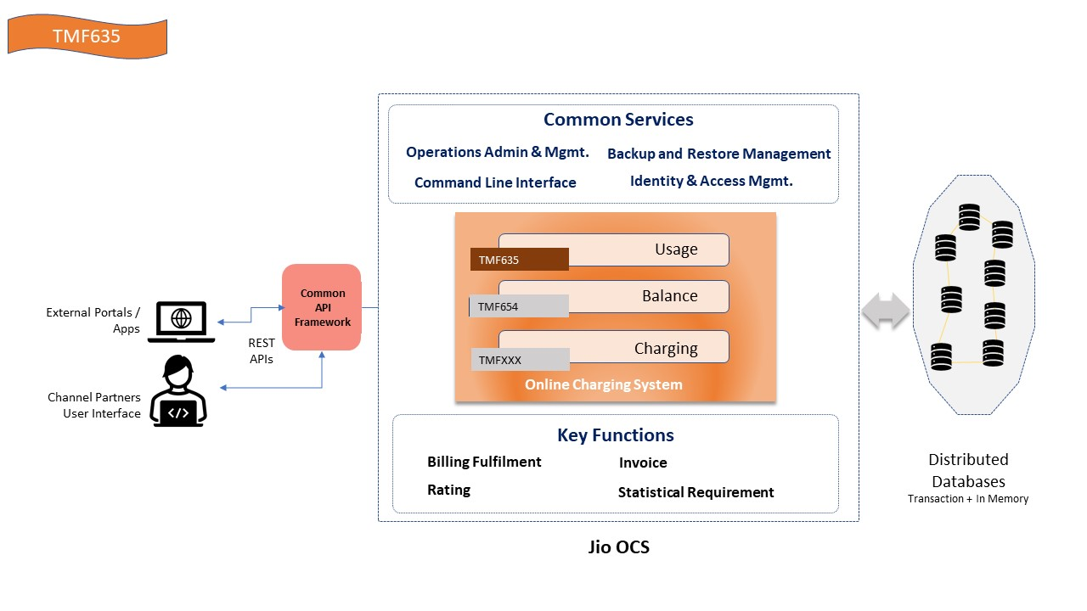

- Test Results

